RSSB Information Model and Authoring Guidelines

**Draft 4.6 from Rule Book project**

4.5 Signed off 15 December 2016 by Alan Cropley

**Version history**

|  |  |  |  |  |
| --- | --- | --- | --- | --- |
| **Date** | **Version** | **Author** | **Section** | **Amendment** |
| 31/10/2016 | 4 | Mekon | For review. | Laura Katajisto |
| 31/10/2016 | 4.1 | Mekon | Pages 18, 55, 57, 62, 74-106 | Alan Cropley |
| 31/10/2016 | 4.1 | Mekon | Pages 18, 55, 57, 62, 74-106 | Alan Jones |
| 15/11/2016 | 4.2 | Mekon | Entire document: edits based on review comments marked with turquoise | Laura Katajisto |
| 23/11/2016 | 4.3 | Mekon | Edits based on review comments marked in grey. Previous changes are now marked with [RB]. | Laura Katajisto |
| 29/11/2016 | 4.4. | Mekon | Fixed two typos. Added <metadata> to Briefing Leaflet <bookmeta>, and <started> into <bookmeta> for Briefing Leaflet and Rule Book bookmap. Added sections “Adding a disclaimer text to the front cover”, “Producing a copyrights page for a Rule Book”, and improved “Creating change bars in Rule Book”. Changed the structure for Briefing Leaflet topic and bookmap. | Laura Katajisto |
| 14/12/2016 | 4.5 | Mekon | New and rewritten content:  Changed term “Briefing Leaflet topic” to “Explanation of Change topic”. Added how to link to the Key Changes topic to Rule Book bookmaps and how to handle cases where there are no Explanation of Change topics. Changed the way briefing leaflet <xref> is added to entire topics that change. Changed the instruction on nesting introductory paragraphs and following lists.  Rewrote sections front cover and back cover, as image linking was simplified.  Error corrections:  Added <contactnumbers>, <emailaddresses>, and <keywords> to the bookmeta tables from other parts of the IM. Fixed examples in Creating change bars in Rule Book. | Laura Katajisto |
| 20/01/2017 | 4.6 | RSSB | Additional guidance to authors regarding elements to be deleted within the bookmap if not required. | Alan Cropley |

**Table of Contents**

Chapter 1: Overview of the RSSB Information Model and Authoring Guidelines 8

Using this document 9

What this document contains? 10

Terms 10

Chapter 2: Planning a DITA project 13

Example annotated topic list (ATL) or work list 13

How the pieces of a DITA document fit together 14

Chapter 3: Information types 16

Beginning a topic 18

Titling topics 18

Adding rule numbers to headings in Rule Book topics 20

Adding metadata to A4 topics 20

DITA examples of <prolog> in A4 topics 22

Concepts 22

Concept structure 23

Concept elements 24

Writing concept topics 25

Sample concept topics 26

References 26

Reference structure 26

Reference elements 27

Writing reference topics 27

Sample reference topics 27

Chapter 4: Block elements 28

Writing paragraphs 28

Writing introductory paragraphs 28

Including <p> elements in other DITA elements 29

Creating lists 29

Choosing the appropriate list type 30

Writing unordered lists 30

Writing ordered lists 31

Writing definition lists 31

Nesting lists 32

Reusing list items 32

Building tables 32

Writing table text 33

Formatting table cells 33

Spanning rows or columns 34

Table elements 36

Figures and media content 37

Adding static graphics 37

Placing and formatting graphics 38

Writing notes 38

Chapter 5: Inline elements 40

Highlighting elements 40

Miscellaneous inline elements 40

Special characters 41

Chapter 6: Maps and bookmaps 42

Maps 42

Map structure 42

Map elements 43

Creating maps 44

Sample map 45

Bookmaps 46

Bookmap structure 46

Bookmap elements for A4 documents 46

Bookmeta in A4 documents 48

Creating maps 53

Documents that have to be printed using several colours 53

Sample bookmap for A4 documents 54

Chapter 7: Linking strategies 56

ID attribute 56

Cross references 57

Relationship tables 58

Creating a relationship table 58

Relationship table elements 59

Linking to topics within the same cell 59

Creating one-way links 60

Chapter 8: Reuse strategy 61

Writing for reuse 61

Reusing topics and maps 62

Reusing elements through collection files 63

When to use 63

Creating and structuring collection files 63

Referencing individual elements from collection files 64

Conditional processing 64

When to use 65

Setting a condition 65

Tracking changes in reused topics 65

Chapter 9: Rule Book authoring 66

Building a Rule Book 66

Rule Book topic types 66

What is a topic and what is a section? 67

Rule Book bookmap 70

Building hierarchy to Rule Book 71

Bookmap structure 74

Bookmap elements for Rule Book 75

Bookmeta in Rule Book bookmaps 77

Documents that have to be printed using several colours 84

Producing a front cover for a Rule Book 84

Adding images for the front cover to bookmap 84

Adding metadata elements for the front cover texts 85

Adding a disclaimer text to the front cover 86

Producing a copyrights page for a Rule Book 87

Role responsibilities topic 88

Creating a role responsibilities topic 89

Linking a role responsibilities topic to a bookmap 89

Rule Book conventions topic 90

Creating the conventions topic 90

Linking the conventions topic to a bookmap 91

Producing a back cover for a Rule Book 91

Adding metadata elements for the back cover texts 91

Authoring Rule Book topics 93

Adding rule numbers to headings in Rule Book topics 93

Adding the topic metadata to Rule Book topics 93

Adding the fundamental operating principle metadata 95

Adding roles and responsibility indicators 95

Adding a criticality red box 96

Adding a note, tip, or important note 96

Adding rationale and guidance for Rule Book topics 96

Adding web links 98

Adding a footnote 98

Adding a video 98

Digital Rule Book metadata 98

Changes and Briefing Leaflet 99

Marking changes between Rule Book issues 99

Creating the Briefing Leaflet summary 101

Creating Explanation of Change topics 102

Creating the Briefing Leaflet bookmap 104

Creating change bars in Rule Book 112

When there is no Explanation of Change topic 115

Linking the Briefing Leaflet key changes to a Rule Book 115

Creating a glossary 116

What are keys and keyrefs? 117

Glossary topic structure 117

Subject scheme map structure 119

Using <abbreviated-form> and @keyref in topics 121

Providing processing instructions for PDF conversions 122

Providing summary information and important dates for the Rule Book 123

Summary 123

Important dates 123

Providing document properties for the Rule Book PDF 124

Chapter 10: Content management 125

CMS Metadata 125

Folder structure 125

File naming convention 128

# Chapter 1: Overview of the RSSB Information Model and Authoring Guidelines

RSSB has adopted a structured authoring environment in XML using the Darwin Information Typing Architecture (DITA), an OASIS standard that defines an XML architecture for designing, authoring, publishing, and managing content. This document describes the specific implementation of this standard at RSSB, documenting the specific structures and elements in use within the RSSB library.

**What is the RSSB vision?**

RSSB has adopted a new authoring culture and technology for creating and managing discrete requirements which can be associated with relevant related information. The decision to implement structured authoring, DITA, and a component content management system (CCMS) will enable the following improvements:

* Provisioning of discrete, assessable requirements to the GB mainline rail industry
* Efficient authoring of requirements and less on-going change
* Single-sourcing of validated information for standards produced by RSSB, accessible to both RSSB and stakeholders

**Why structured authoring?**

Unstructured content is costly and inefficient. Because unstructured content is difficult if not impossible to reuse, writers frequently copy information to multiple locations and make small modifications as they see fit. Copying information in this manner causes rework, increases the chances of error and multiplies the costs associated with maintenance and translation. Unstructured content is also more difficult for end users to understand. Differing content, structure, terminology, and writing style can cause end-user confusion and lower comprehension of the material.

Structured content requires more consistent writing that meets user expectations at the topic level and that eliminates content that users don’t need or that they already know. The discipline needed to focus on each topic helps ensure authors become more thoughtful about the nature of the content, its relevance and accuracy rather than its format. Semantic tagging and metadata enhances content searches for both end users and authors and helps streamline content planning and reuse, customisation, and the production of finished deliverables. Structured content has a more consistent voice and terminology so that information can be repackaged in many different deliverables.

**Why DITA?**

DITA is an XML architecture specifically designed for creating structured technical content. As an XML architecture, DITA offers a number of advantages for information development:

* Open standards, allowing you to easily share and exchange content with other writers or organisations using the same standards.
* An active user community comprised of representatives from some of the largest and most successful, high-tech companies in the world.
* Centralised authoring and control through the use of a DITA compliant Component Content Management System (CCMS)
* A topic-based approach, allowing you to combine and recombine focused content units into a variety of larger publications.
* Separation of form from content, allowing you to present the same content in different formats.
* Meaningful, semantic tagging, allowing you to classify content according to what it is, not what it looks like.
* Conditional processing, allowing you to include or exclude content during publication based on specific criteria such as audience or product.
* Indirect and direct referencing of content, allowing you to reuse and redefine specific content in different contexts.
* Inheritance of attributes and metadata that minimises the individual programming required on each element.

Since its creation in 2005, DITA has consistently gained in popularity and is now the most common architecture used for technical content according to many industry studies. For more information about DITA in general, see [*http://dita.xml.org*](http://dita.xml.org).

The *RSSB Information Model and Authoring Guidelines* is a subset of the DITA 1.2 specification (*http://docs.oasisopen.org/dita/v1.2/os/spec/DITA1.2-spec.html*) and candidate DITA 1.3 functionality. It documents the DITA elements that are commonly used at RSSB and outlines when certain elements should or can be used. Use of any elements that are not described within this information model may yield unexpected results when rendered and is strongly discouraged. Any use of such elements must first be discussed and approved by the owner of the information model.

## Using this document

All RSSB authors who are writing content in XML or who are migrating existing documents to XML, should follow the *RSSB Information Model and Authoring Guidelines*. Take the time to understand the model and guidelines so you can apply them properly. During your project, use this document as a reference to ensure that your content is consistently organised, structured, and tagged. The more you know about the standards, the quicker you will be able to apply them to your content and the better the results will be. If you have any questions or comments regarding the model, please direct them to the RSSB Requirements Management DITA architecture team.

This document includes all the DITA elements that are valid for RSSB documentation. However, you will rarely need to enter these elements by hand. EasyDITA automatically sets up elements and attributes for you. For example, it provides table creation features so that you do not need to manually insert column, row, and heading elements.

In addition, RSSB has many templates that are pre-populated with the elements you need in the order they should appear. By starting every topic you write with a template, you don't have to remember all the required elements discussed in this document.

This information model includes information and instructions on how to author both A4 and Rule Book documents using RMDB. Some parts of A4 and Rule Book are authored differently, and the differences are marked with “A4” and “Rule Book”, respectively. The Rule Book specific instructions regarding its metadata, cover pages, and use of rationale and guidance, for example, are included in their own chapter, Chapter 9. [RB]

Where text is not marked specifically with A4 or Rule Book, the information applies to both. For example, the information and instructions in Chapter 4, Block elements, apply both to Rule Book and A4 documents. As a general guideline, Rule Book authoring has been designed to be as similar to A4 authoring as is possible. [RB]

## What this document contains?

The *RSSB DITA Information Model and Authoring Guidelines* contain the information that you need to produce topic-based content and deliverables that end users need to understand and use information effectively and efficiently.

This document is based on the DITA standard, which includes:

* A core Document Type Definition (DTD) defining the generic topic information type
* A set of specialised DTDs, only three of which are currently used at RSSB:
  + Concept DTD specifies the structure of explanatory content and detailed descriptions
  + Reference DTD specifies the structure of data-oriented information
  + Glossentry DTD specifies the structure of term and definition information for glossaries [RB]
* A set of elements:
  + Generic elements that are common to all information types
  + Elements specific to only certain information types
  + Elements specific to book paradigms, such as frontmatter, parts, and appendices
* DTDs defining the DITA map and bookmap structures, which allow topics to be assembled and structured for output
* Metadata that is used to control page creation, searching, and the digital Rule Book functionality. [RB]
* Support for reuse strategies to generate multiple outputs from the same files, only two of which are used at RSSB:
  + Content references (conrefs)
  + Conditional attributes
* Transforms that can be used in conjunction with RSSB stylesheets and its publishing pipeline to create final deliverables

## Terms

You should be familiar with these terms when reviewing and using the *RSSB Information Model and Authoring Guidelines*.

|  |  |
| --- | --- |
| **Term** | **Definition** |
| **topic** | A titled group of information that can be understood in isolation and used in multiple contexts. It should be short enough to address a single subject or answer a single question but long enough to make sense on its own and be authored as a self-contained unit. A topic must be declared to be one  of five information types: task, concept, reference, troubleshooting, or glossary. |
| **information type** | A categorization that defines the primary purpose of the content within a topic. The information type you select when you create a new topic defines the DTD that controls the elements and sequencing that can be used for information within the topic. |
| **DTD**  **(Document**  **Type**  **Definition)** | Documents that provide the rules for an information type in DITA. For example, the task, concept, and reference DTDs all require that you include a <title> element at the beginning of your topic. This rule is defined in the DTD. |
| **map** | A document that organizes topics and other resources into structured collections of information. DITA maps specify hierarchy and the relationships among the topics within the map; they also provide the context in which variables are defined and resolved. |
| **bookmap** | A specialized DITA map that enables you to create the familiar parts of a book structure, such as front matter, chapters, appendices, and back matter. Bookmaps are used to create complete publications, documents, or even libraries. Despite the name, these publications are not limited to  “books.” |
| **element** | Semantic markers that define the start and end of content. All element names begin with a “<” and end with a “>”. Every element consists of a start tag, such as <p>, and an end tag, such as </p>. Any characters entered between the start and end tags are known as that element's content. Element content can include words, numbers, and other elements as needed or defined. |
| **root element** | The first element within a topic. This element specifies the DITA information type of the topic (<concept>, <task>, and <reference>). All other elements in the topic are nested within this element. |
| **container**  **element** | An element that does not contain character data or other content but is used only to group other elements together. For example, the <steps> element in the task information type is a container element used to group a set of <step> elements. |
| **block**  **element** | An element that contains content and that is common to all DITA information types. You nest these elements within the topic body element (<taskbody>, <conbody>, and <refbody>) to create the basic  topic structure. Block elements include:   * Paragraphs * Lists * Tables * Figures * Notes |
| **inline**  **element** | An element that describes a word or phrase that occurs inside a block element such as a paragraph, list item, or cell in a table. The information contained in these elements is used to optimise search and retrieval for both authors and users. In addition, some inline elements have specific formatting requirements that are handled by the stylesheet. |
| **metadata** | Data that classifies and categorizes content so that authors and end users can more easily locate the information they need. |
| **attribute** | A form of metadata that provides more information about an element and its content. Attributes are defined in an element's start tag. Attributes consist of a name and value (contained in quotation marks). Within this document, attribute names are italicized and prefaced with an at sign (for  example, @id). |
| **markup** | A broad term used to describe the elements and attributes that are applied to content. |
| **nesting** | The practice of placing an XML element within another XML element. Elements are said to be nested if their start and end tags occur within the start and end tags of another element. For example, in the code block example below, two <li> elements are nested within the <ul> element.  <ul>  <li>First list item</li>  <li>Second list item</li> </ul> |
| **conref** | A mechanism for the reuse of content fragments within DITA topics or maps. Conref refers to the ability to pull referenced content from one location into one or more additional locations. See Reusing elements through collection files on page 63 for more information. |
| **conditional**  **processing** | Filtering, flagging, searching, or indexing content based on the association of an element with one or more specified metadata values. See Conditional processing on page 64 for more information. |

# Chapter 2: Planning a DITA project

When a standards document or a rule book needs to be created or updated, authors should begin by working with the project manager in planning the project with a work schedule, an outline, and/or an annotated topic list (ATL). Frequently, these items are created in the form of a spreadsheet that contains the following information:

* Requirements and standards to be covered
* Broad subject areas in the form of parts or chapters
* Titles of the individual topics to be included in those parts, listed in the recommended sequence and hierarchy
* The information type for each topic (concept, task, or reference)
* A brief description of the content of each topic
* The high-level metadata for each topic, including audience, category, keywords, standards committees, and relevant legislation
* Relationships between the topics
* The author and reviewers responsible for the content
* Whether the topic is new, requires modification, or is used as-is

By planning the project, project managers and authors can make best use of the structured nature of DITA content, by identifying reusable content, splitting responsibilities, and working concurrently. The ATL is a tool to coordinate projects and should reflect the thinking and analysis of the subject matter experts. It is a living document and as such requires much coordination between the project manager, the lead author, and technical specialists to remain correct and up-to-date. As progress is made developing the content, the lead author (the author responsible for developing the document) should update both the bookmap and the ATL (if not directly controlled and managed by the project

manager).

## Example annotated topic list (ATL) or work list

Use the RSSB_ATL_template.xls file as a starting point for planning your project with an ATL. The following figure is an excerpt from a sample ATL; all recommended columns are not shown in this image.

**Note:**

The exact structure of the ATL is up to the discretion of the project manager or lead author for each

specific project. You may be asked to provide more, or less, information depending on the needs of the project.



**Figure 1: Example Annotated Topic List**

## How the pieces of a DITA document fit together

The structure designed in the ATL is transferred to a DITA bookmap, with appropriate submaps for parts or chapters, and references to individual topics. During the publishing process, the bookmap, submaps, and topics are assembled into a finished PDF as shown.



**Figure 2: Relationship of bookmaps, maps, and topics to a PDF document**

At RSSB, bookmaps for a standard contain a topic for each requirement. Each requirement topic contains optional sections for the rationale and guidance for the requirement. At publication time, those files are processed through the DITA Open Toolkit, which uses XSLT and XSL-FO to create the PDF, including specifying layout, typography, and numbering.



**Figure 3: Relationship of bookmaps, requirements topics, and rationale and guidance sections to published output**

# Chapter 3: Information types

RSSB categorises its content into three DITA information types as shown in the table. All content must be placed into topics that are based on one of these basic information types.

**Table 1: RSSB information types**

|  |  |  |
| --- | --- | --- |
| **DITA information type** | **Definition** | **RSSB information** |
| Concept | Provides overview and background information that helps end users understand essential information about a requirement, deviation or principle of operation. A concept topic typically answers a “What is...” question. | Requirement, including rationale and guidance |
| Standalone guidance |
| Deviation/Deviation request |
| Overviews |
| Copyright information |
| Synopsis statements |
| Safety information |
| Issue record of a document |
| Introductory information about a standards document |
| Impact assessment |
| Briefing Note (A4) |
| Reference to RSSB information |
| Technical note as RSSB information |
| Lineside operational safety signs |
| Rule Book principles of operation information [RB] |
| Role responsibilities information in Rule Book [RB] |
| Conventions information in Rule Book [RB] |
| Rule Book Briefing Leaflet summary [RB] |
| Rule Book Explanation of Change information [RB] |
| Glossary terms and definitions (A4, not Rule Book) [RB] |
| Reference | Provide “look-up” information that end users might need to refer to when completing a task. A reference topic may answer questions like “How Much...”, “How Many...”, or “What Form...” It is intended to be referred to frequently. | Tabular data |
| Glossary entry | Provide a term and definition for a Rule Book glossary. | Glossary terms and definitions (Rule Book, not A4) [RB] |

As you work, ensure that every requirement or other RSSB content is placed in a separate information type in a single topic file. You will combine topics by placing them in relation to each other in a DITA map to create a publication. Different RSSB publications use different information types as shown in the following table.

|  |  |
| --- | --- |
| **RSSB Publication** | **RSSB Information Types used** |
| Rail Industry Standard | Synopsis statement  Copyright information  Safety information  Requirement (including rationale and guidance)  Tabular data  Glossary terms and definitions |
| Railway Group Standard | Synopsis statement  Copyright information  Safety information  Requirement (including rationale and guidance)  Tabular data  Lineside operational safety signs  Glossary terms and definitions |
| Rail Industry Guidance Note (standalone) | Synopsis statement  Copyright information  Safety information  Overviews  Standalone guidance  Tabular data |
| Deviation/Deviation Request | Deviation |
| Impact Assessment | Impact Assessment |
| Briefing Note (A4) | Briefing Note (A4) |

## Beginning a topic

Regardless of the information type, all topics must include a title and a prolog section before you begin the body of the topic. The following sections provide guidelines for these common elements.

**Note:**

When creating a new topic, always start with the RSSB template for the appropriate information type, if one is available. If you start by copying another topic, you could inadvertently duplicate element IDs and you risk overlooking elements that you might need for the new topic that were removed from the topic you copied.

### Titling topics

DITA requires that you provide a title for all topics, which is typically published as the heading of the topic’s content in the final output and appears in the table of contents and other navigation features to assist users in locating the information.

**Note:**

In some RSSB stylesheets the topic title may not appear in the output for an individual requirement.

Although the titles of requirements topics may not be rendered in the output, you must include a title so that the topics can be found through search and managed effectively.

The title must clearly convey the content found in the topic. When writing titles, follow these guidelines:

* Make the title specific to help users distinguish it from other similar topics.
* Use words that accurately describe the content and that are specific, concise, and meaningful. Avoid headings that identify the type of information, but not the subject matter; for example, Introduction or Overview, without further clarifying words to indicate what content is introduced or what you are providing an overview about. Topic titles not only provide clarity for the user but also will assist other authors in locating relevant information in the repository.
* Use industry standard and commonly used words.
* Use the same terms consistently in topics that cover the same subject.
* Use plural forms of nouns unless the subject makes sense only in the singular.
* Avoid using acronyms and abbreviations in a title, unless they are industry standards.
* Use articles (a, an, the) to improve understanding.
* Although it will not always be possible, try to limit the length of the title to no more than eight words.
* Use sentence case, capitalising only the first word in the title.

The <title> element is the first element within the topic root element (such as <concept> or <reference>). Type your text directly into the <title> element, keeping in mind the following constraints:

* You cannot nest block elements or most inline elements within <title>. Even when they are allowed, avoid using inline elements that might override the format of the heading style, for example bold (<b>). For Rule Book topics, you are allowed to use <ph> to add a heading number. [RB]
* Do not copy a title from other topics by using a “conref”. If you are writing a topic that has the same title as another topic, consider whether both topics should be combined into one normalised topic. If not, add distinguishing information to the titles to help end users understand the difference between the two topics.

In addition to these general guidelines, the following sections discuss unique considerations for each information type.

#### Titling concept topics

When titling a concept topic, follow these guidelines:

* Use noun phrases as a signal to users that the topic will *not* tell them how to complete a task.
* Place important words at the beginning of the title to draw the users’ attention, for example, Installation Guidelines, not Guidelines for Installation.
* Rule Book only: use verb to signal to users that the topic includes information on how, when and by whom actions are taken. [RB]

**DITA example:**

<concept>

<title>Platforms on curved track - considerations</title>

...

</concept>

#### Titling reference topics

When titling a reference topic, follow these guidelines:

* Use noun phrases as a signal to users that the topic will *not* tell them how to complete a task.
* Use the name of the referenced information in the title. For example, if providing specifications for a specific sign, include the name of the sign in the title.
* Title topics for specific categories of reference information consistently. For example, include the word “Sign” in all topic titles dealing with RSSB standards for signs.

**DITA example:**

<reference>

<title>Sign AF01: Emergency indicator</title>

...

</reference>

### Adding rule numbers to headings in Rule Book topics

[RB]

When you are writing topics for a Rule Book, you must write the rule number to each heading manually. Rule Book topics are not numbered automatically. For instructions, see Adding heading numbers to Rule Book topics on page 93.

In the figure below, 3.8 and 3.8.1 are examples of rule numbers in headings.

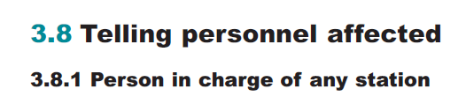

### Adding metadata to A4 topics

When you start or modify a topic, add metadata to the <prolog> section of the topic to capture information about the topic as a whole. The metadata inside the <prolog> will not be displayed with the topic on output but may be used by processes that filter content, generate search indexes, or customise navigation. Include each of the following elements in the prolog in the order listed. All elements are required unless noted otherwise in the description.

There are small differences to the guidance below in adding metadata to Rule Book topics. For more information, see Adding the topic metadata to Rule Book topics on page 93. [RB]

|  |  |
| --- | --- |
| **Element** | **Guidance** |
| **<LeadStdComm>**  **lead standards committee**  **(optional)** | Use the <LeadStdComm> element to include the lead standards committee responsible for this content. If more than one committee is responsible, list the others in the StdComm element later.  **Note:**  <LeadStdComm> is a masking of the DITA standard element <author>. |
| **<StdComm>**  **standards committee**  **(optional)** | Use the <StdComm> element to include all standards committees responsible for this content. If more than one committee is responsible, list the primary committee in the LeadStdComm element earlier.  **Note:**  <StdComm> is a masking of the DITA standard element <publisher>. |
| **<metadata>**  **metadata (mandatory)** | Use the <metadata> element as a container for topic-level metadata, for example, audience or category. |
| **<keywords>**  **keywords**  **(mandatory)** | Nest the <keywords> element in <metadata> as a container for keywords that can be used to help locate the topic. |
| **<keyword>**  **keyword**  **(mandatory)** | Nest the <keyword> element in <keywords> to classify the topic content for easier retrieval or navigation. The values you can assign are limited to a picklist within EasyDITA, referencing the “List of Active Keywords”  document. You can select as many values as apply. |
| **<prodinfo>**  **product information**  **(requirements only)** | Nest the <prodinfo> element in <metadata> as a container for information about the requirement type, affected subsystem, and railway undertaking. For legacy content that is neither NSR nor NTR, remove the <prodinfo> element entirely.  Nest the following elements in <prodinfo>:   |  |  | | --- | --- | | **Element** | **Guidance** | | **<prodname>**  **product name**  **(mandatory)** | Nest the <prodname> element in <prodinfo> to specify the type of requirement in this topic: either NSR or NTR. | | **<vrmlist> and**  **<vrm> version,**  **release,**  **modification list**  **(mandatory)** | Nest the <vrmlist> element in <prodinfo> and the <vrm> element in <vrmlist> to satisfy DITA  requirements. The @versionattribute of <vrm> should be set to “NA”.  **Note:**  These elements appear in the code of the DITA topics, but are hidden in the EasyDITA authoring interface. | | **<component>**  **structural railway**  **sub-system**  **(mandatory)** | Nest the <component> element in <prodinfo> to specify the structural railway sub-system impacted  by the requirement. Choose from the following values:  *RST*  Rolling Stock  *INS*  Infrastructure  *CCS_T/S*  Control Command & Signalling  Telecommunication Systems  *CCS_O/B*  Control Command & Signalling Onboard  *ENE_TS*  Energy Systems  *ENE_OB*  Energy Systems On-board  *TOM*  Traffic Operations and Management (NSR only) | | **<series>**  **railway**  **undertaking (NSR**  **requirements only)** | Nest the <series> element in <prodinfo> to specify the railway undertaking associated with this  requirement. Choose from Build, Design, Operations, and Maintenance. | |
| **<othermeta name="TSI"**  **content="*EU std*">**  **(optional)** | Nest the <othermeta name="TSI"> element in <metadata> to list any EU standards associated with this topic. Provide the list of standards in the  @contentattribute of this element. |
| **<othermeta name="deviation_status"**  **content="*awaiting_approval | current | withdrawn | expired*">**  **(deviation topics only)** | Nest the <othermeta name="deviation_status"> element in <metadata> to specify the status of the deviation using the @contentattribute. You can choose from awaiting approval, current, withdrawn, or expired. |
| **<othermeta name="deviation_type"**  **content="*TLD | NTLD*">**  **(deviation topics only)** | Nest the <othermeta name="deviation_type"> element in <metadata> to indicate whether the deviation is time limited (TLD) or non-time limited (NTLD). Enter the appropriate value in the @contentattribute of this  element. |
| **<othermeta**  **name="deviation_in_catalogue"**  **content="*yes | no*"> ´**  **(deviation topics only)** | Nest the <othermeta name="deviation_in_catalogue"> element in <metadata> to indicate if the deviation has been included in the catalogue. Enter the appropriate value in the @contentattribute of this element. |

### DITA examples of <prolog> in A4 topics

Updated examples from real RSSB topics to be added later.

## Concepts

Concepts provide content that helps readers understand essential information about a standard, a requirement, a deviation, or standalone guidance. Conceptual information helps readers map their existing knowledge to new information needed to adhere to a requirement or to complete a task.

Concepts typically contain:

* Information that answers “What is...?” or “How does this work?”
* Background or overview information such as the introduction to a standard.
* Information that is explanatory or descriptions of concepts that are required to complete a task.
* Information that is not immediately required by users to accomplish a task.
* Advanced organisers that introduce books or chapters.

In Rule Book, use concepts also to tell what to do and when to do something and who should be taking action. [RB]

Concept topics include the following categories of information:

* Requirements, including voluntary requirements
* Deviations and deviation requests
* Standalone guidance
* Principles of operation
* Overviews and introductions
* Safety information
* Copyright statements
* Synopsis statements

### Concept structure

Structure your concept topics as follows, keeping each element in the order shown. If you choose to omit an optional element, go to the next element in the structure. Within the <conbody>, <section> and <example> elements can be used in any order.

* <concept> (mandatory)
  + <title> (mandatory)
  + <prolog> (mandatory)
  + <conbody> (mandatory)
    - Any combination of body elements, such as <p>, <ul>, <table> and so on (optional)
    - Any number of <section> elements (optional)
    - Any number of <example> elements (optional)

Note that with Briefing Leaflet concept topics, you may need to omit the <conbody> to insert a nested <concept>. For more information, see Creating Briefing Leaflet topics with nested concepts on page 102. [RB]

#### RSSB concept templates

RSSB uses the following concept templates for specific types of information. Each template contains placeholders for all required and optional metadata, as well as specific sections required by the type of information the topic contains.

|  |  |
| --- | --- |
| **Template** | **Description** |
| Deviation | Use this template for both a deviation request and its resulting certificate. The template includes titled sections that correspond to all information required for both documents, conditionalised to appear in only the appropriate documents. When creating a deviation request, leave the sections  for certificates blank until the request has been approved and a certificate should be issued. |
| Requirement | Use this template to describe a specific requirement, its rationale, and any guidance on adhering to the requirement. |
| Glossary (A4) | Use this template to create the master glossary, which is conreffed to individual glossary topics within A4 standards when required. Do not use this template for the Rule Book Glossary. For the Rule Book glossary, see Creating a glossary on page 116. [RB] |
| Concept | Use this template for all conceptual information that does not fit into the other available templates, including standalone guidance, overviews and introductions, safety information, copyright information, and synopsis statements. |
| Rule Book Concept | Use this template for all information in the Rule Book. This includes both conceptual information and information on how, when and by whom actions are taken. This template is also used for authoring the role responsibilities and conventions topics in the Rule Book. [RB] |
| Briefing Leaflet Concept | Use this template for the summary of changes and the detailed description of changes in the Rule Book Briefing Leaflet. [RB] |
| Glossentry | Use this template to create the glossary for the Rule Book. For more information on the Rule Book glossary, see Creating a glossary on page 116. [RB] |

### Concept elements

The <conbody> element is the container element for the content within a concept topic. Nest any combination of the following elements within the <conbody> element.

**Note:**

The <conbody> element can also contain any of the block and inline elements that are common to all

information types as described in Chapter 4: Block elements on page 28 and as long as you have not inserted a <section> or <example> element. As soon as you include one of these two elements, all further block elements must be nested within a <section> or <example> element.

|  |  |
| --- | --- |
| **Element** | **Guidance** |
| **<section>**  **section** | Use the <section> element to organise subtopics in the body of a larger concept topic, for example to organise rationale and guidance for a requirement. You must begin a section with a <title> and can then include any of the common block elements within the <section>.  **Note:**  Topics have a flat structure. DITA does not support nested sections. If you need a hierarchy of conceptual information, use multiple topics and combine them in the  appropriate hierarchical structure using a map. |
| **<example>**  **example** | Use the <example> element to illustrate the content of a topic. The <example> element can include any common block elements. It is recommended, but not required, that you begin each <example> with a <title>. |

### Writing concept topics

Concept topics are open-ended, with very little required structure. After you have given your topic a title and completed the prolog, you can include any combination of block and inline elements in any order and nested as needed within smaller sections.

As you write, keep in mind the following guidelines:

* A concept topic should address one complete idea. In many cases, it makes sense to divide a large subject into many smaller topics, with related links. However, avoid transitional language that assumes readers are coming from one topic to another.
* Use minimalist writing techniques to create content that users can easily and quickly understand.
* Start with general information and gradually add more detailed information.
* Write most conceptual information in paragraphs and unordered lists.
* To allow for as much reuse as possible, avoid transitional words that tie content between paragraphs (for example, “therefore”, “furthermore”, “as a result”, and so on).
* Use graphics instead of words wherever possible and include a well-titled caption. Be careful that the image clarifies rather than confuses.
* Do not start a concept topic with a section. If you will be including sections, always start with an introductory paragraph. This can be the short description if you have included one.

#### Dividing a concept topic into sections

If the concept you are writing is long and complex, break the topic into sections, each with its own title.

Keep in mind the following:

* All sections must have a <title> element. For example, the sections regarding rationale and guidance in a requirements topic will have the titles “Rationale” and “Guidance” respectively.
* For topics other than requirements, if the individual sections are long or can stand alone without the context of the other information, consider creating multiple concept topics rather than sections within one concept. You can create a small map file to tie all the individual topics together into one reusable unit.
* Do not include only one section within the topic. If you need only one section, you can likely write the topic so that the material flows from the introductory part of the topic without a section division.

Do not use sections as a way to control the overall structure of a document; for example, to avoid having a section title in a table of contents. It is better to control the structure through the map. Remember, due to reuse, you cannot guarantee that a specific topic with its sections will always appear at the same level in every document. In some situations, you might want the sections to appear in the table of contents.

#### Including examples

The <example> element is a special type of section used to provide a context that might help users understand the concept. It might include drawings, diagrams, specific scenarios, or any other representation of the concept you are explaining.

When creating examples, keep in mind the following:

* Unlike with a <section>, the <title> element within an <example> is optional.
* Include only one example per <example> element.
* Try to include examples that will apply to a wide range of users.

### Sample concept topics

Updated examples from real RSSB topics to be added later.

## References

Reference topics provide look-up, data-oriented information. References are used to define specific, often detailed information, or to bring together “at-a-glance” information (tables) that users refer to as required. References do not typically include descriptions or explanations.

At RSSB, reference topics include the following types of information:

* Tabular data
* Lineside operational safety signs

### Reference structure

Structure your reference topics as follows. Within the <refbody>, <table>, <section>, and <example> can be used in any order and intermixed as needed.

<reference> (mandatory)

* <title> (mandatory)
* <prolog> (mandatory)
* <refbody> (mandatory)
  + One or more <table> elements (optional)
  + One or more <section> elements (optional)
  + One or more <example> elements (optional)

RSSB uses the following reference templates for use with specific types of reference data as described in the following sections.

|  |  |
| --- | --- |
| **Template** | **Description** |
| TabularData.dita | Use this template as a starting point for any information that you might present in a table, such as specifications. The template includes three different tables (three-, four-, and five-column) to choose from. |

### Reference elements

The <refbody> is the container element for the content within a reference topic. Nest any combination of the following elements within the <refbody> element. An asterisk (*) next to the element name indicates that you can nest the block and inline elements that are common to all information types as described in Chapter 4: Block elements on page 28 and Chapter 5: Inline elements on page 40 within the element.

**Note:**

Unlike a concept topic, you cannot include block elements other than <table> outside of a <section> or <example> in a reference topic.

|  |  |
| --- | --- |
| **Element** | **Guidance** |
| **<table>**  **table** | Use a <table> element to create a table that provides you full control over its display properties and layout. For more information on the elements that comprise a fully defined table, see Building tables on page 32. |
| **<section>**  **section\*** | Use the <section> element to organise subtopics in the body of a larger reference topic. Begin a section with a <title> unless it is the first element in the topic. |
| **<example>**  **example\***  **(optional)** | Use the <example> element to illustrate the content of a topic. It is recommended, but not required, that you begin each <example> with a <title> unless it is the first element in the topic. |

### Writing reference topics

Reference topics are meant to be consulted quickly so that the user can get the information about a particular rail or track specification that they need and get back to work. Because the user scans a document for this small bit of information quickly, best practices for reference topics dictate a minimalist construction consisting of consistent, well-segmented data that is labelled in user terms. When writing reference topics:

* Avoid long blocks of narrative information in <p> elements. You can assume that users of reference topics already understand the basics.
* Make information easy to scan by presenting information in lists, tables, or charts whenever possible.
* Because information is not expected to be read from beginning to end, there is no need for transition sentences or other structures for making information flow from one section to the next.

### Sample reference topics

Updated examples from real RSSB topics to be added later.

# Chapter 4: Block elements

Block elements are common to all DITA information types. Nest these elements within the topic body element (<conbody>, <taskbody>, and <refbody>) to create the basic topic structure. Block elements include:

* Paragraphs
* Lists
* Tables
* Figures
* Notes

The following sections describe the use of these elements within a topic.

## Writing paragraphs

The paragraph element (<p>) is the most common element used in topics. However, authors should avoid writing long blocks of text formed by paragraph after paragraph of information because readers tend to ignore those blocks and skip to more easily scannable sections. Practice minimalist techniques when writing your paragraphs to help users easily scan and process the information. Follow these guidelines:

* Limit each paragraph to one idea.
* Keep paragraphs short and to the point. A good goal is three to five sentences.
* Break up long blocks of text with figures, lists, tables, and other visual elements between paragraphs wherever possible.
* Start paragraphs with more general information and move to the specific.

### Writing introductory paragraphs

Many paragraphs provide introductory information to other DITA elements, such as lists, figures, notes, and tables. Do not nest introductory paragraphs and the elements that follow.

Your introductory sentence may end with a colon or a full stop, depending on how logically connected the elements are.

With a colon:

<p>When the work site is to be taken or extended around an engineering train, before you can proceed any further with setting up or extending the work site, the PICOP must tell you when:

</p>

<ul>

<li>every train concerned is at a stand at its specified block marker.</li>

<li>the possession has been taken.</li>

</ul>

Without a colon:

<p>You must stop your train and tell the signaller as soon as you become aware of a defect. There are a variety of defect types.</p>  
<ul>

<li>air suspension</li>

<li>automatic warning system (AWS)</li>

<li>axle boxes</li>

<li>track circuit actuators (TCA) - if the train cannot continue normally</li>

<li>traction interlock switch (TIS)</li>

<li>train protection and warning system (TPWS)</li>

<li>warning horn - complete failure</li>

<li>wheel slide protection - if you believe you may have difficulty stopping the train if it continues in service</li>

</ul>

### Including <p> elements in other DITA elements

Many DITA elements allow you to enter content directly in the element itself, without also including a paragraph element, for example, <section>, <context>, and <prereq>. However, to avoid confusion when these elements require multiple paragraphs or other elements, include <p> tags on all paragraphs in the following elements, even if the element has only one paragraph:

* <consequence>
* <context>
* <desc>
* <example>
* <howtoavoid>
* <note>
* <postreq>
* <section>

Use your discretion on the <li>, <dd>, and <entry> elements. If the content is a full sentence or more or contains multiple paragraphs, include a <p> tag; for fragments that are unlikely to be reused outside the list or table context, leave out the <p> tag.

This approach also enables you to reuse information across topic types. For example, the <context> element could not be reused within a concept topic; however, by enclosing its content within a <p> element, you are able to reuse that content in a concept topic.

Instead of

<context>This paragraph provides context, but is not reusable outside of a task topic.</context>

use

<context>  
 <p>This paragraph provides context and can be reused in other topic

types as necessary.</p>  
</context>

**Note:**

EasyDITA is configured to automatically include the <p> element for you on all applicable tags.

## Creating lists

Lists can assist users in scanning for and locating information quickly. When written correctly, they present information in a logical order, in small, easily understood pieces. When writing lists, keep in mind the following best practices:

* Write lists in a parallel structure. For example, if one list item starts with a verb, make all list items do so; if one list item is a complete sentence, make all items complete sentences.
* Include all common information from the list items in the introductory sentence to avoid repetition.
* It is recommended that you use complete sentences to introduce the list. It will prevent the sentence from being grammatically dependent on the list items.

**Note:**

Do not introduce lists within a prerequisite section at all. The heading is enough for the user to understand the purpose of the list.

* Do not create single-item lists, except in prerequisite sections.
* Unless the list appears in a reference topic, try to limit the number of items to less than nine.

### Choosing the appropriate list type

RSSB uses three list types. Choose the list type based on the type of content it contains, not the way that you think it will be formatted:

* Use an *unordered list* when the sequence of items in the list is not relevant. The items will be formatted with bullets.
* Use an *ordered list* when the sequence of items is important or if you want to differentiate between the list items or make reference to a particular one. The items will be formatted with numbers or letters.
* Use a *definition list* when defining or comparing a series of items. Although you might also choose to use a two-column table, use a definition list when you have a two-part structure made up of a term or short phrase followed by a longer explanation of the term or phrase.

You do not need to use any list element if you have a list of three or fewer, single-word items.

<p>RSSB uses three list types: unordered, ordered, and definition.</p>

### Writing unordered lists

An unordered list begins with a <ul> element and contains any number of nested <li> elements:

|  |  |
| --- | --- |
| **Element** | **Guidance** |
| **<ul>**  **unordered list** | Start an unordered list with the <ul> element. This element is the container for all unordered list items; it does not contain any text itself. |
| **<li>**  **list item** | Use an <li> element for each item in the list; there is no limit to the number of list items you can include. You can nest other block elements, such as paragraphs and notes within the <li> element, but their use should be limited. |

When writing unordered lists, follow these guidelines:

* In general, list items in an unordered list should be short so that the list is scannable. If you find that you are including more than two sentences in your list items, consider if the information would be better included in another way.
* Arrange the list items in a logical way, such as alphabetically. If necessary, provide an introductory explanation about how the list is organised.
* Indicate how the list items relate to each other; for example, are they mutually exclusive items, where only one can be true at a time, or can more than one or all apply to the situation.
* Ensure that it is clear whether the list is comprehensive, showing all available options, or only a subset of the possibilities. For example, the words “including” or “such as” imply the list is not complete, while the words “if applicable” imply the list may contain more items than apply to the user's specific situation.

<ul>

<li>air suspension</li>

<li>automatic warning system (AWS)</li>

<li>axle boxes</li>

<li>brakes</li>

<li>...</li>

</ul>

### Writing ordered lists

An ordered list begins with an <ol> element and contains any number of nested <li> elements:

|  |  |
| --- | --- |
| **Element** | **Guidance** |
| **<ol>**  **ordered list** | Start an ordered list with the <ol> element. This element is the container for all ordered list items; it does not contain any text itself. |
| **<li>**  **list item** | Use an <li> element for each item in the list; there is no limit to the number of list items you can include. You can nest other block elements, such as paragraphs and notes within the <li> element,  but their use should be limited. |

When writing ordered lists, follow these guidelines:

* Avoid using imperative verbs in ordered lists.
* Use ordered lists to document processes; make sure it is clear who the actor is in each step.
* Do not use an ordered list when the stem sentence refers to the specific number of items in the list. Only use the ordered list if the sequence or priority is important.

Example to be provided at a later time.

### Writing definition lists

A definition list begins with a <dl> element and contains any number of nested <dlentry> pairs, consisting of a <dt> element and a <dd> element:

|  |  |
| --- | --- |
| **Element** | **Guidance** |
| **<dl>**  **definition list** | Start a definition list with a <dl> element. This element is the container for all elements in a definition list; it does not contain any text itself. |
| **<dlentry>**  **definition list entry** | Use the <dlentry> element in the <dl> element as a container for each term and definition pair. Insert a separate <dlentry> element each time you introduce a new pair. |
| **<dt>**  **definition term** | Nest a <dt> element within a <dlentry> to identify the word or phrase to be defined. The <dt> element must precede the <dd> element within each <dlentry>. |
| **<dd>**  **definition description** | Nest a <dd> element within a <dlentry> to provide the definition for the corresponding term. If a term has multiple definitions, you can add multiple <dd> elements within a single <dlentry> element. You can include any common block elements, such as paragraphs or other  list types, within the <dd> element. |

When writing definition lists, following these guidelines:

* Do not use a <dl> as a way of nesting “sections” in <section> elements. If you require more than two heading levels within the topic (the topic heading and section title), you should split the topic into multiple subtopics.
* Use a definition list to create a glossary for A4 documents. A content reference (conref) can be used to pull a specific entry from a larger, glossary collection file. See Reusing elements through collection files on page 63 for more information on using collection files. See Creating a glossary on page 116 for information on how to create a glossary for Rule Books. [RB]

### Nesting lists

To create sub-lists, nest list elements in other list elements. RSSB allows you to nest up to two levels of lists, and you can nest any type of list in any other type of list. Be aware, however, that nesting more than one level of list elements can make the list more difficult for users to understand.

### Reusing list items

To allow for the possibility of reusing list items in other locations, follow these guidelines:

* Do not insert a list in the middle of a sentence.
* Do not write list items to complete the introductory sentence.
* Include closing punctuation on list items only if all items in the list are complete sentences. This maximises reuse potential when the context of a list item is not known.
* You can nest block elements, such as paragraphs and notes in list items, but limit their use to keep the list as simple, reusable, and scannable as possible.
* Capitalise the first word in each list item, unless the word should never be capitalised such as a list of commands.
* When including a list in a collection file, give each list item a unique ID so that each can be referenced separately as needed. See Reusing elements through collection files on page 63 for more information on using collection files.

## Building tables

DITA has two types of tables: <table> and <simpletable>. Tables usually include a title and are more complex in structure and are added using easyDITA’s table features. <simpletable> is used for tables that are very regular in structure and do not need a table title. This section deals with regular tables for all content. [RB]

Use EasyDITA’s table features to create tables within your topics. This feature automatically includes all the DITA elements required for each row and column and allows you to optionally add a title at the same time. Table titles are required when you want to make a cross-reference to the table. You must also include a <title> element if you want the table to be auto-numbered. In PDF output, numbering is sequential through the entire publication.

You may want to manually add a <desc> element after the table title (if there is one) to provide any additional information about the table that should always be associated with the table, even when it is reused. Content within the <desc> element is considered part of the table and will be automatically brought with the table when you conref the table. By default, this text will render before the table as an introduction to the table.

Example:

<table>

<title>Station categories</title>

<desc>For the purposes of this standard only, stations are categorised as shown.</desc>

...

</table>

### Writing table text

Tables enable you to organise information into an easily scannable format.

Follow these guidelines to ensure maximum usability on your tables:

* Write content in cells of the same column in a grammatically parallel structure.
* Arrange the table in a logical fashion according to the content of the first column. If the order is not immediately apparent, preface the table with instructions for its use and interpretation.
* Ensure column headings clearly represent the type of content they contain.
* Use title case for all column headings.
* Keep cell contents brief and to the point. In general, avoid writing full sentences in table cells, or including long paragraphs within the table.
* If all information in a column is the same for every row in the table, consider presenting the information in a different way.
* You can include most block and inline elements in a table cell. However, do not nest tables within tables.

### Formatting table cells

The RSSB stylesheets control most table formatting. However, you might need to specify one or more of the following attributes to control alignment of text within the table.

**Note:**

Topic templates containing tables have the following attributes preset.

* Use the @align attribute on the <entry> element to control the horizontal alignment of the text in the column. You can choose between left, center, right, and justify. Left is the default.
* Use the @valign attribute on the <entry> element to control the vertical alignment of the text in the row. You can choose between top, center, or bottom. Top is the default.
* Set the @pgwide attribute to “1” on the <table> element to allow the table to fill the entire page width. Without this attribute, the table will be placed within the current text margins.

Control column widths by dragging the column edges in EasyDITA. It will translate the sizes you choose into relative column widths; that is, all columns will be proportionately sized in the space available while maintaining the relative sizes between the columns. Keep in mind that what you see on the screen does not translate exactly to the final rendered output. You may need to experiment with column sizes before achieving the exact output you would like.

You may also need to create page-wide, complex tables as graphics. The example below shows such as case:

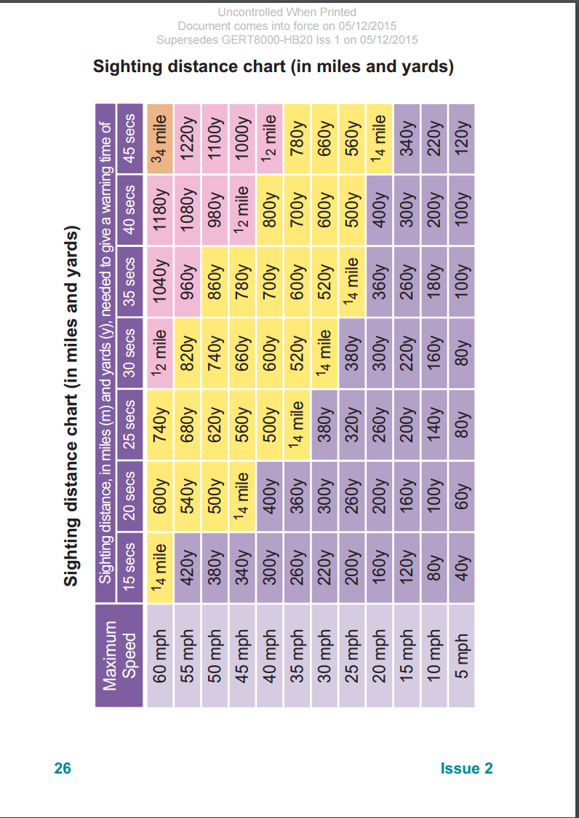

### Spanning rows or columns

**Note:**

To span a cell across multiple rows or columns, use the EasyDITA table features. The following paragraphs explain the attributes that EasyDITA sets when you use the function in case you need to troubleshoot a table that is not displaying as you would like.

To span a cell across multiple rows, enter the number of rows in the span (not counting the current row) using the @morerows attribute in the <entry> element for the first cell in the span. In each subsequent row for the span, omit the <entry> element for that column.

**Spanning across rows, DITA example:**

<table>

<tgroup cols="4">

<colspec colname="c1" colnum="1" colwidth="1*"/>

<colspec colname="c2" colnum="2" colwidth="1*"/>

<colspec colname="c3" colnum="3" colwidth="1*"/>

<colspec colname="c4" colnum="4" colwidth="1.5*"/>

<tbody>

<row>

<entry morerows="1">This cell spans two rows.</entry>  
 <entry>Data</entry>  
 <entry>Data</entry>  
 <entry morerows="2">This cell spans three rows.</entry>

</row>

<row>  
 <entry>Data</entry>  
 <entry>Data</entry>

</row>

<row>

<entry>The span in the first column ends and a new entry is  
 made for this column in the new row.</entry>  
 <entry>Data</entry>  
 <entry>Data</entry>

</row>

<row>  
 <entry>Data</entry>  
 <entry>Data</entry>  
 <entry>Data</entry>  
 <entry>Data</entry>

</row>

</tbody>

</tgroup>

</table>

**Spanning across rows, output**

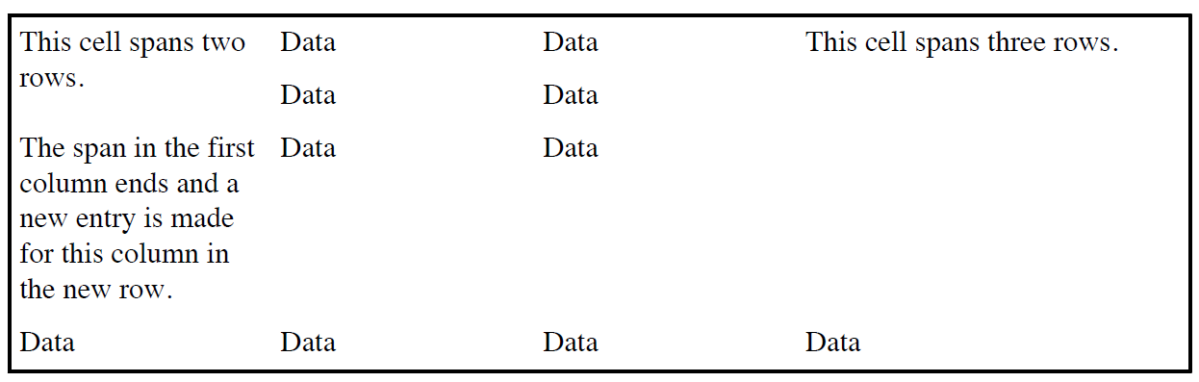

To span a cell across multiple columns, enter the name of the first column of the span (defined in the <colspec> element) in the @namest attribute in the <entry> of the first cell in the span. Enter the name of the last column of the span in the @nameend attribute in the same <entry> element. Do not define <entry> elements for the columns that are spanned.

**Spanning across columns, DITA example:**

<table>

<tgroup cols="4">

<colspec colname="c1" colnum="1" colwidth="1*"/>

<colspec colname="c2" colnum="2" colwidth="1*"/>

<colspec colname="c3" colnum="3" colwidth="1*"/>

<colspec colname="c4" colnum="4" colwidth="1.5*"/>

<tbody>

<row>  
 <entry namest="c1" nameend="c4">This cell spans all four

columns.</entry>

</row>

<row>

<entry namest="c1" nameend="c2">This cell spans the first two  
 columns.</entry>  
 <entry namest="c3" nameend="c4">This cell spans the last two

columns.</entry>

</row>

<row>

<entry>Data</entry>  
 <entry>Data</entry>  
 <entry>Data</entry>  
 <entry>Data</entry>

</row>

</tbody>

</tgroup>

</table>

**Spanning across columns, output**

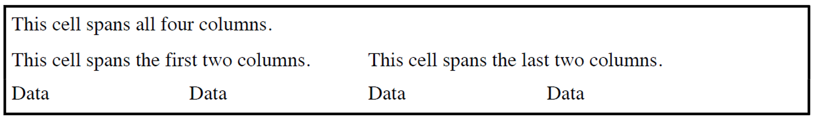

### Table elements

**Note:**

EasyDITA will automatically include the appropriate table elements when you use the table wizard. However, this section is provided for reference and troubleshooting purposes.

Nest the following elements within the <table> element to create a table.

|  |  |
| --- | --- |
| **Element** | **Guidance** |
| **<title>**  **title** | Adding a <title> to your table is optional. However, you must include one if you intend to crossreference the table. The <title> element is used to trigger auto-generated “Table” text, plus table  numbering. Numbering is sequential through the entire publication. |
| **<desc>**  **description** | Use the <desc> element to provide any additional information about the table that should always be associated with the table, even when it is reused. Content within the <desc> element is considered part of the table and will be automatically brought with the table when you conref the table. By default, this text will render before the table as an introduction to the table. |
| **<tgroup>**  **table group** | Use the <tgroup> element to specify the display properties for the columns, rows, spanning, header, and body of the complex table. You must define the number of columns in the table using  the @cols attribute. The <tgroup> element is the container for the <colspec>, <thead>, and <tbody> elements. |
| **<colspec>**  **column specification** | Use the <colspec> element to specify the column information, such as column name, number, cell content alignment, and column width.   * Use the @colname attribute to specify the column name. * Use the @cols attribute to specify the number of columns. * Use the @colwidth attribute to specify the width of each column. Column widths should be expressed as relative values, meaning that they are sized relative to each other rather than given a fixed width. There may be several unique cases in the documentation where fixed column widths are used, but this is rare.   **Note:**  Determining the acceptable column widths frequently takes some  experimentation with these colwidth values, especially if you have specific content that you do not want to wrap within the column. |
| **<thead>**  **table head** | Use the <thead> element to define the heads for the table columns. This element is optional, but must appear before <tbody> if used. The <thead> element can contain one or more <row> elements. |
| **<tbody>**  **table body** | Use the <tbody> element to define the body of the table. The <tbody> element can contain one or more <row> elements. |
| **<row>**  **row** | Use the <row> element to define a single row in the table. Each <row> element contains multiple <entry> elements, each indicating a different column. |
| **<entry>**  **entry** | Use the <entry> element to define a single cell in the table. The number of <entry> elements nested in a <row> element must match the number of <entry> elements defined in the <thead> element, unless you are spanning columns. You can enter content into the <entry> element directly. If necessary, you can add additional elements such as <p>, <ul>, or <ol>. |

## Figures and media content

Use figures and media objects instead of, or to supplement, text in your topics. These elements might include:

* graphs
* illustrations
* schematics
* signs
* equations
* screen captures and icons

### Adding static graphics

Nest static graphics, such as screen captures and icons, in <image> elements, using the @href attribute to point to the appropriate file. As needed, you can also embed an <alt> tag within the <image> element to specify alternate content that displays if the image is not displayed.

If you will cross reference to the graphic, nest the <image> element in a <fig> container element, along with a <title> element. The title will be included in the cross reference to the image. You may also want to reference the file from within a <fig> element in order to associate callouts or descriptive text with the file. Include an <ol> to define callouts or a <desc> element to provide additional information that should always be associated with the figure, even when it is reused. Content embedded within the <fig> element is considered part of the figure and will be automatically

brought with the figure when you reuse it. By default, <desc> content will render before the graphic or media element as an introduction and <ol> content will render below the graphic or object.

You can nest the following elements within <fig>:

|  |  |
| --- | --- |
| **Element** | **Guidance** |
| **<title>**  **title** | Nest the <title> element in <fig> to provide a title for the figure. |
| **<desc>**  **description** | Nest the <desc> element in <fig> to provide additional information about the graphic or media file. |
| **<image>**  **image** | Nest an <image> element within a <fig> element to reference a graphic file in your content repository. Place the file path to the graphic in the @href attribute within the <image> element.  Use the tools provided in EasyDITA to ensure that the reference is coded correctly.  Use <image> tags outside of <fig> elements for any graphics that you do not want to cross reference or associate with additional information. |
| **<alt>**  **alternate text** | Nest the <alt> tag within an <image> element to provide text that can be displayed if for some reason the image cannot be resolved. |

Example to be provided at a later date.

### Placing and formatting graphics

Refer to the RSSB Illustration Guidelines for standards governing the creation of graphics. Keep in mind you have very limited control over the placement or formatting of an image or media element using your DITA tags and attributes. The RSSB stylesheets will place and format graphics according to the following rules:

* By default a figure will be placed within the current text margins. For example, if it is contained within a paragraph, its left side will align with the left edge of the text; if it is in a list, it will be indented to the same left-hand margin as the list element. To override the default and place the figure on the left page margin, set the @expanse attribute to “page”.

<fig expanse="page">  
 <image href="cellrelations.jpg"/>  
 </fig>

* If the image is smaller than the column-width, it will be centered in the horizontal space available.

**Note:**

Use your graphics tools to size images appropriately. Do not attempt to scale your image using DITA.

## Writing notes

Use the <note> element to call attention to important information, best practices, and tips that might be overlooked in the text. They may emphasise a point or contain an explanation or comment.

In the A4 documents, RSSB uses notes only for internal content and they are not meant to be published to users. [RB]

In the Rule Book, RSSB has two uses for notes:

* <note> of type “note” is used to call attention to information.
* <note> of type “attention” is used to mark critical rules. [RB]

Use the @type attribute to indicate the type of note you are including. There are four types of notes:

|  |  |
| --- | --- |
| **Type** | **Definition** |
| Important!  (type=”important”) | Calls attention to crucial supplementary information. |
| Tip (type=”tip”) | Calls attention to best practices or tips. |
| Note (type=”note”) | Calls attention to a significant piece of supplementary information. If you do not specify a @type attribute, it defaults to this type. |
| Criticality red box (type=”attention”) | Calls attention to a critical rule in a Rule Book. [RB] |

When including <note> elements, follow these guidelines:

* Do not use a note when the information it contains is no more important than any other information in the topic.
* Try not to place notes directly after a <title> element.
* Make every attempt to limit the length of note text. Do not exceed a single paragraph. If you need to include more than one paragraph in a note, consider creating a separate section or topic instead.
* Start each <note> element with a block element, such as a paragraph tag.
* Block-level elements (e.g., <p>, <ul>, and <ol>) may be nested but only sparingly. In the Rule Book modules, block-level elements may be nested in the criticality red box <note>. [RB]

**DITA examples:**

<note type="important">

<p>Check battery power indicator.</p>  
</note>

<note type="tip">

<p>Place rechargeable batteries in the charging tray after each shift.</p>

</note>

# Chapter 5: Inline elements

Inline elements describe the words or phrases that occur inside a block element such as a paragraph, list item, or cell in a table. The information contained in these elements is used to optimise search and retrieval for both authors and users. In addition, some inline elements have specific formatting requirements that are handled by the stylesheet. The various formatting differences are explained in this section when applicable.

**Note:** Do not select an inline element based on how it will be rendered, but on what type of information it contains.

## Highlighting elements

RSSB allows the use of the following non-semantic formatting tags:

* <b> bold
* <sub> subscript
* <sup> superscript

## Miscellaneous inline elements

Use these inline elements to specify special processing of the content they contain:

|  |  |
| --- | --- |
| **Element** | **Guidance** |
| **<cite>**  **cite** | When referencing another document, enclose the name of the document in <cite> tags. This element does not create a link between the two documents. If you want to create a hyperlink, see Cross references on page 57. |
| **<draft-comment>**  **draft comment** | Use the <draft-comment> element to provide feedback, suggestions, or clarification to the reviewer or author of a topic. The <draft-comment> element is not generally included in the final output, but can be seen in the editor and on draft versions of the content. When entering a draft comment, specify your initials in the *@author* attribute and a date in the *@time* attribute. Use a format of DD-MMM-YYYY when specifying the date. You should resolve and remove all comments before final publishing. |
| **<fn>**  **footnote** | Use the <fn> element to create footnotes in your topics. The stylesheet will automatically add a superscripted number to the referenced piece of content in A4 topics and an information icon in Rule Book topics. [RB]  If you will use a footnote multiple times, assign an @idattribute to the footnote.  Example:  <fn id="Reuse">This footnote is referenced in multiple places.</fn>  When you want to reference it, use an <xref> to the footnote specifying type="fn".  Example:  <xref href="topicid.xml#topicid/Reuse" type="fn"/> |
| **<tm>**  **trademark** | Use the <tm> element to mark up a trademarked phrase or name. The element <tm> has one required attribute, @tmtype. The trademark type attribute allows for values to define registered marks (reg), service marks (service), and trademarks (tm). During processing, the stylesheet will apply the correct graphic based on the @tmtype attribute. |

## Special characters

You may be required to add special characters into your topics. Add these characters using the easyDITA authoring interface:

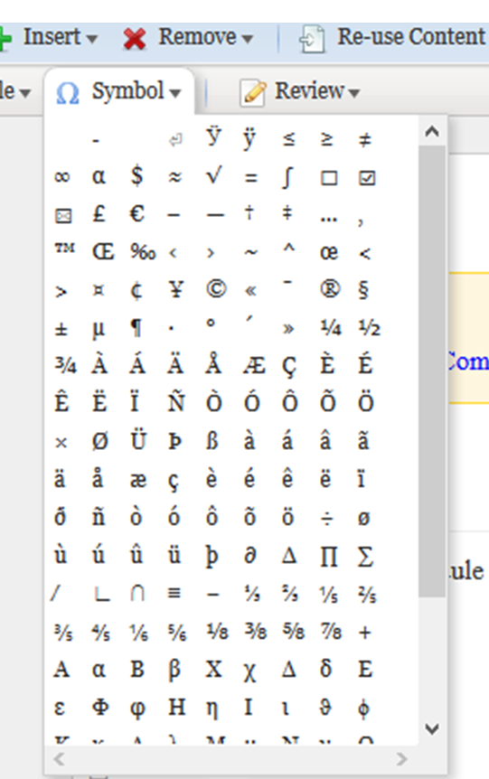

All ASCII characters are supported, including commonly associated formatting controls, such as non-breaking hyphens and non-breaking spaces.

# Chapter 6: Maps and bookmaps

Maps and bookmaps are used to organise and compile topics and other content into larger units. They specify the sequence and hierarchy of topics, other maps, and non-DITA resources, such as PDF files. Maps and bookmaps define the table of contents for a deliverable, and they establish the relationships among the topics they reference. Both bookmaps and maps have a .ditamap file extension.

When creating a deliverable, use maps and bookmaps to define your authoring framework by building these files first. Create empty “stub” or placeholder topics for the new topics established by your annotated topic list (ATL), and locate the existing topics that you will reuse in this new project. Doing so provides a starting point for authoring new topics and integrating existing ones.

## Maps

Well-structured maps help users find information quickly and form the basis for all navigation and linking. At RSSB, maps may be used to define an entire deliverable, as well as subparts for the deliverable. Use maps to:

* Organise content into chapters or appendices
* Organise related topics into single reusable units
* Organise topics that all relate to a single user goal
* Divide large sets of related information into smaller, more manageable units
* Establish relationships between parent/child and sibling topics

You might also build temporary maps to send a set of topics to an editor or reviewer even if these topics will not be referenced together in the final deliverable.

If you are creating a Rule Book, the sequence and hierarchy of topics is created using nested topics in bookmap rather than in maps. However, the use of maps is also possible. The question of using nested topics or maps must be later be revisited by RSSB when they have Rule Book content in easyDITA and can see which approach works better with RMDB and Rule Book authors. [RB]

### Map structure

Most map structures depend on the specific content in the particular deliverable. You create that structure by combining and nesting topic and map references as needed. You must begin your map with a title, but all other elements can be interspersed as needed.

* <map> (mandatory)
  + <title> (mandatory)
  + Any number, at any level, and in any order of the following:
    - <topichead>
    - <topicgroup>
    - <mapref>
    - <topicref>
  + <reltable> (optional)

RSSB uses four map templates:

|  |  |
| --- | --- |
| **Template** | **Description** |
| Part1Map.ditamap | Use this template for building the standard chapter for Part 1 of a requirements document. This map includes placeholders for all common topics in this part of a document, such as background, health and safety, and copyright sections. |
| RSSBMap.ditamap | Use this template to create maps of all parts and appendices in larger documents. Although you can nest topic, map, and glossary references directly in a bookmap, build each part or appendix in a separate map to keep your bookmap cleaner and more readable.  **Tip:** If your part or appendix contains fewer than three topics, consider building it directly in the bookmap. |
| RuleBook.ditamap | Use this template to create maps for the Rule Book. [RB] |
| BriefingLeaflet dita | Use this template to create the map for the Rule Book Briefing Leaflet. [RB] |

### Map elements

Nest the following items in the <map> base element when creating a map.

|  |  |
| --- | --- |
| **Element** | **Guidance** |
| **<title>**  **title** | Use the <title> element to define a title for the group of topics; for example, a part or section heading. |
| **<topicref>**  **topic reference** | Use the <topicref> element to point to a single DITA topic. You must include the @hrefattribute to point to the path and file name for the DITA topic or external file you want to include. Use multiple <topicref> elements to point to multiple topics to build your deliverable. Nesting the <topicref> elements in one another creates a navigational and hierarchical structure. |
| **<mapref>**  **map reference**  **(optional)** | Use the <mapref> element to point to a map of DITA topics. You must include the @href attribute to point to the path and file name for the DITA map you want to include. |
| **<topicgroup>**  **topic group**  **(optional)** | Nest <topicref> elements in a <topicgroup> to establish linking relationships between them. Use the @collection-typeattribute to establish the type of relationship. See Linking topics on page 44 for more information. |
| **<topichead>**  **topic head**  **(optional)** | Use the <topichead> element to provide a title-only entry within the rendered content or to provide a section title for a group of topics within a Table of Contents. To define the title, nest a <navtitle> element within a <topicmeta> element within this element.  <topichead>   <topicmeta>  <navtitle>Location of new platforms</navtitle>  </topicmeta>   </topichead> |
| **<reltable>**  **relationship table**  **(optional)** | Use the <reltable> element to specify relationships between topics. See Relationship tables on page 58 for information about building relationship tables. |

### Creating maps

A map file consists of a hierarchical organisation of <topicref> and<mapref> elements. Each of these elements requires an @hrefattribute that points to an individual topic or map.

When building a map, consider the following strategies:

* Rather than nest topics several levels deep, consider creating submaps that you then reference with a <mapref>. In general, it’s a good idea to create submaps whenever you are nesting more than five topics to keep your maps clean and easily interpretable by others.
* Avoid nesting topics more than four levels deep.
* A table of contents is automatically built when you process a map. To keep a topic from appearing in the TOC, set the @tocattribute to “no”.

#### Titling maps

In general, follow the same guidelines for writing map titles as for topics; see Titling topics on page 18. In addition, however, consider the following:

* In general, map titles will tend to be less specific than topic titles because they are summarising the content of all the topics nested within the map. Think about how you might categorise the information in the map; often that category should be part of the map title.
* Ensure the title indicates the range of topics it contains. For example, if the content covers requirements for both vertical and horizontal alignment of platforms for constructing new platforms, a map title of “Location of new platforms” would be appropriate.
* In any single publication, the map titles will be closely tied together. Each will deal with some aspect of the overall topic of the book. Therefore, be careful to make each map title clearly differentiated in terms of its specific contents compared to others in the same publication.
* Avoid starting all map titles with the same words. Users are scanning for words that help them differentiate between the maps; put those words first.

#### Linking topics

In addition to establishing a hierarchy among topics, the way you group topics together in your map affects the manner in which you establish links among them. In DITA, parent and child topics automatically receive a two-way link between each other. However, all other relationships must be explicitly established through attributes or relationship tables. The @collection-typeattribute enables you to establish links through the hierarchical structure of your map, thereby saving you effort in defining those links through a relationship table. You can establish two types of relationships with the @collection-typeattribute:

|  |  |
| --- | --- |
| **Attribute** | **Description** |
| **family** | All topics within the group are related to all other topics. |
| **sequence** | Topics are related to the topics immediately before and after them in the map through Next and Previous links. |

Specify the @collection-typeattribute on the parent topic of the topics you want to link together.

<topicref collection-type="family" href="cR_TrackLocationStraightTrack.dita">  
 <topicref href="cR_TrackLocationPlatformRadii.dita"/>  
 <topicref href="cR_TrackLocationPlatformExtensionRadii.dita"/>  
 <topicref href="cR_TrackLocationPlatformCurveConsiderations.dita"/>  
 <topicref href="cR_DesignValueForCant.dita"/>  
</topicref>

**Note:** In some cases you may not want to link all the children of a parent together. In this case, you can first nest the related topics in a <topicgroup> and then assign the @collection-typeattribute to establish the type of relationship.

<topicref href="cR_TrackLocationStraightTrack.dita">

<topicgroup collection-type="family" >

<topicref href="cR_TrackLocationPlatformRadii.dita"/>  
 <topicref href="cR_TrackLocationPlatformExtensionRadii.dita"/>  
</topicgroup>  
<topicref href="cR_TrackLocationPlatformCurveConsiderations.dita"/>  
<topicref href="cR_DesignValueForCant.dita"/>

</topicref>

When topics are not physically grouped together within the hierarchy of the map, you must use a relationship table to establish links among them. See Relationship tables on page 58 for instructions.

### Sample map

This example shows only the basic map elements with a placeholder for a relationship table. See Relationship tableson page 58 for more information on relationship tables.

<map>  
<title>Horizontal track alignment through station platforms</title>

<topichead>

<topicmeta>

<navtitle>Horizontal track alignment through station

platforms</navtitle>

</topicmeta>  
<topicref href="cR_TrackLocationStraightTrack.dita"/>  
<topicref href="cR_TrackLocationPlatformRadii.dita"/>  
<topicref href="cR_TrackLocationPlatformExtensionRadii.dita"/>  
<topicref href="cR_TrackLocationPlatformCurveConsiderations.dita"/>  
<topicref href="cR_DesignValueForCant.dita"/>

</topichead>  
<reltable>....</reltable>  
</map>

## Bookmaps

RSSB uses bookmaps as the top-level containers for publications. Bookmaps contain references to maps and topics within elements that semantically match the traditional structure of a book, such as parts and appendices. Bookmaps also include metadata that defines information about the book and that may be used to generate content on the cover and title pages of the book.

### Bookmap structure

Structure your bookmaps as follows, keeping each element in the order shown.

* <bookmap> (mandatory)
  + <booktitle> (mandatory)
    - <booklibrary> (mandatory)
    - <mainbooktitle> (mandatory)
  + <bookmeta> (mandatory)
  + <frontmatter> (mandatory)
    - <bookabstract> (optional)
    - <booklists> (mandatory)
      * <toc> (mandatory)
      * <figurelist> (optional)
      * <tablelist> (optional)
    - <preface> (optional)
  + one or more <part> elements (mandatory)
  + any number of <appendix> elements (optional)
  + backmatter> (optional)
    - <booklists> (optional)
    - <glossarylist> (optional)
  + <reltable> (optional)

### Bookmap elements for A4 documents

Nest the following in the <bookmap> root element when creating a bookmap. For instructions regarding the elements in the Rule Book bookmap, see Bookmap elements for Rule Book on page 75. [RB]

|  |  |
| --- | --- |
| **Element** | **Guidance** |
| **<booktitle>**  **booktitle** | Use the <booktitle> element as a container for the <booklibrary> and <mainbooktitle> elements. |
| **<booklibrary>**  **book library** | Use the <booklibrary> element to provide the Requirements Management Class, for example, Rail Industry Standard, Railway Group Standard, or Rule Book. This element is used in conjunction with the <mainbooktitle> to form the entire name of the publication. |
| **<mainbooktitle>**  **main book title** | Use the <mainbooktitle> element to provide the descriptive name of the document, for example Interface between station platforms, Track and trains, Compatibility between electric trains and electrification systems, or Preparation and movement of locomotive hauled trains. |
| **<bookmeta>**  **book metadata** | Use the <bookmeta> element as a container for metadata that applies to the entire publication. See Bookmeta on page 48 for the metadata you can define within a bookmap. |
| **<frontmatter>**  **front matter** | Use the <frontmatter> element as a container for content that belongs before the body of the document. |
| **<bookabstract>**  **book abstract** | Use the <bookabstract> element to reference a topic used within a bookmap which contains a brief summary of book content, generally output as part of the book’s frontmatter. An example would be the “Synopsis” which appears on the cover of a Working Manual. |
| **<booklists>**  **book lists** | Use the <booklists> element as a container for reference lists such as the Table of Contents. |
| **<toc>**  **table of contents** | Use the <toc> element to include a Table of Contents in the output. The processor will automatically generate this list with the number of levels specified in the stylesheet. |
| **<figurelist>**  **figure list** | Use the <figurelist> element to include a list of figures in the output. Only figures that include a <title> element will be included in this list. This element is optional. |
| **<tablelist>**  **table list** | Use the <tablelist> element to include a list of tables in the output. Only tables that include a <title> element will be included in this list. This element is optional. |
| **<preface>**  **preface** | Use the <preface> element to reference a topic or map containing introductory information about a book, such as the purpose and structure of the document. |
| **<part>**  **part** | Use the <part> element to reference a submap using the @hrefattribute to point to the appropriate map file. You can also build a part within the bookmap by nesting <topicref> and/or <mapref> elements within the <part> element (see Map elements on page 43 for information about those elements). However, RSSB uses submaps in most cases to build both parts and appendices. A bookmap should always include at least one <part> element. Rule Book bookmaps, however, are built using <part> and nested topicrefs and not submaps. [RB] |
| **<appendix>**  **appendix** | If your book contains any appendices, use the <appendix> element to reference a submap using the @hrefattribute to point to the appropriate map file. You can also build an appendix within the bookmap by nesting <topicref> and/or <mapref> elements within the <appendix> element. However, RSSB uses submaps in most cases to build both parts and appendices. |
| **<backmatter>**  **back matter** | Use the <backmatter> element as a container for content that belongs after the body of the document. |
| **<glossarylist>**  **glossary list** | Use the <glossarylist> element to point to the glossary for this publication using the @hrefattribute to point to the appropriate topic file. |
| **<reltable> relationship**  **table** | Use the <reltable> element to specify relationships between topics. See Relationship tables on page 58 for information about building relationship tables. |

### Bookmeta in A4 documents

In addition to the metadata you can define in any topic, bookmap metadata provides information that describes the book that you are creating. The content of bookmeta is used to populate the front and back covers of the document. Nest the following elements, in the order specified, within the <bookmeta> element in your bookmap:

**Note:** The RSSB bookmap template includes placeholders for all bookmeta elements. You need only insert the correct information.

|  |  |
| --- | --- |
| **Element** | **Guidance** |
| **<authorinformation>**  **author information** | Use the <authorinformation> element as a container for <organizationinfo>.   |  |  | | --- | --- | | **Element** | **Guidance** | | **<organizationinfo>**  **organization information** | Nest the <organizationinfo> element in <authorinformation> as a container for the company name, address, contact numbers and urls.  Nest the following element in the <organizationinfo> element:  **<namedetails>**  **name details**  Add as a first level container.  Nest the following element in the <namedetails> element:  **<organizationnamedetails>**  **organization name details**  Add as a second level container.  Nest the following elements in the <organizationnamedetails> element:  **<organizationname>**  **organization name**  The name of the organization,  RSSB, Ltd.  Nest the following element in the <organizationinfo> element:  **<addressdetails>**  **address details**  A container for the organization's  address.  Nest the following elements in the <addressdetails> element:  *<thoroughfare> thoroughfare*  The address and street name.  *<locality> locality*  A container for the city and post code.  *<localityname> locality name*  The city.  *<postalcode> postal code*  The post code.  *<administrativearea>*  *administrative area*  The postal town.  *<country> country*  The country.  **<urls>**  A container for all urls you want to  include.  *<url>*  A web site address. Include one <url> for each web site you want to include. | |
| **<publisherinformation>**  **publisher information** | Use the <publisherinformation> element as a container for information about who published the book, where, and when.  The RSSB bookmap templates include all these elements. You need only enter the appropriate month, day, and year for the publication completion date.  Nest the following elements in the <publisherinformation> element:   |  |  | | --- | --- | | **Element** | **Guidance** | | **<organization>**  **organization** | Provide the name of the publishing company. | | **<printlocation>**  **print location** | Provide the location where the document was printed. Note that only a select few RSSB documents are published externally. | | **<published>**  **published** | Provide a container for the issue date, the date the document was published.  Nest the following elements in the <published> element:  **<completed>**  **completed**  Second-level container for the issue date.  Nest <month>, <day> and <year> elements to provide the specific date. | |
| **<bookid>**  **book identification** | Use the <bookid> element as a container for the version and issue of the publication.  Nest the following elements in the <bookid> element:   |  |  | | --- | --- | | **Element** | **Guidance** | | **<edition>**  **edition** | Provide the issue number of the document, generally stated on the front cover. This element is used in the Rule Book, but the issue is not written as text but as a number because it is used in the digital Rule Book to show correct information to the correct reader at the right time. [RB] | | **<booknumber>**  **book number** | Provide the document number of the publication. For a publication, the book number may include  the document type, identifying numbers and characters, and the issuing group; for example: RIS-2706-RST. | |
| **<bookchangehistory>**  **book change history**  **(optional)** | Use the <bookchangehistory> element as a container for information about who reviewed or approved the publication and which documents have been superseded. The dates for “in force”, “compliance” and “withdrawn” are also captured in this section.  Nest the following elements in the <bookchangehistory> element:   |  |  | | --- | --- | | **Element** | **Guidance** | | **<approved>**  **approved**  **(optional)** | Use as a container for information about the person who approved or authorised the publication and the date it was approved.  Nest the following elements in the <approved> element:  **<person value="">**  **person**  **(optional)**  Use the <person> element to provide the name of the person who approved the document.  **<organization>**  **organization**  **(optional)**  Use the <organization> element to provide the organization or standards committee which has approved the document.  **<completed>**  **completed**  **(optional)**  Use the <completed> element to capture the  date the document was approved using the  <month>, <day>, and <year> elements  described earlier.  **<summary>**  **summary**  **(optional)**  Use the <summary> element to provide the title of the person listed in the <person> element. | | **<bookevent>**  **book event**  **(optional)** | Use the <bookevent> element as a container for a unique event in the history of the document, aside from approval or issue date. Specifically, you can capture each of the following events as they occur. Specify the  event you are including by nesting a <bookeventtype> element in <bookevent> and setting the @nameattribute to the value shown in the first column of the following table. Nest <person>, <date>, and  <summary> elements (as described earlier) based on the specific event as described in the table.  Nest the following elements in the <bookevent> element:  **bookeventtype name=**  *submitted*  When the document was submitted for approval (<completed>, by whom (<person>) and that person's title (<summary>)  *supersedes*  When the document supersedes another  (<completed>) and the specific document that takes its place (<summary>)  *superseded*  When the document is superseded by another  (<completed>) and the specific document that takes its place (<summary>)  *in-force*  The earliest date for compliance to this document (<completed>)  *compliance*  The latest date for compliance to this document (<completed>)  *withdrawn*  The date this document is withdrawn from  consideration (<completed>)  RSSB bookmap templates may include these elements. | |
| **<bookrights>**  **book rights** | Use the <bookrights> element as a container for copyright information. Nest the following elements in the <bookrights> element:   |  |  | | --- | --- | | **Element** | **Guidance** | | **<copyrfirst>**  **first copyright** | The copyright year, contained in a <year> element. | | **<bookowner>**  **book owner** | The owner of the copyright. In all cases, this element will  contain an <organization> element. | | **<organization>**  **organization** | The copyright holder of the book. |   All RSSB bookmap templates include these elements. You need only complete the appropriate dates.  <bookrights>  <copyrfirst><year>2014</year></copyrfirst>  <bookowner>  <organization>RSSB</organization>  </bookowner>  </bookrights> |

### Creating maps

A bookmap file consists of a hierarchical organization of <part> and <appendix> elements. Each of these elements requires an @hrefattribute that points to specific submaps. Although you can also use <topicref> and <mapref>,elements within a bookmap, RSSB typically uses submaps for parts unless the part is less than three or four topics long.

In general, the same guidelines for structuring maps also apply to bookmaps. However, keep in mind the following additional guidelines when creating bookmaps:

* The title of your bookmap should obviously be the name of your publication. Nest a <booklibrary> element within <booktitle> and provide the Requirements Management Class of the document; for example, Rail Industry Standard, Railway Group Standard, or Rule Book. Then nest a <mainbooktitle> element and provide a descriptive name of the document. These two elements together form the title of your publication.
* Although the <bookabstract> element appears immediately before the table of contents, it will not render as a topic in that location. This information is used to generate a synopsis statement on the front cover of certain publication types.
* While a map will automatically generate a table of contents, you must nest a <booklists> element in a <frontmatter> element, and a <toc> element within the <booklists> element in order to generate a table of contents for a bookmap. Optionally, you can also generate a list of figures (<figurelist>) and/or a list of tables (<tablelist>) by nesting them in the <booklists> element as well. Keep in mind that only figures or tables that include a <title> element will be added to these lists.
* Do not include an @hrefattribute on <toc>, <tablelist>, or <figurelist> elements. These sections will be automatically generated for you. If you specify an @href*,* the processor will embed the specified file instead of generating current content. You must, however, specify an @hreffor a <glossarylist>; there is not currently a processor that will automatically compile a glossary based on the terms used in the topics included in the map.
* Although the <glossarylist> element is placed in a <booklists> element in the <backmatter> in a similar manner to the <toc>, it does not automatically generate a glossary. You must reference a file in the <glossarylist> element using the @hrefattribute.
* If you are building a part or appendix directly in the bookmap (for instances when they are less than three or four topics long), do not include an @hrefin the <part> or <appendix> element. Instead, nest the appropriate <topicref> elements within the <part> or <appendix> element.

### Documents that have to be printed using several colours

[RB]

If your document has, for example, graphics that have several colours instead of just black and white and it should be printed with colours, you must mark that document. This applies to both A4 documents and Rule Book.

Use an @outputclassattribute value of "colour" on <bookmap> to indicate that the document uses colour.

### Sample bookmap for A4 documents

This example shows bookmap elements, with empty placeholders for bookmeta and relationship table information.

<bookmeta>

<authorinformation>

<organizationinfo>

<namedetails>

<organizationnamedetails>

<organizationname>RSSB</organizationname>

</organizationnamedetails>

</namedetails>

<addressdetails>

<administrativearea>Islington</administrativearea>

<country>United Kingdom</country>

<locality>

<localityname>London</localityname>

<postalcode>EC1V 1NY</postalcode>

</locality>

<thoroughfare>Block 2, Angel Square 1 Torrens Street</thoroughfare>

</addressdetails>  
 <urls>

<url>http://www.rssb.co.uk</url>

</urls>

</organizationinfo>

</authorinformation>  
<publisherinformation>  
 <organization>RSSB</organization>  
 <printlocation>United Kingdom</printlocation>  
 <published>  
 <completed>

<month>09</month>

<year>2014</year>

</completed>

</published>  
</publisherinformation>

<bookid>

<edition>Issue One</edition>

<booknumber>RIS-2706-RST</booknumber>  
</bookid>

<bookchangehistory>

<bookevent>

<bookeventtype name="supercedes"/>  
 <summary>This Rail Industry Standard does not supersede

or replace any other Ralway Group documents.</summary>

</bookevent>

<bookevent>

<bookeventtype name="in_force"/>

<completed>

<day>30</day>

<month>06</month>

<year>2013</year>

</completed>  
<summary>RIS-2706-RST Issue 1 in in force</summary>

</bookevent>

<bookevent>

<bookeventtype name="compliance"/>

<completed>

<day>30</day>

<month>09</month>

<year>2013</year>

</completed>

<summary>RIS-2706-RST Issue 1 must be complied with</summary>

</bookevent>

</bookchangehistory>

<bookrights>

<copyrfirst>

<year>2013</year>

</copyrfirst>  
<bookowner>

<organization>Rail Safety and Standards Board</organization>

</bookowner>  
</bookrights>

</bookmeta>

# Chapter 7: Linking strategies

Although topics in a topic-based structured authoring environment are meant to stand alone, they may still be enhanced by other related content in another topic. In addition to using the @collection-typeattribute to link topics that are grouped together in a map (Linking topics on page 44), you can define links between non-sequential topics in two distinct ways:

* Using inline cross references within a topic
* Using relationship tables at the map level

## ID attribute

The @idattribute assigns an identifier to an element so the element can be referenced and reused. It is required on all root elements. All other elements can have an @idattribute, but it is not required unless you plan to reference the element. All topic IDs must be unique, and IDs must be unique across all elements within a single topic. If two elements have the same ID, all references will go to the first element with the ID. Automatic IDs will guarantee all topic IDs are unique.

**Note:** IDs do not need to be unique across topics. Since the topic @idis also part of any reference made to an element, the reference will be unique if elements in different topics have the same @id.

Based on the common items reused and cross-referenced in RSSB, EasyDITA has been configured to automatically assign IDs to the following elements each time you include the element in a file:

* <bookmap>
* <map>
* <concept>
* <reference>
* <section>
* <example>
* <table>
* <fig>
* <note>
* <step>

If you intend to reference or reuse any other element type, you must request that EasyDITA assign an @id first. Optionally, you can provide your own ID to make it more meaningful when you are looking for the appropriate item to reference. When creating your own ID, follow these guidelines:

* IDs should be unique across all elements **within**a topic. If two elements have the same @id, all references will go to the first element with the ID.
* Start the @idwith a letter. Thereafter, use only alphanumeric characters and the punctuation marks underscore (_), hyphen (-), period (.), and colon (:). No other characters including spaces are allowed.
* Start the @idwith an indication of the type of element being referenced (for example li_ or step_).
* When referencing elements that have a title, such as sections, figures, and tables, use the title as the ID, removing spaces between the words and using camel case (capitalising the first letter of each word). There is no limit to the length of the @id.

## Cross references

When referencing other content within the same publication, use the <xref> tag to create an active link to the referenced content. You can create a cross reference to any element with a defined @idattribute value. However, the <xref> element should be used sparingly. A link in the middle of a sentence may distract the reader and increase the cost of maintaining and translating the topic. It can also limit the reusability of the topic.

Avoid a cross reference if any of the following is true:

* It will confuse the end user.
* The referenced content is such a small piece of information that repeating the information would not make the new topic overly long; for example, three to five paragraphs. Users prefer to see all the required information in one topic, rather than being required to navigate to multiple topics, especially with regard to task topics.
* The content you want to reference occurs within the same topic. In this case, use language that refers to the information “found in this topic”.
  + **Note:** If you are referencing a step within a procedural topic, in order to provide instructions for the next step to perform, you will use a cross reference in order to ensure that the correct step number is generated.
* You expect to reuse the topic separate from the content you are considering cross-referencing.

When entering a cross reference, include the following information:

**Note:** Use EasyDITA to link to elements without having to code the following information by hand.

* Use the @href attribute to point to a topic, element, or website. See the following table for the proper syntax.

|  |  |
| --- | --- |
| **Situation** | **Syntax** |
| For topic references | filename.dita#topicid |
| For an element within a topic | filename.dita#topicid/elementid |
| For websites | http://www.url.com |
| For linking to an element in the same file | topicid/elementid |

* Use the @typeattribute in the <xref> element to specify the target for your link. The type of target determines the content included in the actual reference, as shown in the following table:

|  |  |
| --- | --- |
| **Content being referenced** | **Output** |
| Topic | "*Topic Title*" on page xx |
| Section | "*Section Title*" on page xx |
| Example | "*Example Title*" on page xx |
| Step | Step *#* on page xx |
| Table | *Table Title* on page xx |
| Figure | *Figure Title* on page xx |
| Footnote | # |

* To link to an external source, set the @scopeattribute to "external".
* To link to a non-DITA topic, set the @formatattribute to the format of the file; for example, PDF or HTML.

## Relationship tables

RSSB uses relationship tables to define and manage links to related topics within a PDF deliverable. Relationship tables free you from the burden of creating and maintaining links in your individual topics. Links hardcoded within individual topics are usually hard to maintain and often break when you move or delete the target topic. By using relationship tables at the map level, you ensure that the links you establish are between topics included in the map, eliminating broken links, and if you need to change a link, you need only make the change once, in the map itself rather than in every topic affected by the change.

Relationship tables are created using a table of rows and columns to define links. Each row in the table represents a unique relationship, which is generally rendered as a link, and each cell lists participants in the relationship. Each topic in a cell links to the topic in the other cells in the same row. The resulting output will have an added section at the end of each topic labelled “Related Topics”, containing the links defined in the relationship table.

### Creating a relationship table

Use EasyDITA’s relationship table tool to create a two-column relationship table. Build the relationships between topics by adding <topicref> elements to the appropriate rows and columns. As you add the topic references, keep in mind the following rules governing relationship tables:

* Each row in the table represents a separate set of relationships and links.
* No relationships exist between the rows in a table.
* Each cell can contain multiple topic references. However, by default, no relationship is established between topics that share the same cell. See Linking to topics within the same cell on page 59 for instructions on creating such links.
* Topic references can be repeated in multiple rows.

In addition, consider these best practices:

* Wherever possible, use DITA’s automatic hierarchical linking to avoid the need for creating relationships. For example, within a map, DITA automatically creates two-way linking between parent topics and each of their children topics; you do not need to include those relationships in your relationship table.
* Be careful not to duplicate links. For example, if the topic already contains an <xref> to a topic, do not include that same relationship in the relationship table.
* Make sure all links take users to meaningful, related content.
* Limit the number of relationships you include to less than five per topic. Too many links can be overwhelming for users.
* Take the time to validate your links before publication.
* Include relationship tables in the map level common to all topics in the relationship. For example, if topics are in separate submaps, establish their relationship in the bookmap that references their individual maps.

### Relationship table elements

Use the following elements when creating a relationship table:

**Note**: Use EasyDITA’s relationship table commands to build a relationship table without needing to hand code these elements.

|  |  |
| --- | --- |
| **Element** | **Guidance** |
| **<reltable>**  **relationship table** | Use the <reltable> element to create the framework for the relationship table. Add all elements in the relationship table between the beginning and ending tags of the <reltable> element. The <reltable> element is a child of the <map> or <bookmap> element. |
| **<relheader>**  **relationship table header** | Use the <relheader> element as a container for the column specifications, including header rows, if desired. |
| **<relcolspec>**  **relationship column specification** | Use the <relcolspec> element to define each column in the relationship table. Each <reltable> should contain two <relcolspec> elements to form meaningful relationships  among your topics. |
| **<relrow>**  **relationship table row** | Use the <relrow> element to define the relationships among the topics in each relationship row. Each <relrow> element defines a new set of relationships. You can add as many <relrow> elements as needed to the relationship table. |
| **<relcell>**  **relationship table cell** | Use the <relcell> element to define the topic references. These topic references will be linked during processing. Nest <topicref> elements for each topic involved in the  relationship, using the @hrefattribute to point to the appropriate topic. You must include two <relcell> elements in each <relrow> to correspond to the two columns defined in the <relcolspec> elements. |

### Linking to topics within the same cell

In a relationship table, topic references in the same cell are not linked together. However, there are instances when they should be linked.

To link topics in a cell together, group them with a <topicgroup> element and set its @collection-typeattribute to “family”.

If the topics should be viewed in a specific order, set the @collection-typeattribute to “sequence” instead. Topics will be linked as Next and Previous topics in the sequence the topics occur in the cell. Use this option when you have an all-encompassing task that has multiple sub-task topics.

**Note:** If you find you are creating sequential relationships in relationship tables, reconsider the grouping of your topics within your maps. It makes sense to include sequential elements next to each other in the map, which would allow you to establish the relationship between the topics directly in the <topicref> element in the map, rather than through a relationship table.

### Creating one-way links

By default, the links in a relationship table go both ways. However, you might want to make the links one way. For example, you might want to point multiple topics to a glossary, but you would not want the glossary to link back to all those individual topics.

To create a one-way link, set the @linkingattribute in the topic reference that you do not want to link back from to “targetonly”. Conversely, you could also set the @linkingattribute in the topic reference that you do not want to link back to as “sourceonly”. The two rows in the example accomplish exactly the same thing.

<relrow>  
 <relcell>  
 <topicref href="t_tasktopic.dita"/>  
 </relcell>  
 <relcell>  
 <topicref href="g_glossary.dita" linking="targetonly"/>  
 </relcell>  
</relrow>  
<relrow>  
 <relcell>  
 <topicref href="t_tasktopic.dita" linking="sourceonly"/>  
 </relcell>  
 <relcell>  
 <topicref href="g_glossary.dita"/>  
 </relcell>  
</relrow>

# Chapter 8: Reuse strategy

The RSSB reuse strategy is based on the commonality seen across the RSSB requirements and standards themselves. With careful planning and conditional processing, RSSB can single-source information between its standards. The RSSB Information Architecture relies on several different approaches to support its reuse strategy:

* Maps point to common topics or other maps that can be reused in their entirety.
* Collection files contain common content that can be reused.
* Conditional processing filters content based on specific data.

Use this table to choose between the approaches described in this section.

|  |  |
| --- | --- |
| **If the following is true** | **Use this approach** |
| Maps or topics can be used without any changes in  another publication | Reusing topics and maps on page 62 |
| You want to reuse portions of another topic within your  current topic | Reusing elements through collection files on page 63 |
| Specific content within a topic applies only to a specific  audience or a specific publication | Conditional processing on page 64 |

## Writing for reuse

Before employing any DITA reuse mechanism, you should carefully analyse what content can be used exactly as it already exists and what content must change due to real differences. Often, multiple topics are created that say essentially the same thing because of personal preferences among authors, editors, and subject matter experts. But in a reuse-centric environment, these preferences must be set aside to gain the maximum reuse benefit.

To avoid creating repetitious content when an existing topic can be used implementing the various reuse strategies described in this section, authors should follow these guidelines when creating new content:

* Establish a “single point of truth”.

For reuse to work, authors need to accept that common information needs be written in one and only one topic. Even if the way it is written is not the way you would have written it, it is a waste of time and budget to rewrite the same information. Further, propagating different versions of the same information increases the likelihood that not all versions will be updated in the future. In addition, multiple explanations of the same content can be confusing to end users.

* Search for an existing topic before writing a new one.

Before creating new content, search the content management system to locate content that has already been written and reuse it. To help with your search, use metadata, keywords, phrases, or other criteria to find content that is reusable for your assignment. Searching for reusable content can save hours of writing time and reduce repetitious content within the repository.

* Write clear, descriptive titles.

Topic titles are one of the most important cues to your end users in helping them find information; the more descriptive the title, in words that are meaningful to the end user, the easier it is for users to read and comprehend the information. Writing meaningful titles from an end-user perspective helps set the context for the information and frequently lessens the need for explanatory paragraphs within the topic. Clear, descriptive titles for topics also help other writers find content that may be appropriate for them to include in their maps.

* Include thorough metadata.

Metadata, describing the content and the situations in which the content is applicable, is just as important as the actual content in a reuse environment. If others don’t know what content a topic contains or they can’t find it, they can’t reuse it.

* Ensure topics are stand-alone and cover one complete subject only.

Well-constructed topics cover a single subject and do not require any other topics to be understood by the customer. When you mix content types in a single topic or include multiple subjects, you limit the situations in which the topic might be reused. All subjects covered by the topic must apply in any situation in which you want to reuse it. By separating subjects and content type, you have more flexibility in which information you reuse.

* Limit the number of <xref> elements within your topics.

When you explicitly link to other topics, you limit the reuse of that topic only to publications that also include the referenced topics. It is better to add links through relationship tables in the publication map, so that all links are determined by what topics are within that map. See Relationship tables on page 58 for more information.

* When details are not important, leave them out. The more explicit the details you provide, the more difficult to reuse that content in other situations where the details may not all apply. Use all encompassing words and phrases like the following that indicate details are not complete or that all details may not apply in certain situations:
  + such as
  + including
  + where applicable

## Reusing topics and maps

The simplest form of reuse is using maps or topics exactly as they were created the first time in a new map or publication. For example:

* Publishing the same map for more than one output type, such as PDF and HTML. The content itself does not change, only the output format. This is how RSSB produces the Rule Book modules for print, website, and to the digital Rule Book application and portal. [RB]
* Including corporate legal notices, trademarks, safety information, standard front matter, and the conventions and back matter topics in the Rule Book modules [RB]. These topics have frequently gone through a rigorous corporate approval process and should not be changed. You will reference them from each publication map that you create.
* Including topics that apply to multiple audiences or standards. Such concept topics can be written once and referenced from different publication maps.

When reusing topics or maps, make sure to update metadata to include information about the new contexts. Your CMS will track all locations where a topic is reused; however, you should still update information such as audience, if you are extending the use of the topic.

If a topic cannot be reused exactly as is, it’s possible you might be able to make revisions to extend its use. Be sure to check where else the topic is used and consider the implications of your change in these other contexts. If the changes do not apply in all situations, consider how you might use the other reuse mechanisms to accommodate every situation.

## Reusing elements through collection files

Collection files are used to hold standard content that you want to reuse by reference in other topics. They enable you to edit similar content in one location and maintain simple and direct links between small pieces of standard, reusable content and the topics in which they are used. Authors are able to easily locate reusable content in common folders and files. In addition, creating collection files helps to protect shared content from changes that would not apply in all reuse situations. When making changes in collection files, authors understand that the content is reused and that they need to be aware of the implications of changing content.

### When to use

Use collection files any time that you want to reuse standard content within your current topic. In that case, store the common content in a collection topic and then reference it.

It is possible to create a topic body that is nothing but content references to other topics. However, if you find that all the references go to the same topic, you should probably be reusing that topic, perhaps with variables or conditional processing, instead of creating a new one. In addition, in all cases, the topic title must be unique. Do not conref titles.

### Creating and structuring collection files

When creating or adding information to a collection file, follow these guidelines:

* With the exception of elements exclusive to task topics, use <reference> topics for your collection topics. Use the <section> element with titles to logically sort the collected content into related groupings so authors can more easily locate information in the collection.
* Sort content into element-specific collection files, such as:
  + Notes
  + Warnings
  + Cautions
  + Steps
  + Prerequisites
  + Postrequisites
  + Descriptive paragraphs

By storing reusable information by element type, authors can more easily locate information when it is needed.

**Note:** Do not create collection files for <title> or <shortdesc> elements. These elements should be unique for each topic to help distinguish it from other topics.

* To control the size of collection files, limit their content to a specific scope. If content applies across all RSSB standards, put that content together; however, if content is shared only within a specific subset of content, create a collection file for that more limited scope, rather than including all content within the same file.
* Store collection files in the Common Content folder at the appropriate level of reuse. See Folder structure on page 125 for more information about the folder structure within RSSB.
* Ensure each element in the file has a unique ID. Use EasyDITA to generate an ID if it does not automatically assign it when you add the element.
* Keep in mind that any nested elements are included when you reference an element. Be sure to nest all content that will be used together in a single element; however, if nested content might also be reused alone, ensure that you have provided IDs on those nested elements as well. If an element might be reused without its nested content, do not nest the content in the collection file; in situations where all content is needed, you will have to include multiple references.
* Use XML comments to document your collection files. Include information that helps identify when each element in the file is referenced as well as metadata keywords that might help authors find the specific content they need.

### Referencing individual elements from collection files

**Note:**

Use EasyDITA’s conref functionality to reference content from a collection file. EasyDITA will

automatically ensure the reference is allowed in that location and insert the proper code and syntax. The following information is provided for troubleshooting purposes and illustrates how a conref might be coded by hand.

In order to reference information from a collection file, the referenced information must be valid at the location you are referencing it in the new topic. To ensure that the element is valid, insert an empty element of the same type you are referencing at the location where you want the information to occur. Then assign a @conrefattribute to the element that points to the appropriate element in the collection file.

The reference must be in the following syntax: FilePathAndName#topicID/elementID.

For example, suppose you want to reference the following hazard statement which is found in the file CollectionFiles/coll_Caution.dita, which has a topic id of "Caution".

<hazardstatement type="caution" id="chemicals">...</hazardstatement>

You would include the following element in your topic:

<hazardstatement conref="CollectionFiles/coll_Caution.dita#Caution/chemicals"/>

The @conrefattribute can reference only one element at a time. However, all nested elements within that element are also included in the reference. Before referencing an element, make sure that all nested content applies in your specific situation.

## Conditional processing

Conditional processing allows authors to label content according to the situations to which it applies. When you later process the content, you can use these labels to exclude content that does not apply to the current situation. This enables you to manage content for multiple purposes in a single source. For example, the deviation template has conditional attributes predefined that allow you to generate both deviation requests and deviation certificates from the same file, even though these two documents contain different information.

### When to use

In addition to the pre-defined conditions present in the deviation template, you might manually add conditional attributes to any content that applies only to a specific audience using the @audienceattribute. This content will not be excluded from the output, but will be flagged according to the audience to whom it is directed.

<li audience="xxx">This content applies only to the xxx audience.</li>

Because content in this situation is not excluded from the output, but flagged, do not conditionalise content at less than a paragraph level; for example, a sentence within the paragraph. Inline flags could make the final output very confusing and difficult to interpret. If portions of a paragraph apply to multiple audiences, either find a way to separate that content from the content that differs or does not apply, or repeat it for each applicable audience.

### Setting a condition

To add a condition to any element, add an @audienceattribute on the element, using one or more of the predefined values in the drop down list. On output, this attribute will be processed as follows:

* Content that does not include an @audience attribute will render without a flag.
* Content with conditional values will be prefaced with the corresponding flag defined by the RSSB stylesheet.
* Content with more than one value specified for the @audience attribute, will be prefaced with all corresponding audience flags. Try to limit the number of relevant audiences to no more than three.

## Tracking changes in reused topics

As content is modified and reused in a new version of the content, you may want to flag the changes in the final output so that users can easily scan for changes made since the last release of that content; for example, all new and changed content added since the last release might be formatted with change bars. In addition, these changes can not only be tied to a specific version, but a specific regulatory change, allowing you to show all changes in the entire repository that are related to the same source and to provide traceability that a specific change was indeed made as required.

You can track these changes at an element level in your topic by adding a @revattribute to any element in the topic. Set the value of this attribute to the source of the change; for example, <p rev="TSI12345"> would indicate that the paragraph was added or changed due to information found in TSI12345.

**Note:**

Do not use the @revattribute for minor changes such as editorial issues that are unrelated to a change in the subject matter.

When generating output for your new deliverable, you can then tell easyDITA to include change bars for specific @revvalues.

# Chapter 9: Rule Book authoring

Even though the previous chapters of this document apply to Rule Book authoring, there are certain tasks that are specific to Rule Book authoring only. To make it simpler for all authors reading this document, these tasks are described separately in this chapter.

## Building a Rule Book

A Rule Book module consists of

* Front cover
* Copyright page
* Role responsibilities topic (for whom the Rule Book module is meant to)
* Conventions topic
* Table of Contents (automatically generated)
* Content (the rules)
* Back cover

The front cover metadata, role responsibilities topic, content, and back cover metadata all need to be created or included by Rule Book authors. The conventions topic can be reused as-is in most Rule Book modules.

### Rule Book topic types

A topic is a titled piece of information that can be understood alone, without reading any other information before or after it. A topic needs to be short enough to address only a single subject, but long enough to make sense on its own.

Topics are divided into different information types, and with the Rule Book, only the concept and glossary information types are used.

Rule Book content is written as concept topics. Concepts help readers understand essential information about a rule, and in the case of Rule Book, also provide information on what to do, what not to do, and when and how to act.

**Examples of different concept topics:**

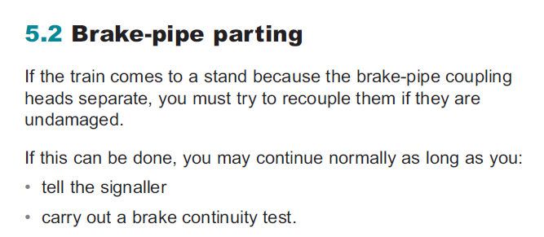 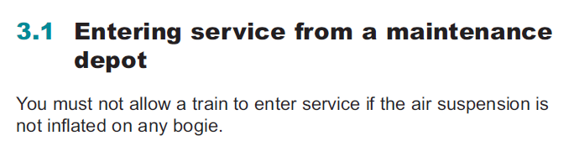

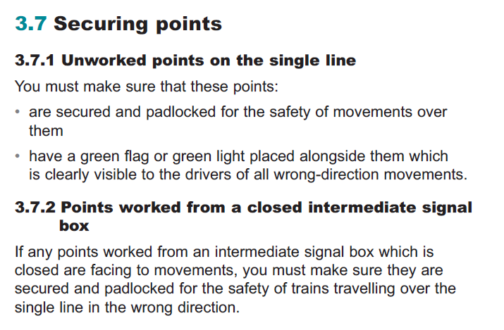

Each numbered heading in the examples above starts a new concept topic.

The Rule Book Glossary is created using glossary topics. These are special topics that are meant only for defining glossary terms, their definitions and abbreviations.

**Examples of different glossary topics:**

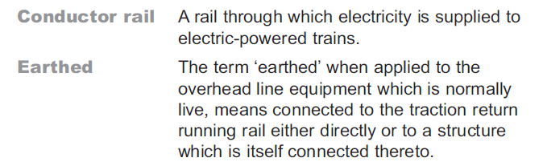 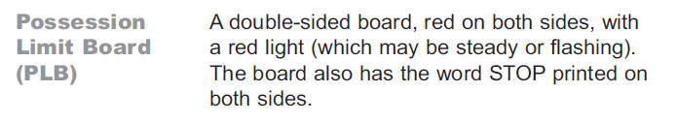

Each bold term and the following definition in the examples above is included in a single glossary topic.

### What is a topic and what is a section?

Handle everything with a rule number in the heading as a concept topic. Note that numbered headings are not the same as numbered lists – here, only the title of the topic matters. The example below shows a topic.



The number (in the example above, 3.1) and heading (in the example above, Entering service from a maintenance depot) are both part of the topic title:

<title><ph>3.1</ph> Entering service from a maintenance depot</title>

Handle everything with no number in the heading as a <section>. Topics can contain one or more <section> elements. The example below shows a topic (1.1 Driver reporting a defect) that includes a section (a) Stopping the train immediately).

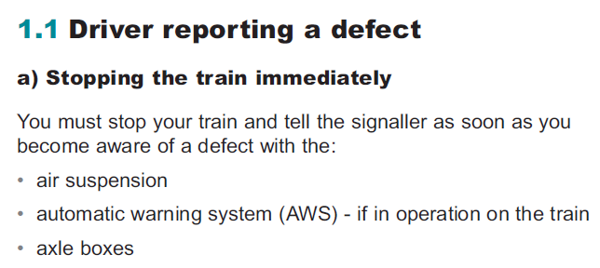

More examples:

|  |  |  |
| --- | --- | --- |
| **Example** | **Heading** | **Elements** |
|  | 1 Reporting defective or isolated on-train equipment | <concept> |
| 1.1 Driver reporting a defect | <concept> |
| a) Stopping the train immediately | <section>  Note that the bulleted list is an element (<ul>) that is added inside this <section>. |

|  |  |  |
| --- | --- | --- |
| **Example** | **Heading** | **Element** |
|  | 1 General instructions | <concept> |
| 1.1 Rules, regulations and instructions | <concept> |
| 1.2 Getting on and off rail vehicles | <concept>  Note that the bulleted list is an element (<ul>) that is added inside this <concept>. |
| 1.3 Mechanical and electrical plant or other equipment | <concept> |

|  |  |  |
| --- | --- | --- |
| **Example** | **Heading** | **Element** |
|  | 1 Definitions | <concept> |
| Absolute block section | <section> |
| Block signals | <section>  Note that the bold text, for example **Home signal**, is just bold text (<b>) inside a paragraph (<p>). |
| Clearing point | <section> |

|  |  |  |
| --- | --- | --- |
| **Example** | **Heading** | **Element** |
|  | 3.6 Blocking the section | <concept> |
| Part A: Blocking back inside home signal | <section> in concept 3.6 Blocking the section |
| 3.6.1 When this regulation must be used | <concept>  Note that the bold text, for example **train out of section**, is just bold text (<b>) inside a paragraph (<p>).  Note that the bulleted list is an element (<ul>) that is added inside this <concept>. |
| 3.6.2 Obstructing the line | <concept>  Note that the bold text, for example **train on line**, is just bold text (<b>) inside a paragraph (<p>) or a bulleted list item (<li>).  Note that the bulleted list is an element (<ul>) that is added inside this <concept>. |

## Rule Book bookmap

The main map for a Rule Book is a bookmap. Bookmaps contain references to maps and topics within elements that semantically match the traditional structure of a book, such as parts and appendices. Bookmaps also include metadata that defines information about the book and that may be used to generate content on the cover and title pages of the book.

The Rule Book bookmap is similar to the bookmap used for the A4 documents, with the following differences:

* There are two new topics: the role responsibilities topic and the conventions topic
* Graphics must be attached to the bookmap to create the front and back covers
* Metadata for creating the front and back cover must be added
* Certain metadata has changed from optional to mandatory so that the digital Rule Book can be published from this same material

### Building hierarchy to Rule Book

To create a structure for a Rule Book, you must build the structure of the book (a hierarchy of topics) to the bookmap. The examples below illustrate the concept of hierarchy.

In this example from the table of contents, chapter 1 is on the highest level, and topics 1.1 – 1.5. are on the second level.

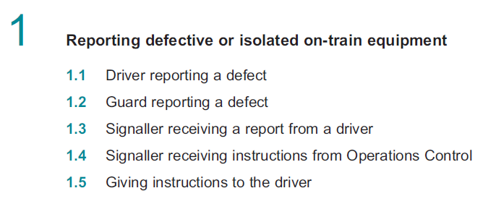

In this example from part content, number 3 is on the highest level, topic number 3.5 is on the second level, and topic 3.5.1 is on the third level.

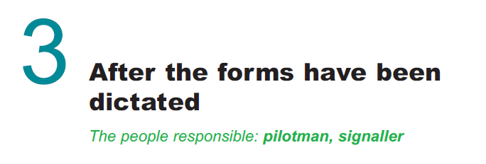

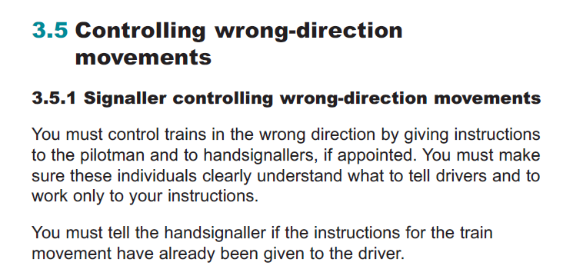

DITA has two ways of building hierarchy: either by using topics nested in other topics, or using maps that include the topics. Both ways can be used by RSSB, but the one which is easier to authors should be used.

#### Building hierarchy using nested topics

Nesting means that elements are placed inside other elements. For example:

<topic>*Level 1*

<topic>*Level 2*</topic>

<topic>*Level 2*

<topic>*Level 3*</topic>

</topic>

</topic>

#### Creating heading topics

If you build your book structure using nested topics, you may need to create heading topics that only have a <title> in them. In some cases, these topics may also include other elements such as <shortdesc> for the responsibility indicator and <note>.

**Example – the heading topic is highlighted with a red box, and nested topics with blue boxes:**

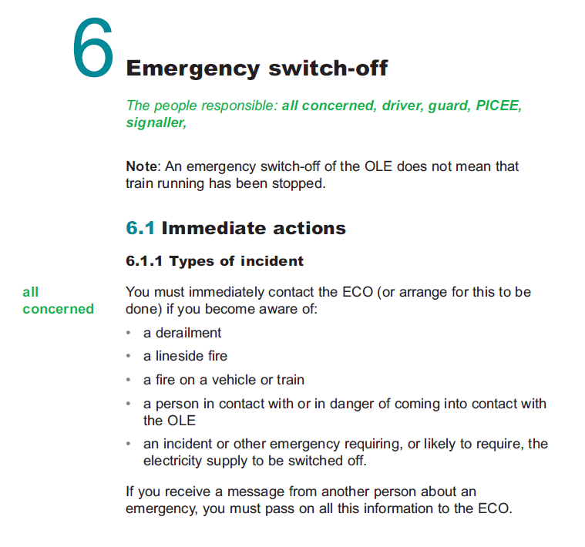

#### Nesting topics

To nest topics in a bookmap, add a <part> element and create the nested structure inside that <part>. Only one <part> is required, as it is used only for identifying which section is the actual content and not, for example, creating levels in a table of contents.

<part>

<topicref href="AC_6.1.dita">

<topicref href="AC_6.1.1.dita"/>

<topicref href="AC_6.1.2.dita"/>

<topicref href="AC_6.1.3.dita"/>

</topicref>

<topicref href="AC_6.2.dita">

<topicref href="AC_6.2.1.dita"/>

<topicref href="AC_6.2.2.dita"/>

</topicref>

</part>

Contents of AC_6.dita:

<concept>

<title><ph>6</ph> Emergency switch-off</title>

<shortdesc>The people responsible: <ph outputclass="responsibility-roles">all concerned, driver, guard, PICEE, signaller</ph></shortdesc>

<prolog>

...

</prolog>

<conbody>

<note>  
 <p>An emergency switch-off of the OLE does not mean that

train running has been stopped.</p>

</note>

</conbody>

</concept>

Contents of AC_6.1.dita:

<concept>

<title><ph>6.1</ph> Immediate actions</title>  
</concept>

Contents of AC_6.1.1.dita:

<concept>

<title><ph outputclass="rule-number">6.1.1</ph> Types of incident</title>

<conbody>

<p outputclass="responsibility-roles">all concerned</p>

<p>You must immediately contact the ECO (or arrange for this to be

done) if you become aware of:

<ul>

<li>a derailment</li>

<li>a lineside fire</li>

<li>a fire in a vehicle or train</li>

<li>a person in contact with or in danger of coming into

contact with the OLE</li>

<li>an incident or other emergency requiring, or likely to require, the electricity supply to be switched off.</li>

</ul>

</p>

<p>If you receive a message from another person about an emergency, you must pass on all this information to the ECO.</p>

</conbody>  
</concept>

#### Building hierarchy using maps

To keep your bookmap cleaner and easier to read, you can also create maps and include your topics in that map. Note that even with maps, you will need heading topics and nested topics like described above.

The map is included inside <part> in bookmap:

<part>

<topicref href="chapter2.ditamap">

</part>

The map “chapter2.ditamap” has the following structure:

<map>

<title>Chapter 2</title>

<topicref href="TW5_2.dita">

<topicref href="TW5_2.1.dita"/>

<topicref href="TW5_2.2.dita"/>

<topicref href="TW5_2.3.dita"/>

<topicref href="TW5_2.4.dita"/>  
</topicref>  
</map>

### Bookmap structure

Structure your bookmaps as follows, keeping each element in the order shown.

* <bookmap> (mandatory)
  + <booktitle> (mandatory)
    - <booklibrary> (mandatory)
    - <mainbooktitle> (mandatory)
    - <booktitlealt> (optional)
  + <bookmeta> (mandatory)
  + <frontmatter> (mandatory)
    - <notices> (mandatory)
    - <booklists> (mandatory)
      * <toc> (mandatory)
      * <figurelist> (optional)
      * <tablelist> (optional)
  + one <part> element (mandatory for nesting Rule Book topics)
  + backmatter> (optional)
    - <booklists> (optional)
  + <reltable> (optional)

The bookmap can only been as the order and structure of content in the published output.

In the example below, the front cover page and the copyrights page are built using metadata in <bookmap> and <bookmeta>. The role responsibilities page (“You will need this module if…”) and the conventions pages are built from <notices> in <frontmatter>. The table of contents is built based on the <toc> element in <frontmatter>.

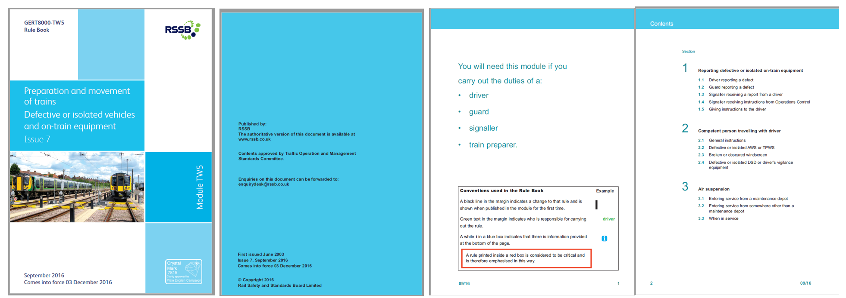

In the example below, chapter 1 is built from the topics included in the bookmap with <part>, and the back cover page is again built using metadata in <bookmeta>.

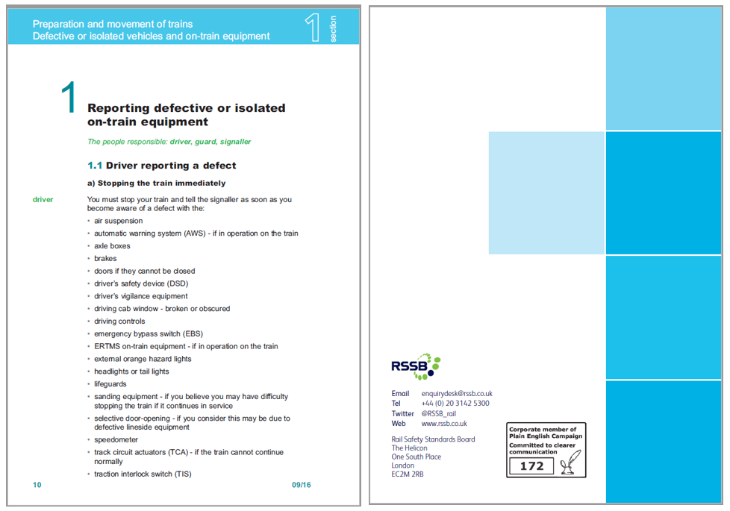

### Bookmap elements for Rule Book

The Rule Book bookmap also includes metadata that is used to generate the front cover of the Rule Book PDFs and control certain functionality in the digital Rule Book. You must pay attention to the correctness of this metadata as it enables showing correct content to the correct readers digitally.

Nest the following in the <bookmap> root element when creating a bookmap. For instructions regarding the elements in the A4 bookmap, see Bookmap elements for A4 documents on page 46.

|  |  |
| --- | --- |
| **Element** | **Guidance** |
| **<booktitle>**  **booktitle** | Use the <booktitle> element as a container for the <booklibrary>, <mainbooktitle> and <booktitlealt> elements.  Nest the following elements in the <booktitle> element:   |  |  | | --- | --- | | **Element** | **Guidance** | | **<booklibrary>**  **book library** | Use the <booklibrary> element to provide the Requirements Management Class. For example, add “Rule Book” to Rule Book, or “Railway Group Standards (NTRs)” to A4 standards. This element is used in conjunction with the <mainbooktitle> to form the entire name of the publication. | | **<mainbooktitle>**  **main book title** | Use the <mainbooktitle> element to provide the descriptive name of the document, for example AC electrified lines or Preparation and movement of trains. | | **<booktitlealt>**  **alternative book title** | Use the <booktitlealt> element to provide a subtitle for a document, if needed. This subtitle appears on the cover page of the Rule Book PDF, for example. Not all Rule Book modules have a subtitle.  **DITA example:**  <booktitle> <booklibrary>Rule Book</booklibrary>  <mainbooktitle>Preparation and movement of trains</mainbooktitle>  <booktitlealt>Defective or isolated vehicles and on-train equipment  </booktitlealt>  </booktitle>  **DITA example:**  <booktitle>  <booklibrary>Rule Book</booklibrary> <mainbooktitle>Rule Book  </mainbooktitle>  <booktitlealt>Briefing Leaflet  </booktitlealt>  </booktitle>  **DITA example:**  <booktitle>  <booklibrary>Rule Book</booklibrary> <mainbooktitle>Handbook 20  </mainbooktitle>  <booktitlealt>General duties of a safe work leader (SWL) working outside a possession  </booktitlealt>  </booktitle> | |
| **<bookmeta>**  **book metadata** | Use the <bookmeta> element as a container for metadata that applies to the entire publication. See Bookmeta in Rule Book bookmaps on page 77 for the metadata you must define within a bookmap. |
| **<frontmatter>**  **front matter** | Use the <frontmatter> element as a container for content that belongs before the body of the document.  Nest the following elements in the <frontmatter> element:   |  |  | | --- | --- | | **Element** | **Guidance** | | **<notices>**  **<notices** | Use the <notices> element to include the role responsibilities and conventions topics in the output. You must add the correct @outputclass attribute to each <notices> elements. See Role responsibilities topic on page 88 and Rule Book conventions topic on page 90 for more instructions.  These necessary topics are included in the bookmap template with <notices> and they have the correct @outputclass attribute. | | **<booklists>**  **book lists** | Use the <booklists> element as a container for reference lists such as the Table of Contents.  Nest the following element in the <booklists> element:  **<toc>**  **table of contents**  Use the <toc> element to include a Table of Contents in the output. The processor will automatically generate this list with the number of levels specified in the stylesheet. | |
| **<part>**  **part** | Use the <part> element to build a chapter, and nest topics with <topicref> elements inside <part>. A bookmap should always include just one <part> element inside which the topics are nested. See Building hierarchy using nested topics in bookmaps on page 71 for more information. |
| **<backmatter>**  **back matter** | Use the <backmatter> element as a container for content that belongs after the body of the document. |

### Bookmeta in Rule Book bookmaps

In addition to the metadata you can define in any topic, bookmap metadata provides information that describes the book that you are creating. The content of bookmeta is used to populate the front and back covers of the Rule Book PDF and control certain functionality in the digital Rule Book.

Nest the following elements, in the order specified, within the <bookmeta> element in your bookmap:

|  |  |
| --- | --- |
| **Element** | **Guidance** |
| **<authorinformation>**  **author information** | Use the <authorinformation> element as a container for <organizationinfo>.   |  |  | | --- | --- | | **Element** | **Guidance** | | **<organizationinfo>**  **organization**  **information** | Nest the <organizationinfo> element in <authorinformation> as a container for the company name, address, contact numbers and urls.  Nest the following element in the <organizationinfo> element:  **<namedetails>**  **name details**  Add as a first level container.    Nest the following element in the <namedetails> element:  **<organizationnamedetails>**  **organization name details**  Add as a second level container.  Nest the following elements in the <organizationnamedetails> element:  **<organizationname>**  **organization name**  The name of the organization, i.e.  Rail Safety Standards Board.  This is used on the   * + copyright   + back cover   Nest the following element in the <organizationinfo> element:  **<addressdetails>**  **address details**  A container for the organization's address. These values appear on the back cover of the Rule Book PDF.  Nest the following elements in the <addressdetails> element:  *<thoroughfare> thoroughfare*  The street name. In the Rule Book, “The Helicon, One South Place”.  *<locality> locality*  A container for the city and post code.  *<localityname> locality name*  The city. Nest inside <locality>.  In the Rule Book, “London”.  *<postalcode> postal code*  The post code. Nest inside <localityname>.  In the Rule Book, EC2M 2RB.  **<contactnumbers>**  A container for all phone numbers you want to include.  *<contactnumber>*  An phone number. In the Rule Book, +44 (0) 20 3142 5300.  **<emailaddresses>**  A container for all e-mails you want to  include.  *<emailaddress>*  An e-mail address. In the Rule Book, enquirydesk@rssb.co.uk.  **<urls>**  A container for all urls you want to  include.  *<url>*  A web site address. Include one <url> for each web site you want to include. In the Rule Book, you will also need to add an @outputclass attribute as there are multiple uses for the <url>. For example:  <url outputclass=”twitter”> @RSSB_rail</url>  <url outputclass=”web”>  www.rssb.co.uk</url> | |
| **<publisherinformation>**  **publisher information** | Use the <publisherinformation> element as a container for information about who published the book, where, and when.  The RSSB bookmap templates include all these elements. You need only enter the appropriate month, day, and year for the publication completion date.  Nest the following elements in the <publisherinformation> element:   |  |  | | --- | --- | | **Element** | **Guidance** | | **<organization>**  **organization** | Provide the name of the publishing company. The default value is RSSB. | | **<published>**  **published** | First-level container for the issue date: the date when the document was published.  Nest the following elements in the <published> element:  **<completed>**  **completed**  Second-level container for the issue date.  Nest <month>, <day> and <year> elements to provide the specific date. | |
| **<metadata>**  **metadata** | Use the <metadata> element to add any additional metadata to the bookmap. With the Rule Book, <metadata> includes processing instructions for the PDF transformation.  Nest the following elements in the <metadata> element:   |  |  | | --- | --- | | **Element** | **Guidance** | | **<keywords>**  **keyword** | Provide data for PDF document properties.  Nest <keyword> inside <keywords>.  See Providing document properties for the Rule Book PDF on page 124 for more details. | | **<othermeta>**  **other metadata**  **name=”colour”**  **content=”blue / green / purple”** | Provide the colour of the book. By default, the following colours will be defined within the bookmap, and the author will need to delete as applicable.  <othermeta name="colour" content="blue">  </othermeta>  <othermeta name="colour" content="green">  </othermeta>  <othermeta name="colour" content="purple">  </othermeta> | | **<othermeta>**  **other metadata**  **name=”size”**  **content=”A5 / A6”** | Provide the size of the book. By default, both sizes are provided, and the author will need to delete as applicable.  <othermeta name="size" content="A5">  </othermeta>  <othermeta name="size" content="A6">  </othermeta> | | **<othermeta>**  **other metadata**  **name=”type”**  **content=”module / handbook / glossary / briefing”** | Provide the type/layout of the book. By default, all types/layouts are provided, and the author will need to delete as applicable.  <othermeta name="type" content="module">  </othermeta>  <othermeta name="type" content="handbook">  </othermeta>  <othermeta name="type" content="glossary">  </othermeta>  <othermeta name="type" content="briefing">  </othermeta> | |
| **<category>**  **category** | Use the <category> element to add the manual or manuals or any other collections to which the Rule Book belongs.  The abbreviation used for the manuals and their meaning:   * MMANUAL = Master Manual * DMANUAL = Drivers Manual * TOSMANUAL = Train operations staff Manual * SSTMANUAL = Signaller and Signalling Technician Manual * TWMANUAL = Track workers Manual * POSSMANUAL = Possession workers Manual   By default, the bookmap will contain all the above values and the author will be required to delete as applicable. |
| **<bookid>**  **book identification** | Use the <bookid> element as a container for the version and issue of the publication.  Nest the following elements in the <bookid> element:   |  |  | | --- | --- | | **Element** | **Guidance** | | **<bookpartno>**  **book part number** | Provide the module number of the document such as “TW5” for the Rule Book front cover. Do not use in A4 documents. | | **<edition>**  **edition** | Provide the issue number of the document, generally stated on the front cover.  The issue number in <edition>, together with the document number in <booknumber> and in-force date in <bookchangehistory>, are used to control the visibility of content in the digital Rule Book. | | **<booknumber>**  **book number** | Provide the document number of the publication. For a publication, the book number may include the document type, identifying numbers and characters, and the issuing group; for example: GERT8000-TW5.  The document number in <booknumber>, together with the issue number in <edition> and in-force date in <bookchangehistory>, are used to control the visibility of content in the digital Rule Book. | |
| **<bookchangehistory>**  **book change history** | Use the <bookchangehistory> element as a container for information about who reviewed or approved the publication and which documents have been superseded. The dates for “in force”, “compliance” and “withdrawn” are also captured in this section.  The in-force date in <bookchangehistory>/<bookevent> together with the document number in <booknumber> and issue number in <edition> are used to control the visibility of content in the digital Rule Book. This is why <bookchangehistory> and <bookevent> are mandatory in Rule Book bookmaps.  Nest the following elements in the <bookchangehistory> element:   |  |  | | --- | --- | | **Element** | **Guidance** | | **<approved>**  **approved**  **(optional)** | Use as a container for information about the person who approved or authorised the publication and the date it was approved.  Nest the following elements in the <approved> element:  **<person value="">**  **person**  **(optional)**  Provide the name of the person who approved the document.  **<organization>**  **organization**  **(optional)**  Provide the organization or standards committee which has approved the document.  **<started>**  **started**  **(compulsory)**  Provide the month and year when the document was first issued using the <month> and <year> elements described earlier.  **<completed>**  **completed**  **(optional)**  Provide the date the document was approved using the <month>, <day>, and <year> elements described earlier.  **<summary>**  **summary**  **(optional)**  Provide the title of the person listed in the <person> element. | | **<bookevent>**  **book event** | Use as a container for a unique event in the history of the document, aside from approval or issue date. Specifically, you can capture each of the following events as they occur. Specify the event you are including by nesting a <bookeventtype> element in <bookevent> and setting the @nameattribute to the value shown in the first column of the following table. Nest <person>, <date>, and <summary> elements (as described earlier) based on the specific event as described in the table.  The in-force date in <bookchangehistory> together with the document number in <booknumber> and issue number in <edition> are used to control the visibility of content in the digital Rule Book. This is why <bookchangehistory> is mandatory in Rule Book bookmaps.  Nest the following elements in the <bookevent> element:  **bookeventtype name=**  *submitted*  When the document was submitted for approval (<completed>, by whom (<person>) and that person's title (<summary>)  *supersedes*  When the document supersedes another  (<completed>) and the specific document that takes its place (<summary>)  *superseded*  When the document is superseded by another  (<completed>) and the specific document that takes its place (<summary>)  *in-force*  The earliest date for compliance to this document (<completed>). This value is used to control the visibility of content in the digital Rule Book and it is mandatory in Rule Book bookmaps.  *compliance*  The latest date for compliance to this document (<completed>)  *withdrawn*  The date this document is withdrawn from  consideration (<completed>)  RSSB bookmap templates include these elements. | |
| **<bookrights>**  **book rights** | Use the <bookrights> element as a container for copyright information. Nest the following elements in the <bookrights> element:   |  |  | | --- | --- | | **Element** | **Guidance** | | **<copyrfirst>**  **first copyright** | The copyright year, contained in a <year> element. A default copyright year is provided in the bookmap template. | | **<bookowner>**  **book owner** | The owner of the copyright.  Nest the following element into <bookowner>:  **<organization>**  **organization**  A default owner is provided in the bookmap template. |   All RSSB bookmap templates include these elements. You need only complete the appropriate dates.  <bookrights>  <copyrfirst><year>2017</year></copyrfirst>  <bookowner>  <organization>RSSB</organization>  </bookowner>  </bookrights> |

**Note:** The RSSB bookmap template includes placeholders for all bookmeta elements. You need only insert the correct information.

### Documents that have to be printed using several colours

[RB]

If your document has, for example, graphics that have several colours instead of just black and white and it should be printed with colours, you must mark that document. This applies to both A4 documents and Rule Book.

Use an @outputclassattribute value of "colour" on <bookmap> to indicate that the document uses colour.

## Producing a front cover for a Rule Book

The front cover of a Rule Book currently consists of a train visual, the Crystal Mark logo, and document information such as the name and issue number of a Rule Book.

The front cover is produced automatically during publishing from DITA to PDF using metadata.

However, for the automatic front cover generation to work, you must:

* Add the train visual and Crystal Mark images to the <bookmap> with individual <data> elements and @name attributes
* Add certain metadata elements to the <bookmap> for the texts on the front cover.

**Note:** Authors must take care that these metadata elements are correct in the bookmap, as they are also used by the digital Rule Book to show correct information to each reader.

### Adding images for the front cover to bookmap

The PDF publishing scenario expects that the train visual and the Crystal Mark logo are included in the bookmap. The box visuals and their colour is handled by the publishing stylesheet. The images needs to be of the correct size for each Rule Book.

The front cover images are added to the bookmap as a <data> element inside <bookmeta>. In easyDITA, you do this by dragging the graphic onto the <bookmeta> element and selecting <data> as the element type. The bookmap template has these elements as a placeholder.

You will need two <data> elements for the bookmap: one that includes the train visual, and one that includes the Crystal Mark logo.

You must add the @name attribute “**frontcover-image**” to the <data> element that includes the train visual for the front cover, and the @name attribute “**crystalmark-image**” to the <data> element that includes the Crystal Mark logo.

You must also add the @format attribute for both data elements so that the file is identified as a graphic. The format can be any accepted graphics format, such as PNG, JPG or GIF.

**DITA example:**

<bookmeta>

...

<data name="frontcover-image" href="frontcover_TW1.png" format="png" />  
<data name="crystalmark-image" href="backcover_TW1.png" format="png" />

</bookmeta>

### Adding metadata elements for the front cover texts

The metadata elements that are required for the front cover texts appear both inside and outside of <bookmeta>. The following table lists the elements and the text that they generate during publishing.

|  |  |
| --- | --- |
| **Bookmap element** | **Used for generating…** |
| <booktitle> / <booklibrary> | …the Requirements Management class, i.e. Rule Book. |
| <booktitle> / <mainbooktitle> | …the name of the document, for example, Preparation and movement of trains. |
| <booktitle> / <booktitlealt> | …the possible subtitle for the document. |
| <publisherinformation> / <published> / <completed> | …the month when the document was released, for example, September 2016. |
| <bookmeta> / <bookid> / <bookpartno> | …the module name of the publication, for example, Module TW5. |
| <bookmeta> / <bookid> / <edition> | …the issue number of the publication, for example, 11. Use only numerals. |
| <bookmeta> / <bookid> / <booknumber> | …the document number of the publication, for example, GERT8000-TW1. |
| <bookchangehistory> / <bookevent> / <bookeventtype name=”in-force / compliance / superseded / supersedes / withdrawn / submitted ”> | …the important dates for the publication such as the date when the publication comes into force, for example, 03 December 2016. |

<booknumber>

<booklibrary>

<mainbooktitle>

<edition>

<completed>

<bookevent> type in-force

<bookpartno>

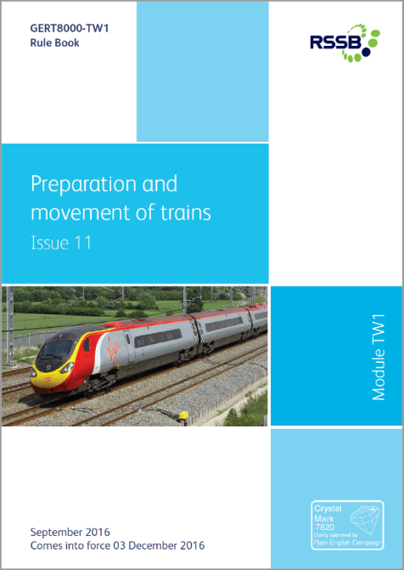

### Adding a disclaimer text to the front cover

There may be cases where the front cover of the Rule Book document has a disclaimer. For example:

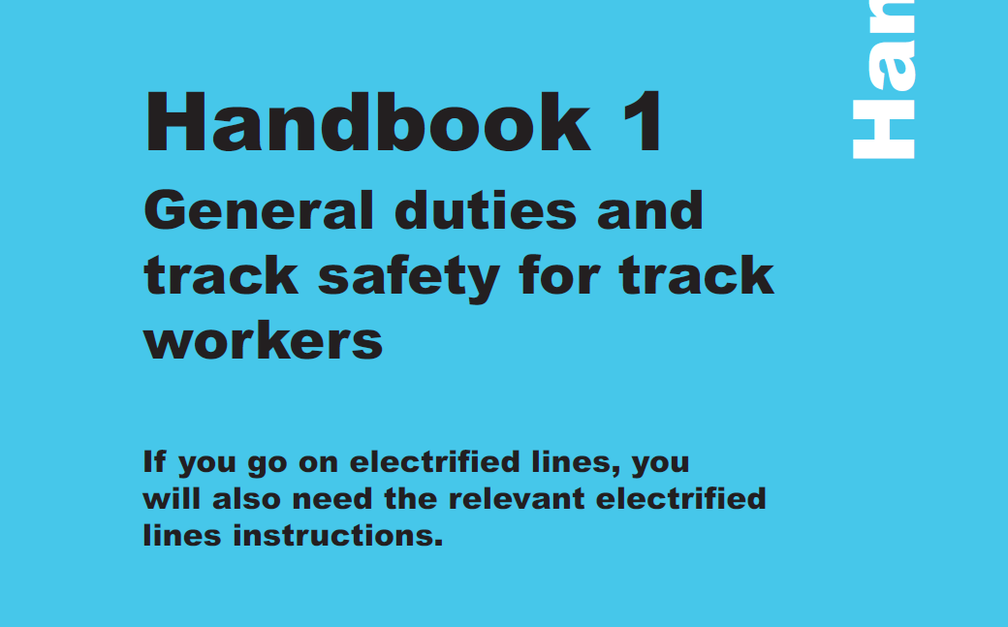

In cases such as these, add another <booktitlealt> with an @outputclass attribute “**cover-disclaimer**” to the bookmap.

**DITA example:**

<booktitle>

<booklibrary>Rule Book</booklibrary>

<mainbooktitle>Handbook 1</mainbooktitle>

<booktitlealt>General duties and track safety for track workers</booktitlealt>

<booktitlealt outputclass=”cover-disclaimer”>If you go on electrified lines, you will also need the relevant electrified lines instructions.</booktitlealt>

</booktitle>

## Producing a copyrights page for a Rule Book

The copyrights page of a Rule Book is created automatically during publishing from DITA to PDF from metadata entered in the <bookmeta> of each bookmap.

For the automatic copyrights page generation to work, you must ensure that these metadata elements have been added into <bookmeta>.

**Note:** Complete texts are not needed, as they are also added automatically during publishing. These texts reside in a separate file and are not part of the DITA content in easyDITA.

The templates have the necessary content as placeholders.

|  |  |
| --- | --- |
| **Text** | **Generated from** |
| Published by:  RSSB  The authoritative version of this document is available at www.rssb.co.uk | <publisherinformation><organization>  **DITA example:**  <publisherinformation> <organization>RSSB</organization>  …  </publisherinformation>  The texts “Published by” and “The authoritative version of this document is available at www.rssb.co.uk” are added automatically and does not need to be written in the bookmap. |
| Contents approved by Traffic Operation and Management Standards Committee. | <bookchangehistory><approved><organization>  **DITA example:**  <bookchangehistory>  <approved>  <person>name of the person who  approved the document</person>  <organization>Traffic Operation and  Management Standards Committee  </organization>  …  </bookchangehistory>  The text “Contents approved by” is added automatically and does not need to be written in the bookmap. |
| Enquiries on this document can be forwarded to: enquirydesk@rssb.co.uk | This text is added automatically and does not need to be written in the bookmap. |
| First issued [month] [year] | <bookchangehistory><approved><started>  **DITA example:**  <bookchangehistory>  <approved>  <person>name of the person who  approved the document</person>  <organization>Traffic Operation and  Management Standards Committee  </organization>  <started>  <month>June</month>  <year>2003</year>  </started>  …  </bookchangehistory>  The text “First issued” is added automatically and does not need to be written in the bookmap. |
| Issue number and publishing date, for example  Issue 7, September 2016 | <bookmeta> / <bookid> / <edition>  and  <publisherinformation> / <published> / <completed> |
| Comes into force 03 December 2016 | <bookchangehistory> / <bookevent> / <bookeventtype name=”in-force”>  Use the day, month, and year elements to add the date.  The text “Comes into force” is added automatically and does not need to be written in the bookmap. |
| © Copyright 2016  Rail Safety and Standards Board Limited | <bookrights> / <copyrfirst>  and  <bookrights> / <bookowner> / <organization> |

## Role responsibilities topic

Each Rule Book lists the roles that should understand and use the Rule Book module on the first pages of the Rule Book. This content is usually not reusable because the responsible roles change from book to book, and you must create a separate topic for each Rule Book.

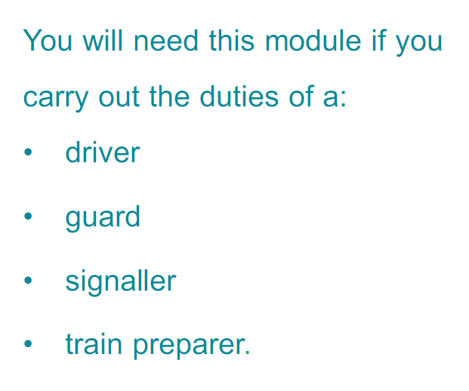

### Creating a role responsibilities topic

The role responsibilities topic is a <concept> topic. This topic type provides you more flexibility to author topic content according to the needs of each Rule Book.

The role responsibilities topic contains the following elements:

* <title> for the “You will need this module if you carry out the duties of a:” heading
* <ul> for the list of roles to be listed
* Any other allowed element for required content, for example <p> or <note>

**DITA example:**

<concept id="concept_rule_responsibilities">

<title>You will need this module if you carry out the duties of a:</title>

<conbody>

<ul id="ul_roles">

<li>driver</li>

<li>guard</li>

<li>signaller</li>

<li>train preparer.</li>

</ul>

</conbody>

</concept>

### Linking a role responsibilities topic to a bookmap

Link the role responsibilities topic to the bookmap’s <frontmatter> using a <notices> element. In easyDITA, you do this by dragging the graphic onto the <frontmatter> element and selecting <notices> as the element type. The bookmap template has this element as a placeholder with the correct outputclass.

To separate this topic from other topics linked with <notices>, you must add an @outputclass attribute to the <notices> element. The value of the @outputclass attribute must be **responsibility-page**.

**DITA example:**

<frontmatter>

<notices href="role_responsibilities.dita" outputclass="responsibility-page" toc="no"/>

…

</frontmatter>

## Rule Book conventions topic

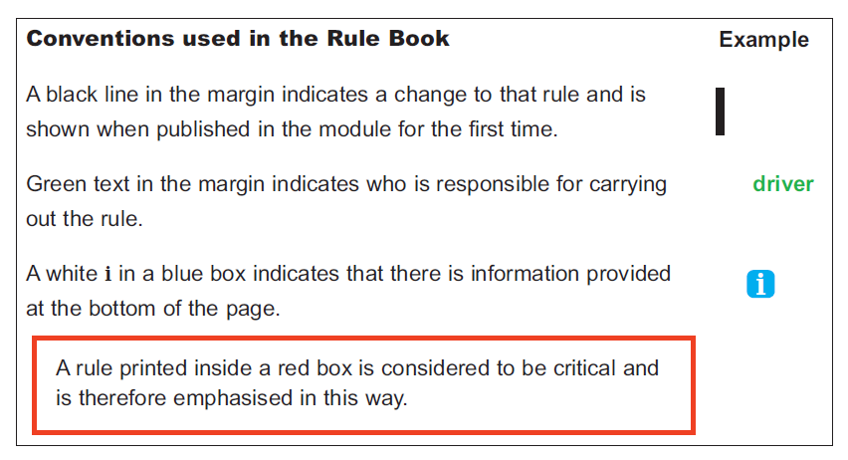Each Rule Book lists the conventions used in the Rule Book in a conventions topic in front of the book. The conventions topic is reusable in all Rule Book modules and located in the Rule Book Common folder in RMDB.

### Creating the conventions topic

The conventions topic is a <concept> topic.

The conventions topic contains the following elements:

* <title> for the “Conventions” heading
* <table> for the rest of the content
  + <entry> inside the <table> cells for description
  + <image> inside the <table> cells for the illustration depicting the convention

**DITA example:**

<concept id="concept_conventions">

<title>Conventions</title>

<conbody>

<table frame="all" class="- topic/table ">  
<tgroup cols="2" colsep="0" rowsep="0" class="- topic/tgroup ">  
<colspec colname="1" colwidth="4*" class="- topic/colspec "/>  
<colspec colname="2" colwidth="1*" class="- topic/colspec "/>  
<thead>

<row>

<entry>Conventions used in this content</entry>

<entry>Example</entry>

</row>

</thead>  
<tbody>

<row>

<entry>A black line in the margin indicates a change to that rule and is shown when published in the module for the first time.</entry>

<entry><image href="conventions_change_bar.jpg"/></entry>

</row>

<row>

<entry>Green text in the margin indicates who is responsible for carrying out the rule.

</entry>

<entry><image href="Convention_audience_image.jpg”/></entry>

</row>

<row>

<entry>A white i in a blue box indicates that there is information provided at the bottom of the page.</entry>

<entry><image href="Conventions_information_icon.jpg"/></entry>

</row>

<row>

<entry><note type="attention"><p>A rule printed inside a red

box is considered to be critical and is therefore emphasised in  
 this way.</p></note></entry>

<entry/>

</row>

</tbody>  
</tgroup>  
</table>

</conbody>

</concept>

### Linking the conventions topic to a bookmap

Link the conventions topic to the bookmap’s <frontmatter> using a <notices> element. In easyDITA, you do this by dragging the graphic onto the <frontmatter> element and selecting <notices> as the element type. The bookmap template has this element as a placeholder with the correct outputclass.

To separate this topic from other topics linked with <notices>, you must add an @outputclass attribute to the <notices> element. The value of the @outputclass attribute must be **conventions**.

**DITA example:**

<frontmatter>

<notices href="rule_book_conventions.dita" outputclass="conventions" toc="no"/>

…

</frontmatter>

## Producing a back cover for a Rule Book

The back cover of a Rule Book currently consists of box graphic visuals, the Plain English Campaign member number, the RSSB logo, and contact information.

The back cover is produced automatically during publishing from DITA to PDF using metadata.

However, for the automatic back cover generation to work, you must add certain metadata elements to the <bookmap> for the texts on the back cover.

### Adding metadata elements for the back cover texts

The metadata elements that are required for the back cover texts appear inside of <bookmeta>. The following table lists the elements and the text that they generate during publishing.

|  |  |
| --- | --- |
| **Bookmap element** | **Used for generating…** |
| <authorinformation> / <organizationinfo> /  <namedetails> /  <organizationnamedetails> /  <organizationname> | …the name of the organisation, i.e. Rail Safety Standards Board. |
| <authorinformation> / <organizationinfo> /  <addressdetails> | …the street address, city, and post code. |
| <authorinformation> / <organizationinfo> /  <contactnumbers> /  <contactnumber> | …the phone number for RSSB. |
| <authorinformation> / <organizationinfo> /  <emailaddresses> /  <emailaddress> | …the e-mail address for RSSB. |
| <authorinformation> / <organizationinfo> /  <urls> /  <url> | …the websites and other internet resources that RSSB needs to add.  In the Rule Book, you will also need to add an @outputclass attribute to each <url> as there are multiple uses for the <url>. For example:  <url outputclass=”twitter”> @RSSB_rail</url>  <url outputclass=”web”>  www.rssb.co.uk</url> |



## Authoring Rule Book topics

The instructions in the previous chapters regarding content authoring (headings, paragraphs, unordered lists, and so on) apply to content written for Rule Book topics as well. This section instructs you in authoring content specific to the Rule Book topics which is not used in any other RSSB document.

### Adding rule numbers to headings in Rule Book topics

When you are writing topics for a Rule Book, you must write the heading number manually. Rule Book topics are not numbered automatically.

The heading number is added to the <title> inside a <ph> element. A space follows the <ph> and the actual heading.

**DITA example:**

<concept>  
<title><ph>6.1</ph> Vehicles which must be placed out of use</title>  
<conbody>  
 ...  
</conbody>  
</concept>

### Adding the topic metadata to Rule Book topics

When you start or modify a topic, add metadata to the <prolog> section of the topic to capture information about the topic as a whole. The metadata inside the <prolog> will not be displayed with the topic on output but may be used by processes that filter content, generate search indexes, or customise navigation. Include each of the following elements in the prolog in the order listed. All elements are required unless noted otherwise in the description.

|  |  |
| --- | --- |
| **Element** | **Guidance** |
| **<LeadStdComm>**  **lead standards committee**  **(optional)** | Use the <LeadStdComm> element to include the lead standards committee responsible for this content. If more than one committee is responsible, list the others in the StdComm element later. This is always TOM SC for Rule Book content.  **Note:**  <LeadStdComm> is a masking of the DITA standard element <author>. |
| **<StdComm>**  **standards committee (optional)** | Use the <StdComm> element to include all standards committees responsible for this content. If more than one committee is responsible, list the primary committee in the LeadStdComm element earlier.  **Note:**  <StdComm> is a masking of the DITA standard element <publisher>. |
| **<metadata>**  **metadata (mandatory)** | Use the <metadata> element as a container for topic-level metadata, for example, audience or keywords. |
| **<audience>**  **audience (optional)** | Nest the <audience> element in <metadata> to specify the appropriate audience for the topic. You can add as many audience elements as needed.  For rule book topics, select one or more NOP roles from the dropdown list.   * All = All concerned * ALLAC = All in AC electrified lines * ALLDC = All in DC electrified lines * CP = Competent person * CPTBW = Competent person for temporary block working * COSS = Controller of Site Safety (COSS) * CK = Crossing keeper * DP = Designated person (DP) * DVR = Driver * DVROTM = Driver of an on track machine * ES = Engineering Supervisor (ES) * GRD = Guard * HSM = Handsignaller * IWA = Individual Working Alone (IWA) * LCA = Level crossing attendant * LO = Lookout * MC = Machine Controller (MC) * OTPO = On-track plant operator * OC = Operations controller * OOTM = Operator of an on-track machine * PAM = Person authorising the movement * PCTM = Person controlling train movements * PDT = Person dispatching train * PICOPLAT = Person in charge (PIC) of platform * PICEE = Person in charge of electrical emergency (PICEE) * POCL = Person in charge of loading and unloading rail vehicles during engineering work * PICS = Person in charge of sidings * PICOP = Person in charge of the possession (PICOP) * PICOS = Person in charge of the siding possession (PICOS) * PIC = Person in charge when using a hand trolley * PWRV = Person working on a rail vehicle * PMN = Pilotman * PS = Platform staff * PO = Points operator * PC = Protection controller (PC) * RP = Responsible person * RSA = Route setting agent * SWL = Safe Work Leader (SWL) * STR = Shunter * SGR = Signaller * ST = Signalling technician * SW = Site warden * SRSTN = Staff responsible for train dispatch or the safety of the public and staff on stations * TOC = Train operator's controller * TP = Train preparer |
| **<keywords>**  **keywords**  **(mandatory)** | Nest the <keywords> element in <metadata> as a container for keywords that can be used to help locate the topic. |
| **<keyword>**  **keyword**  **(mandatory)** | Nest the <keyword> element in <keywords> to classify the topic content for easier retrieval or navigation. The values you can assign are limited to a picklist within EasyDITA, referencing the “List of Active Keywords”  document. You can select as many values as apply. |
| **<othermeta name="FOP"**  **content="*FOP1*">**  **(optional)** | Nest the <othermeta name="FOP"> element in <metadata> to list the fundamental operating principles associated with this topic. Provide the fundamental operating principles in the @contentattribute of this element. |

### Adding the fundamental operating principle metadata

The fundamental operating principle metadata is added as an <othermeta> to the topic’s <prolog>. The topic may be associated with one or several fundamental operating principles. If RSSB so later chooses, they can go into further detail by adding the fundamental operating principle to the @product attribute of each block-level element.

### Adding roles and responsibility indicators

The responsibility indicator appears in two places in the Rule Book content:

* After the topic heading, preceded by “People responsible:” or “Person responsible”
* Next to each paragraph where responsibility needs to be specifically informed

#### Responsibility indicator after the topic heading

To add the responsibility indicator after the topic heading, use the <shortdesc> element with a nested <ph> with the @outputclass attribute. The @outputclass attribute value must be “**responsibility-roles**”.

**DITA example:**

<shortdesc>The people responsible: <ph outputclass="responsibility-roles">all concerned</ph></shortdesc>

#### Responsibility indicator next to the paragraphs

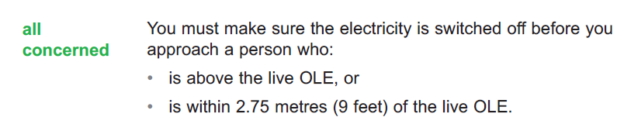To add the responsibility indicator next to the paragraph, use a <p> element with the @outputclass attribute. The @outputclass attribute value must be “**responsibility-roles**”.

**DITA example:**

<p outputclass="responsibility-roles">all concerned</p>

### Adding a criticality red box

Critical rules in a Rule Book are emphasised by surrounding them with a red box:

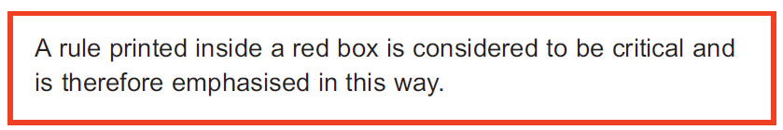

Content that needs the criticality red box is added as a <note>. The <note> has a @type attribute “attention”. Block-level elements such as <p> may be nested in the <note>, and the <note> may include as many nested elements as is required.

**DITA example:**

<note type="attention">

<p>OLE, pantographs and all roof-mounted electrical equipment on trains are extremely dangerous. It may be fatal if you touch or go near any of them, or if you allow anything to touch or go near them.</p>

<p>You must treat these items as being live at all times unless they have been made safe as shown in the instructions in this module.</p>

</note>

### Adding a note, tip, or important note

The Rule Book topics include notes that emphasise certain texts:

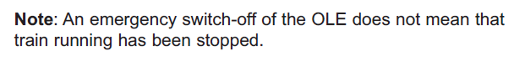

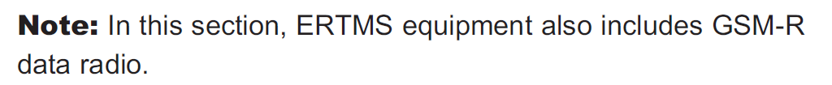

With the exception of the criticality red box, Rule Book modules follow the same guidance on <note> elements as any other RMDB document. For more information, see Writing notes on page 38.

### Adding rationale and guidance for Rule Book topics

For each rule in a Rule Book, you must record:

* the rationale of the rule: why this is the rule, why the rule exists, why it has a specific value or process in it
* the guidance: how to apply the rule, what is the context for the rule, any further information regarding the rule

The rationale and guidance are added to content using <data> elements. By default, the <data> element is not rendered in an output, but custom processing can be developed to manipulate the element. The <data> elements are separated with the different @name attributes. The rationale and guidance content must be written inside <data>, not inside the @value attribute.

<data name="rationale">Element for the rationale.</data>

<data name="guidance">Element for the guidance.</data>

You can add the <data> element to any element in a topic, inside the element.

**DITA example:**

<p>The OLE must be examined following:

<ul>

<li>

a tripping of the OLE when the ECO asks you to arrange examination of the OLE - the OLE must be examined between the locations the ECO gives you

<data name="rationale">Element for the rationale.</data>

<data name="guidance">Element for the guidance.</data>

</li>

</ul>

</p>

**DITA example:**

<context>

<p>

When the section of line concerned is clear other than any trains at a stand as shown in section 2.2, or where the possession is to be taken for the purpose of removing derailed vehicles or any other obstruction, the following must apply.

<data name="rationale">Element for the rationale.</data>

<data name="guidance">Element for the guidance.</data>

</p>

</context>

**DITA example:**

<steps-unordered>

<step>

<cmd>

You must make sure the signals that you agreed with the PICOP will protect the possession have been placed to danger.

<data name="rationale">Element for the rationale.</data>

<data name="guidance">Element for the guidance.</data>

</cmd>

</step>

<step>

...

</step>

</steps-unordered>

An alternative approach for recording rationale and guidance is using a <section> with @audience attribute “internal”. This approach is already used with the A4 standards to record changes. However, as with other elements described in this information model, changing the approach requires checking if the change affects the implementation and functionality of the digital Rule Book.

### Adding web links

To add a web link to the Rule Book content, you must use an <xref> element with the @format and @scope attributes. The value of the @format attribute must be “html” and the value of the @scope attribute must be “external”.

**DITA example:**

<xref href="http://www.rssb.co.uk/opsweb" format="html" scope="external"/>

The @format attribute defines that you are linking to a content that is not a DITA file, and the @scope attribute defines that you are linking to an external topic.

### Adding a footnote

Use the <fn> element to create footnotes in your topics. The stylesheet will automatically add an information icon in Rule Book topics.

**DITA example:**

<p>If you become aware that on-train equipment is defective and this may affect normal movement of the train, you must tell the driver immediately.<fn>In this module the term ‘normal movement of the train’ means that the train can accelerate, travel and stop in the normal way without speed restriction or special travel conditions</fn></p>

### Adding a video

The video usage at RSSB is being planned. The way of adding videos described in this information model applies only to videos stored in YouTube. RSSB must also plan how do they want their video to be viewed in the digital Rule Book, for example will it be full screen or not, and what controls are shown to the user.

Videos are to be used only in the digital Rule Book, not in PDFs. In PDFs, the video should be replaced by a link to the video.

If a video is being used, an introductory text such as “View the video on…” should be used. The text should appear in both the PDF and the digital Rule Book.

To link to a YouTube video, you must use the video’s embed link.

**DITA example:**

<object width="640" height="360" data="//www.youtube.com/embed/i-80SGWfEjM?rel=0">  
 <param name="src" value="//www.youtube.com/embed/i-80SGWfEjM?rel=0"/>  
 <param name="movie" value="//www.youtube.com/embed/i-80SGWfEjM?rel=0"/>  
 <param name="allowFullScreen" value="true"/>  
 <param name="allowscriptaccess" value="always"/>  
</object>

## Digital Rule Book metadata

The digital Rule Book works on the same metadata as the Rule Book PDFs.

To show the correct information to the correct user at the correct time, the following metadata values are needed in the bookmap:

* Issue number in <bookmeta> / <bookid> / <edition>
* Document number in <bookmeta> / <bookid> / <booknumber>
* Important dates for the publication in <bookmeta> / <bookchangehistory> / <bookevent> / <bookeventtype> specified with the different @name attributes such as in-force, withdrawn or superseded
* Manual or manuals to which a Rule Book module belongs in <category>

## Changes and Briefing Leaflet

The Rule Book update is accompanied by a separate Briefing Leaflet that lists all the changed Rule Book modules and explains the changes made in them as a high-level summary.

In the Rule Book module itself, the changed parts are marked with a change bar in the topic:

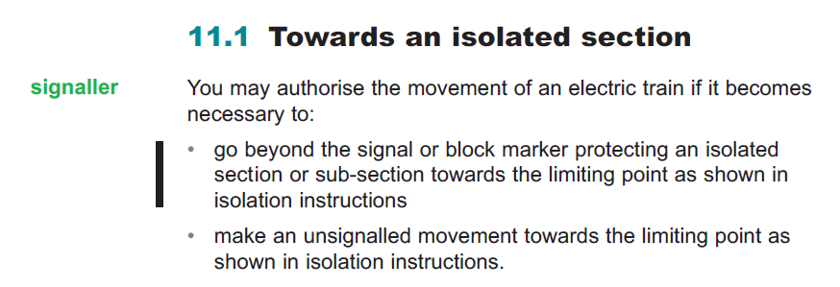

### Marking changes between Rule Book issues

To create the change bar in the PDF, to enable the changes functionality in the digital Rule Book, and to preserve the link between the change and the Briefing Leaflet, the following is needed:

* Briefing Leaflet summary
* “Explanation of Change” topics
* Briefing Leaflet bookmap
* In Rule Book topics, <xref> to the change described in the Explanation of Change topics

**Briefing Leaflet summary**

Each Briefing Leaflet has a Briefing Leaflet summary topic. It lists all changed or new modules that come into force on a certain date. The Briefing Leaflet summary is the first item linked to a Briefing Leaflet bookmap.

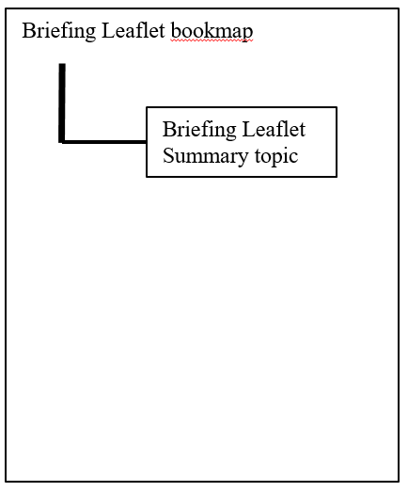 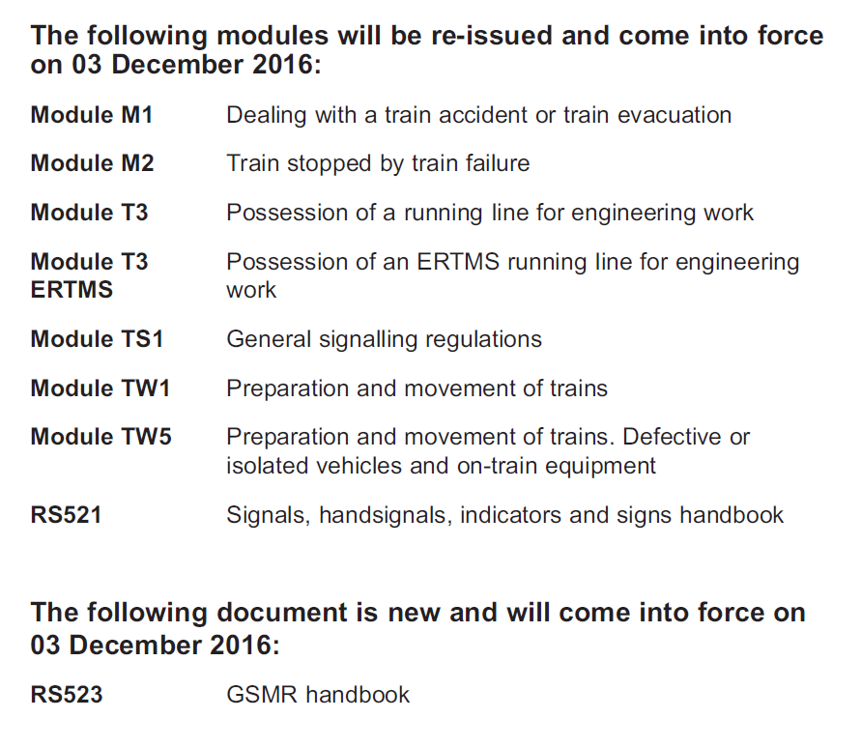

**Explanation of change topics**

Each changed Rule Book module will be accompanied with a set of “Explanation of Change” topics describing the details of each change. Multiple topics are required to build the desired structure, but in the examples below they are shown with one single box for clarity’s sake.

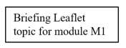 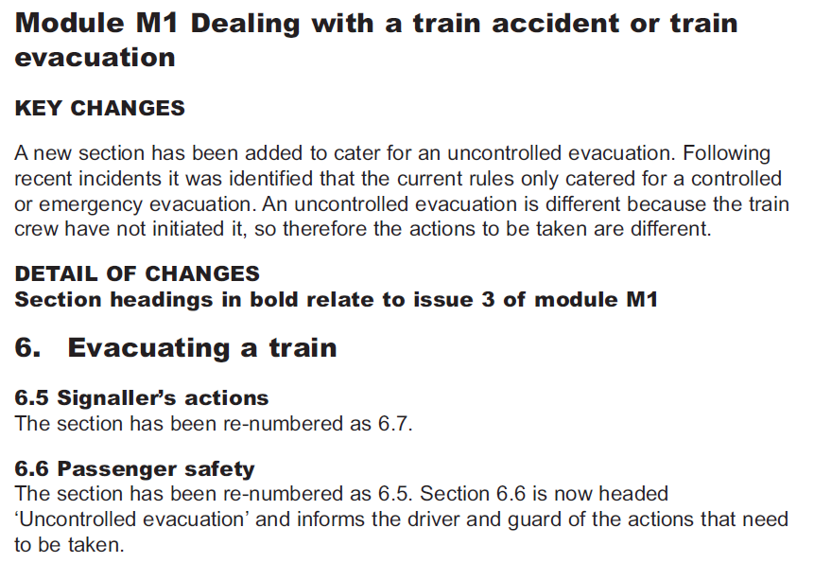

**Briefing Leaflet bookmap**

Each Briefing Leaflet is created with a bookmap. The bookmap includes a link to the Briefing Leaflet summary and to all Explanation of Change topics, and has all metadata required to publish the Briefing Leaflet.

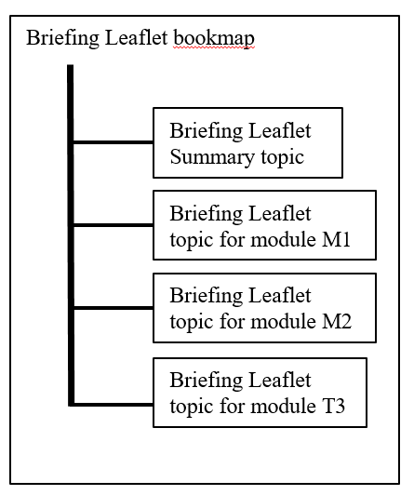

**<xref> in the Rule Book topics**

In each changed Rule Book topic, add an <xref> element to each element with changed, added or deleted text: title, paragraph, list item, and so on. The <xref> points to the Explanation of Change topic with the description of each specific change.

### Creating the Briefing Leaflet summary

The Briefing Leaflet summary is a <concept> topic that contains the following elements:

* <title> for the “The following modules will be re-issued…” topic heading
* <simpletable> for the module numbers and names
* <section> for any other information that is needed. The section will have a <title> and <simpletable> for the required content.

After you have inserted one <section> you can only insert other <section> elements.

**Note:**

In this information model, the paragraph “For details please read this briefing document.” has been moved to this page as information-model-wise it fits best there. In the DITA example below, it is shown as the last <section>.

You must give an @outputclass attribute “**change-summary**” to the Briefing Leaflet summary topic.

**DITA example:**

<concept id="concept_BLT_summary" outputclass="change-summary">

<title>The following modules will be re-issued and come into force on 03 December 2016:</title>  
<conbody>

<simpletable>

<strow>

<stentry><b>Module M1</b></stentry>

<stentry>Dealing with a train accident or train

evacuation</stentry>

</strow>

<strow>

<stentry><b>Module M2</b></stentry>

<stentry>Train stopped by train failure</stentry>

</strow>

<strow>

<stentry><b>Module T3</b></stentry>

<stentry>Possession of a running Iine for engineering

work</stentry>

</strow>  
 ...

</simpletable>

<section>

<title>The following document is new and will come into force on 03

December 2016:</title>

<simpletable>

<strow>

<stentry><b>RS523</b></stentry>

<stentry>GSMR handbook</stentry>

</strow>

</simpletable>

</section>

<section>

<p>For details please read this briefing document.</p>

</section>

</conbody>  
</concept>

### Creating Explanation of Change topics

The Explanation of Change topics are created as <concept> topics. You need several topics to create the desired structure for the content. Other topics are real topics with paragraph content, but certain topics are just “heading topics” which means they only have a heading required for the structure.

You must give an @outputclass attribute “**change-topic**” to each Explanation of Change topic.

The example below illustrates how content is put together.

Example page from a Briefing Leaflet:

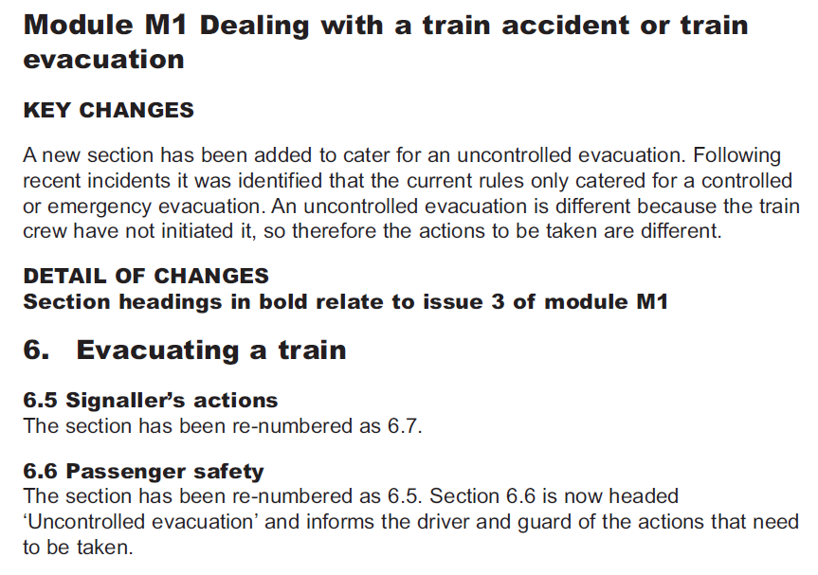

Explanations for the topic structure:

|  |  |
| --- | --- |
| **Text on page** | **Explanation** |
| **Module M1 Dealing with a train accident or train evacuation** | <concept> topic.  The topic needs a <title> and a <prolog> but you can delete <conbody> as it has no content.  This is a so-called “heading topic” as it only includes a heading but no other content. |
| **KEY CHANGES**  A new section has been added… | <concept> topic.  “KEY CHANGES” is in <title>.  The topic also has a <prolog>.  The paragraph text “A new section has been added…” is a <p> inside <conbody>. |
| **DETAIL OF CHANGES**  **Section headings in bold relate to issue 3 of module M1** | <concept> topic.  “DETAIL OF CHANGES” is in <title>.  The topic also has a <prolog>.  The bold text “Section headings in bold…” is a <shortdesc> before <prolog>.  You can delete <conbody> as it has no content. |
| **6. Evacuating a train** | <concept> topic.  The topic needs a <title> and a <prolog> but you can delete <conbody> as it has no content.  This is a so-called “heading topic” as it only includes a heading but no other content. |
| **6.5 Signaller’s actions**  The section has been re-numbered... | <concept> topic.  “6.5 Signaller’s actions” is in <title>.  The topic also has a <prolog>.  The paragraph text “The section has been re-numbered…” is a <p> inside <conbody>. |
| **6.6 Passenger safety**  The section has been re-numbered… | <concept> topic.  “6.6 Passenger safety” is in <title>.  The topic also has a <prolog>.  The paragraph text “The section has been re-numbered…” is a <p> inside <conbody>. |

### Creating the Briefing Leaflet bookmap

The Briefing Leaflet bookmap collects together the Briefing Leaflet summary and all module-specific Explanation of Change topics. The bookmap includes the same elements and bookmeta metadata as all Rule Book module bookmaps. These elements and metadata are used for generating the front and back cover of the Briefing Leaflet PDF and used in the digital Rule Book.

The Explanation of Change topics are all linked in a nested structure inside a <part> element. Add all topics required for one module inside one <part>. For example, there will be <part> for Module M1, another <part> for Module M2, another <part> for Module T3, and so on. The multiple <part> elements are used only for organisation purposes and making the bookmap easier to read.

For the sake of clarity, the elements in <bookmeta> have been removed from this example, but it needs to be added to the Briefing Leaflet bookmap too.

**DITA example:**

<bookmap>

<booktitle>

<booklibrary>Rule Book</booklibrary>

<mainbooktitle>Rule Book</mainbooktitle>

<booktitlealt>Briefing Leaflet</booktitlealt>

</booktitle>

<bookmeta>

...  
</bookmeta>  
<part>  
 <topicref href="briefing_leaflet_summary.dita"/>  
</part>

<part>  
 <topicref href="M1_heading.dita">

<topicref href="M1_key_changes.dita"/>  
 <topicref href="M1_detail_of_changes.dita">

<topicref href="M1_change_6_heading.dita">

<topicref href="M1_change_6_5.dita"/>

<topicref href="M1_change_6_6.dita"/>  
</topicref>

</topicref>  
</topicref>

</part>  
<part>

<topicref href="M2_heading.dita">

<topicref href="M2_key_changes.dita"/>

<topicref href="M2_detail_of_changes.dita">

<topicref href="M2_change_3_heading.dita">

<topicref href="M2_change_3_3.dita"/>

<topicref href="M2_change_3_6.dita"/>

</topicref>

</topicref>  
</topicref>

</part>

</bookmap>

#### Bookmeta in Briefing Leaflet bookmaps

Nest the following elements, in the order specified, within the <bookmeta> element in your bookmap:

|  |  |
| --- | --- |
| **Element** | **Guidance** |
| **<authorinformation>**  **author information** | Use the <authorinformation> element as a container for <organizationinfo>.   |  |  | | --- | --- | | **Element** | **Guidance** | | **<organizationinfo>**  **organization**  **information** | Nest the <organizationinfo> element in <authorinformation> as a container for the company name, address, contact numbers and urls.  Nest the following element in the <organizationinfo> element:  **<namedetails>**  **name details**  Add as a first level container.    Nest the following element in the <namedetails> element:  **<organizationnamedetails>**  **organization name details**  Add as a second level container.  Nest the following elements in the <organizationnamedetails> element:  **<organizationname>**  **organization name**  The name of the organization, i.e.  Rail Safety Standards Board.  This is used on the   * + copyright   + back cover   Nest the following element in the <organizationinfo> element:  **<addressdetails>**  **address details**  A container for the organization's address. These values appear on the back cover of the Briefing Leaflet PDF.  Nest the following elements in the <addressdetails> element:  *<thoroughfare> thoroughfare*  The street name. In the Briefing Leaflet, “The Helicon, One South Place”.  *<locality> locality*  A container for the city and post code.  *<localityname> locality name*  The city. Nest inside <locality>.  In the Briefing Leaflet, “London”.  *<postalcode> postal code*  The post code. Nest inside <localityname>.  In the Briefing Leaflet, EC2M 2RB.  **<contactnumbers>**  A container for all phone numbers you want to include.  *<contactnumber>*  An phone number. In the Rule Book, +44 (0) 20 3142 5300.  **<emailaddresses>**  A container for all e-mails you want to  include.  *<emailaddress>*  An e-mail address. In the Rule Book, enquirydesk@rssb.co.uk.  **<urls>**  A container for all urls you want to  include.  *<url>*  A web site address. Include one <url> for each web site you want to include. In the Briefing Leaflet, you will also need to add an @outputclass attribute as there are multiple uses for the <url>. For example:  <url outputclass=”twitter”> @RSSB_rail</url>  <url outputclass=”web”>  www.rssb.co.uk</url> | |
| **<metadata>**  **metadata** | Use the <metadata> element to add any additional metadata to the bookmap. With the Rule Book, <metadata> includes processing instructions for the PDF transformation.  Nest the following elements in the <metadata> element:   |  |  | | --- | --- | | **Element** | **Guidance** | | **<keywords>**  **keyword** | Provide data for PDF document properties.  Nest <keyword> inside <keywords>.  See Providing document properties for the Rule Book PDF on page 124 for more details. | | **<othermeta>**  **other metadata**  **name=”colour”**  **content=”blue / green / purple”** | Provide the colour of the book. | | **<othermeta>**  **other metadata**  **name=”size”**  **content=”A5 / A6”** | Provide the size of the book. | | **<othermeta>**  **other metadata**  **name=”type”**  **content=”module / handbook / glossary / briefing”** | Provide the type of the book. | |
| **<publisherinformation>**  **publisher information** | Use the <publisherinformation> element as a container for information about who published the book, where, and when.  The Briefing Leaflet bookmap templates include all these elements. You need only enter the appropriate month, day, and year for the publication completion date.  Nest the following elements in the <publisherinformation> element:   |  |  | | --- | --- | | **Element** | **Guidance** | | **<organization>**  **organization** | Provide the name of the publishing company. The default value is RSSB. | | **<published>**  **published** | First-level container for the issue date: the date when the document was published.  Nest the following elements in the <published> element:  **<completed>**  **completed**  Second-level container for the issue date.  Nest <month>, <day> and <year> elements to provide the specific date. | |
| **<bookid>**  **book identification** | Use the <bookid> element as a container for the version and issue of the publication.  Nest the following elements in the <bookid> element:   |  |  | | --- | --- | | **Element** | **Guidance** | | **<bookpartno>**  **book part number** | Provide the module number of the document such as “RBBL” for the Briefing Leaflet. Do not use in A4 documents. | | **<edition>**  **edition** | Provide the issue number of the document, generally stated on the front cover. Use a number, not text.  The issue number in <edition>, together with the document number in <booknumber> and in-force date in <bookchangehistory>, are used to control the visibility of content in the digital Rule Book. | | **<booknumber>**  **book number** | Provide the document number of the publication. For a publication, the book number may include the document type, identifying numbers and characters, and the issuing group. For the Briefing Leaflet, use RBBL.  The document number in <booknumber>, together with the issue number in <edition> and in-force date in <bookchangehistory>, are used to control the visibility of content in the digital Rule Book. | |
| **<bookchangehistory>**  **book change history** | Use the <bookchangehistory> element as a container for information about who reviewed or approved the publication and which documents have been superseded. The dates for “in force”, “compliance” and “withdrawn” are also captured in this section.  The in-force date in <bookchangehistory>/<bookevent> together with the document number in <booknumber> and issue number in <edition> are used to control the visibility of content in the digital Rule Book. This is why <bookchangehistory> and <bookevent> are mandatory in Briefing Leaflet bookmaps.  Nest the following elements in the <bookchangehistory> element:   |  |  | | --- | --- | | **Element** | **Guidance** | | **<approved>**  **approved**  **(optional)** | Use as a container for information about the person who approved or authorised the publication and the date it was approved.  Nest the following elements in the <approved> element:  **<person value="">**  **person**  **(optional)**  Provide the name of the person who approved the document.  **<organization>**  **organization**  **(optional)**  Provide the organization or standards committee which has approved the document.  **<started>**  **started**  **(compulsory)**  Provide the month and year when the document was first issued using the <month> and <year> elements described earlier.  **<completed>**  **completed**  **(optional)**  Provide the date the document was approved using the <month>, <day>, and <year> elements described earlier.  **<summary>**  **summary**  **(optional)**  Provide the title of the person listed in the <person> element. | | **<bookevent>**  **book event** | Use as a container for a unique event in the history of the document, aside from approval or issue date. Specifically, you can capture each of the following events as they occur. Specify the event you are including by nesting a <bookeventtype> element in <bookevent> and setting the @nameattribute to the value shown in the first column of the following table. Nest <person>, <date>, and <summary> elements (as described earlier) based on the specific event as described in the table.  The in-force date in <bookchangehistory> together with the document number in <booknumber> and issue number in <edition> are used to control the visibility of content in the digital Rule Book. This is why <bookchangehistory> is mandatory in Briefing Leaflet bookmaps.  Nest the following elements in the <bookevent> element:  **bookeventtype name=**  *submitted*  When the document was submitted for approval (<completed>, by whom (<person>) and that person's title (<summary>)  *supersedes*  When the document supersedes another  (<completed>) and the specific document that takes its place (<summary>)  *superseded*  When the document is superseded by another  (<completed>) and the specific document that takes its place (<summary>)  *in-force*  The earliest date for compliance to this document (<completed>). This value is used to control the visibility of content in the digital Rule Book and it is mandatory in Briefing Leaflet bookmaps.  *compliance*  The latest date for compliance to this document (<completed>)  *withdrawn*  The date this document is withdrawn from  consideration (<completed>)  RSSB bookmap templates may include these elements. | |
| **<bookrights>**  **book rights** | Use the <bookrights> element as a container for copyright information. Nest the following elements in the <bookrights> element:   |  |  | | --- | --- | | **Element** | **Guidance** | | **<copyrfirst>**  **first copyright** | The copyright year, contained in a <year> element. A default copyright year is provided in the bookmap template. | | **<bookowner>**  **book owner** | The owner of the copyright. In all cases, this element will contain an <organization> element. A default owner is provided in the bookmap template. | | **<organization>**  **organization** | The copyright holder of the book. A default organisation is provided in the bookmap template. |   All RSSB bookmap templates include these elements. You need only complete the appropriate dates.  <bookrights>  <copyrfirst><year>2017</year></copyrfirst>  <bookowner>  <organization>RSSB</organization>  </bookowner>  </bookrights> |

**Note:** The Briefing Leaflet bookmap template includes placeholders for all bookmeta elements. You need only to insert the correct information.

### Creating change bars in Rule Book

To create a change bar, there are certain concurrent steps. In this example, only one paragraph changes:

1. Make the change in the Rule Book topic, for example, edit the text in a paragraph.
2. Create an Explanation of Change topic that describes the specific change, for example, what was done with the paragraph text in the Rule Book topic.
3. Add an <xref> from the changed element in the Rule Book topic, for example inside the changed paragraph, to the Explanation of Change topic.
4. Add an @outputclass attribute for the <xref> with the value “**change”**.
5. Create the other necessary topics to build the necessary structure to the Briefing Leaflet.

The <xref> triggers the change bar to the Rule Book PDF and digital Rule Book and enables the tap-to-view-change functionality in the digital Rule Book: when you tap the change bar, you will see the Key Changes, and also the Explanation of Change topic.

In the example below, you will be tagging the heading of the topic “6.5 Passenger safety” as the heading number has changed from 6.6 to 6.5 in the Rule Book update.

**Rule Book topic that has changed:**

<concept>

<title><ph>6.5</ph> Passenger safety</title>

<prolog>

<author></author>

<publisher></publisher>  
<metadata>

<audience></audience>

<keywords>

<keyword></keyword>

</keywords>

<othermeta name="operating-principle" content="1"/>

</metadata>

</prolog>

<conbody>

<p>You must decide the best way to evacuate the train safely, taking into account:

<ul>

<li>how the passengers will be moved from the site</li>

<li>the need for passengers to cross the least number of lines, if possible, to reach a safe position.</li>

</ul>

</p>

<p>You must warn passengers to stay in a safe position until they can be escorted from the line.</p>  
</conbody>  
</concept>

**Briefing leaflet describing the change:**

<concept id="BL_module_M1_change_6_6" outputclass="change-topic">

<title><ph>6.6</ph> Passenger safety</title>

<prolog>

<author></author>

<publisher></publisher>  
<metadata>

<audience></audience>

<keywords>

<keyword></keyword>

</keywords>

</metadata>

</prolog>

<conbody>  
<p>The section has been re-numbered as 6.5. Section 6.6 is now headed ‘Uncontrolled evacuation’ and informs the driver and guard of the actions that need to be taken.</p>  
</conbody>

</concept>

**Rule Book topic showing the xref:**

<concept id="RB_6_6_Passenger safety">

<title><ph>6.6</ph> Passenger safety<ph><xref href="BL_M1_change_6_6.dita#BL_module_M1_change_6_6" outputclass=”change”/></ph></title>

<prolog>

<author></author>

<publisher></publisher>  
<metadata>

<audience></audience>

<keywords>

<keyword></keyword>

</keywords>

<othermeta name="operating-principle" content="1"/>

</metadata>

</prolog>

<conbody>

<p>You must decide the best way to evacuate the train safely, taking into account:

<ul>

<li>how the passengers will be moved from the site</li>

<li>the need for passengers to cross the least number of lines, if possible, to reach a safe position.</li>

</ul>

</p>

<p>You must warn passengers to stay in a safe position until they can be escorted from the line.</p>  
</conbody>

</concept>

**Note:**

You must add <ph> element inside <title> to be able to add the <xref>. You can add the <xref> inside most elements directly without the help of <ph>, for example:

<p>You can speak to the driver of the failed train using the train radio, to get or give any necessary information, at any time before or during the movement.**<xref href="BL_M2_change_3_3.dita#BL_module_M2_change_3_3" outputclass="change"/>**</p>

#### Location of the <xref> element with changed element content

The presence of the <xref> with outputclass=”change” element triggers the change bar generation and enables the tap-to-view-change functionality in the digital Rule Book.

The location of the <xref> provides info for the PDF and digital Rule Book publishing stylesheets about the length and coverage of the change bar.

|  |  |
| --- | --- |
| **<xref> inside** | **Action** |
| **Individual element like <p> or <li>**  <p>Paragraph text.**<xref href="link_to_change_topic_1.dita" outputclass="change"/>**</p>  <li>List item text.**<xref href="link_to_change_topic_2.dita" outputclass="change"/>**</li> | Adds a change bar next to the element. |
| **Element with other elements nested inside it**  <p>Paragraph text.**<xref href="link_to_change_topic_3.dita" outputclass="change"/>**  <ul>  <li>List item 1</li>  <li>List item 2</li>  </ul>  </p> | Adds a change bar next to the element and all elements nested in it. |
| **Several elements after each other**  <p>Paragraph text.**<xref href="link_to_change_topic_1.dita" outputclass="change"/>**</p>  <p>Paragraph text.**<xref href="link_to_change_topic_1.dita" outputclass="change"/>**</p>  Or  <p>Paragraph text.  <ul>  <li>List item text.**<xref href="link_to_change_topic_1.dita" outputclass="change"/>**</li>  <li>List item text.**<xref href="link_to_change_topic_1.dita" outputclass="change"/>**</li>  </ul>  </p> | Adds a joined change bar next to both elements. |

#### Location of the <xref> element with removed content

If the content has been removed, for example an entire paragraph has been deleted, leave the element of that content to the DITA file and add the <xref> in it. This will produce a bit of empty space and a change bar next to the space.

For example, if a paragraph has been removed, the DITA file would say:

<p>**<xref href="link_to_change_topic_about_deletion.dita" outputclass="change"/>**

#### Location of the <xref> element when an entire topic has been changed or removed

If an entire topic has been changed or deleted, the <xref> is added to the <title> inside a <ph> element. The @outputclass attribute must be set to “**change-topic**” to differentiate it from xrefs marking a single element.

**DITA example:**

<title>  
<ph>6.6</ph>Uncontrolled evacuation<ph><xref href="link_to_change_topic_6.6.dita" outputclass=”change-topic”/></ph>  
</title>

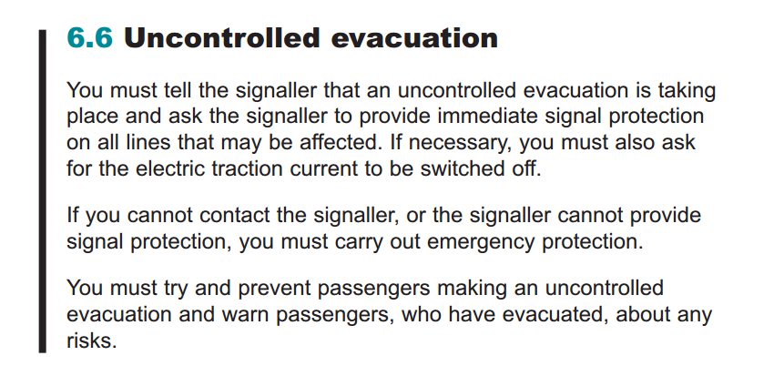

### When there is no Explanation of Change topic

There may be cases where no Explanation of Change topics are produced, for example when only a single term has changed and there is no need to explain that in each paragraph that mentions the term. In these cases, you still need the change bar next to those elements such as paragraphs where the term has changed. In these cases, tapping the change bar in the Digital Rule Book opens just the Key Changes topic but no Explanation of Change topic.

You will need to add the <xref> to the changed element like you normally do, but the <xref> does not need to point to any file as there is no Explanation of Change topic to which it could point. The @outputclass attribute needs to be “**change-keychange**”, so that the changes that have no Explanation of Change topic produced to them can be automatically identified. The end result is an empty <xref> with an @outputclass attribute, as the example below shows.

**DITA example:**

<p>Paragraph text where a term has changed.**<xref outputclass="change-keychange"/>**</p>

### Linking the Briefing Leaflet key changes to a Rule Book

The Briefing Leaflet’s key changes topic must also be linked to each Rule Book bookmap for digital Rule Book publishing.

Add the topic to the bookmap’s <frontmatter> with <topicref>. The <topicref> must have an @outputclass attribute “**keychanges**” and @toc attribute set to “**no**”.

**DITA example:**

<frontmatter>   
...

<topicref href="briefing_leaflet_M1_key_changes.dita" toc="no" outputclass="keychanges"/>   
...

</frontmatter> The topic will automatically be published for the digital Rule Book only.

## Creating a glossary

Glossary in DITA is built using three objects:

* <glossentry> glossary topics that include the glossary term, its definition, and an abbreviation if required – most Rule Book glossary terms have no abbreviation
* a subject scheme map that includes links to all <glossentry> topics
* terms marked in Rule Book topics using the <abbreviated-term> or <term> element and a @keyref attribute that points to the <glossentry> topic

Create one glossary topic per one glossary term:

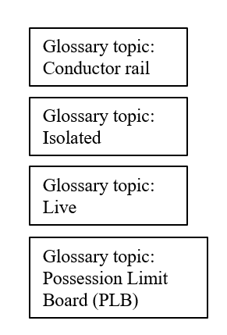

Create one subject scheme map for the entire glossary and link all topics in it:

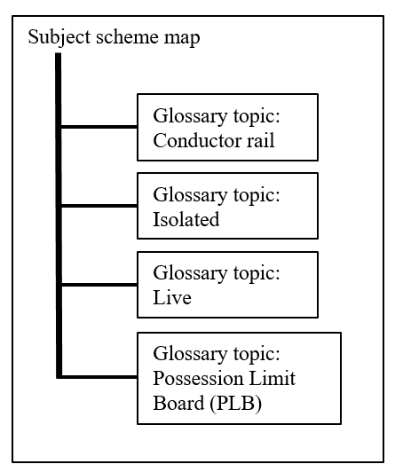

Add the terms using <abbreviated-term> and <term> into the Rule Book topics. You can use as many <abbreviated-term> and <term> in Rule Book topics as you need, and you can also mix both.

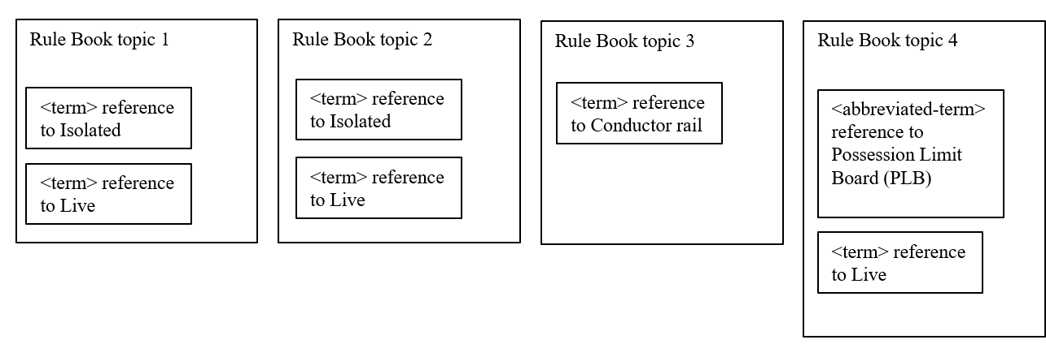

### What are keys and keyrefs?

DITA 1.2 included for the first time keys and keyrefs. They are used for defining content such as a term in one topic and using the term as a reference in another topic. In RSSB usage, a glossary term would be tagged with a @keys attribute value, and that term would be used in a regular Rule Book topic using the @keyref attribute.

A @keys attribute value must always be unique, but it can be used in an unlimited number of topics with the @keyref attribute.

### Glossary topic structure

Create one glossary topic per one glossary term.

There are two kinds of glossary terms:

* terms that have no abbreviation, such as “Isolated”
* terms that have an abbreviation, such as “Possession Limit Board (PLB)”

Both of these are described in the glossary topic (<glossentry>), but the number of elements used differs depending on whether a term uses an abbreviation or not. The <glossentry> topic type includes several elements, but RSSB uses just a selected few of those as those are enough to enable the glossary creation for the Rule Book.

Each <glossentry> topic must have an @id attribute. It is best practice to create the @id attribute using the topic type and the term itself separated by underscore, for example glossentry_earthed or glossentry_conductor_rail.

#### Terms with no abbreviation

The terms that use no abbreviation require only two elements in their glossary topics, one for the term itself and another for its definition. Most terms in the Rule Book Glossary are terms with no abbreviation and use this simpler glossary topic.

|  |  |
| --- | --- |
| **Element** | **Guidance** |
| **<glossterm>**  **glossary term** | Add the term you want to define, for example, Isolated. |
| **<glossdef>**  **glossary term definition** | Add the definition of the term, for example, “Electrical equipment is isolated when it is disconnected from all sources of electricity supply in a secure way.” |

**DITA example for term with no abbreviation:**

<glossentry id="glossentry_earthed">

<glossterm>Isolated</glossterm>

<glossdef>Electrical equipment is isolated when it is disconnected from all sources of electricity supply in a secure way.

</glossdef>  
</glossentry>



In the published digital Rule Book, the glossary topic could look something like this. The word in italics is the term, and when the user hovers over it, the definition from <glossdef> is shown. (This example has been created with the generic DITA OT transformation and does not reflect the RSSB-branded digital Rule Book.)

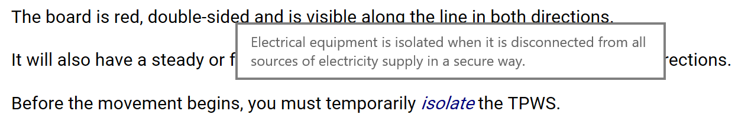

#### Terms with an abbreviation

The terms that use an abbreviation require more elements in the glossary topic to include all the information needed. First, you must provide the term and its definition, and then, the abbreviation.

|  |  |
| --- | --- |
| **Element** | **Guidance** |
| **<glossterm>**  **glossary term** | Add the term you want to define, for example, “Possession Limit Board”. |
| **<glossdef>**  **glossary term definition** | Add the definition of the term, for example, “A double-sided board, red on both sides, with Limit Board a red light (which may be steady or flashing). The board also has the word STOP printed on both sides.” |
| **<glossbody>**  **glossary body** | Container for the full term and abbreviation in <glossSurfaceForm> and <glossAlt>. |
| **<glossSurfaceForm>**  **glossary surface form** | Add the full term and its abbreviation that you want to show the first time that text is encountered. For example, the first time that the term is seen in a PDF, it would be printed as “Possession Limit Board (PLB)”. |
| **<glossAlt>**  **glossary alternative form** | Container for the abbreviation in <glossAcronym>. |
| **<glossAcronym>**  **glossary acronym** | Add the abbreviation that you want to show after the first encounter with this term. For example, in the case of Possession Limit Board, “PLB”. |

**DITA example for term and its abbreviation:**

<glossentry id="glossentry_conductor_rail">

<glossterm>Possession Limit Board</glossterm>  
<glossdef>A double-sided board, red on both sides, with Limit Board a red light (which may be steady or flashing). The board also has the word STOP printed on both sides.</glossdef>  
<glossBody>

<glossSurfaceForm>Possession Limit Board (PLB)

</glossSurfaceForm>

<glossAlt id="glossAlt_PLB">

<glossAcronym>PLB</glossAcronym>

</glossAlt>

</glossBody>

</glossentry>

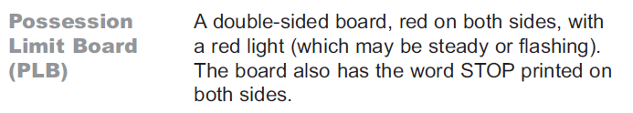

In the published output, the glossary topic could look something like this. The first mention is from the <glossSurfaceForm> and the second mention from the <glossAcronym>. (This example has been created with the generic DITA OT transformation and does not reflect the RSSB-branded digital Rule Book.)



There is no special formatting required for the terms and acronyms in the Rule Book. They should inherit the same formatting as the element inside which they are used.

### Subject scheme map structure

Individual glossary topics can be combined into a complete glossary using a glossary map or a subject scheme map. The subject scheme map is used with the Rule Book glossary because it is needed to enable certain functionality in the digital Rule Book.

The main guideline for glossary creation is that you must create one glossary topic per one glossary term, and one subject scheme map for the entire glossary and link all topics in it.

A subject scheme map is a specialised map for creating taxonomy or different metadata collections. It has special elements for these purposes, but those elements map to a regular map:

* Instead of a <topichead>, the subject scheme map has <subjectHead> and <subjectHeadMeta>
* Instead of a <topicref>, the subject scheme map has <subjectdef>

A subject scheme map can be edited like a regular map.

|  |  |
| --- | --- |
| **Element** | **Guidance** |
| **<subjectScheme>**  **subject scheme** | Add a a container for the title and the rest of the subject scheme content. Add the @outputclass attribute “glossary” to the subject scheme map.  Nest the following inside <subjectScheme>:   |  |  | | --- | --- | | **Element** | **Guidance** | | **<title>**  **title** | Add as a container for a title. | | **<subjectHead>**  **subject heading** | Add as a container for a grouping of information. You can have as many <subjectHead> elements as is required. | |

The main content of a subject scheme is inside the <subjectHead> element.

|  |  |
| --- | --- |
| **Element** | **Guidance** |
| **<subjectHead>**  **subject heading** | Add as a container for a grouping of information.  Nest the following inside <subjectHead>:   |  |  | | --- | --- | | **Element** | **Guidance** | | **<subjectHeadMeta>**  **subject heading metadata** | Add as a container for a title.  Nest the following inside <subjectHeadMeta>:  **<navtitle>**  navigation title  Write a name for the grouping of information, for example, “Electrified Lines” or “Lineside Equipment”.  **<subjectdef>**  subject definition  Add a link to the glossary topic using the @href attribute as you would add any topicref. Assign a unique @keys attribute to each <subjectdef>. It is best practice to use the term also as the @keys attribute. For example, the @keys attribute for the glossary topic for the term “Isolated” would be “Isolated”, and the @keys attribute for the glossary topic for the term “Conductor rail” would be “ConductorRail” | |

**DITA example:**

<subjectScheme outputclass="glossary">

<title>Glossary</title>

<subjectHead>

<subjectHeadMeta>

<navtitle>Electrified Lines</navtitle>

</subjectHeadMeta>

<subjectdef href="glossary_topics/glossentry_conductor_rail.dita"

keys="ConductorRail"/>

<subjectdef href="glossary_topics/glossentry_earthed.dita" keys="Earthed"/>

<subjectdef keys="Isolated" href="glossary_topics/glossentry_isolated.dita"/>

</subjectHead>

<subjectHead>

<subjectHeadMeta>

<navtitle>Engineering Work</navtitle>

</subjectHeadMeta>

<subjectdef keys="AffectNormalPassageOfTrains"  
href="glossary_topics/glossentry_affect_normal_passage_of_trains.dita"/>

</subjectHead>  
</subjectScheme>

### Using <abbreviated-form> and @keyref in topics

Use the <abbreviated-form> and <term> elements to mark terms in topics.

To mark a term which has an abbreviation in your Rule Book topic, you must use the <abbreviated-form> element. This element means that the text (term + abbreviation) written in <glossSurfaceForm> is shown when the term appears for the first time, but after that all other appearances of that term show only as the abbreviation written in <glossAlt> / <glossAcronym>.

**DITA example:**

<p>A <abbreviated-form keyref="possession_limit_board"/> identifies the boundary of a possession. A <abbreviated-form keyref="possession_limit_board"/> may also be used as part of the protection for a line blockage.</p>

**Output example:**



To mark a term which has no abbreviation in your Rule Book topic, you must use the <term> element. This element means that the text (term) written in <glossterm> is shown each time the term appears.

**DITA example:**

<p>

Before the movement begins, you must temporarily <term keyref="isolated">isolate</term> the TPWS.

</p>

**Output example:**



The output examples are done using DITA Open Toolkit and are just examples of the content and element behaviour, not the formatting.

## Providing processing instructions for PDF conversions

When Rule Book content is published from RMDB, the PDF conversion can process the DITA files into the desired look & feel automatically using metadata without any input from authors. This is how the size and colour of the published PDF is decided.

To enable automatic processing into the correct size and colour, certain data needs to be added to the <bookmeta> in each bookmap:

|  |  |
| --- | --- |
| **Element** | **Guidance** |
| **<bookmeta> /**  **<metadata>** | Use the <metadata> element to add any additional metadata to be bookmap. With the Rule Book, <metadata> includes processing instructions for the PDF transformation.  Nest the following elements in the <metadata> element:   |  |  | | --- | --- | | **Element** | **Guidance** | | **<othermeta>**  **other metadata**  **name=”colour”**  **content=”blue / green / purple”** | Provide the colour of the book.  Select one of the available values according to the book you are working with. | | **<othermeta>**  **other metadata**  **name=”size”**  **content=”A5 / A6”** | Provide the size of the book.  Select one of the available values according to the book you are working with. | | **<othermeta>**  **other metadata**  **name=”type”**  **content=”module / handbook / glossary / briefing”** | Provide the type of the book.  Select one of the available values according to the book you are working with. | |

## Providing summary information and important dates for the Rule Book

Record a summary and important dates for a Rule Book in <bookmeta> in each bookmap.

### Summary

The summary describes what the document is and to whom it is relevant, and includes any other information.



|  |  |
| --- | --- |
| **Element** | **Guidance** |
| **<bookmeta> /**  **<shortdesc>** | Use the <shortdesc> element to add a summary of the Rule Book. |

### Important dates

The important dates are, for example, the issue date, publish date, and in-force date for a Rule Book.

Add the important dates in the <bookmeta> in each bookmap.

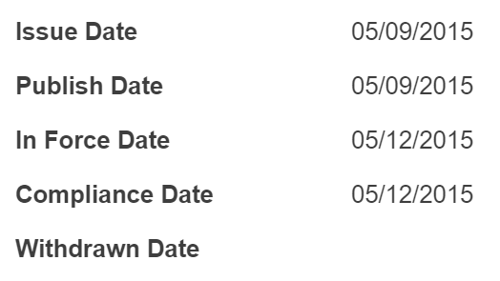

|  |  |
| --- | --- |
| **Element** | **Guidance** |
| **<bookmeta> /**  **<bookchangehistory> /**  **<bookevent>**  **book event** | Capture the important dates for the document in the different <bookevent> elements.  Specify the event you are including by nesting a <bookeventtype> element in <bookevent> and setting the @nameattribute to the value shown in the first column of the following table. Nest <person>, <date>, and <summary> elements based on the specific event as needed.  Nest the following elements in the <bookevent> element:  **bookeventtype name=**  *submitted*  When the document was submitted for approval (<completed>, by whom (<person>) and that person's title (<summary>)  *supersedes*  When the document supersedes another (<completed>) and the specific document that takes its place (<summary>)  *superseded*  When the document is superseded by another (<completed>) and the specific document that takes its place (<summary>)  *in-force*  The earliest date for compliance to this document (<completed>). This value is used to control the visibility of content in the digital Rule Book and it is mandatory in Rule Book bookmaps.  *compliance*  The latest date for compliance to this document (<completed>)  *withdrawn*  The date this document is withdrawn from consideration (<completed>) |

## Providing document properties for the Rule Book PDF

Each published PDF includes document properties that describe the PDF. These values are inserted to the PDF from the bookmap. Ensure you have added the following into the bookmap:

|  |  |  |
| --- | --- | --- |
| **PDF property** | **Bookmap element** | **Used for generating…** |
| Title | <booktitle> / <mainbooktitle>  + <booktitlealt>  (if it exists) | …the name of the document, for example, Preparation and movement of trains. |
| Author | <bookmeta> /  <publisherinformation> / <organization> | …the author of the document, i.e. RSSB. |
| Subject | <bookmeta> / <shortdesc> | …the description of what document the document is and to whom it is for. Used also as the summary of the document. See Summary on page 123. |
| Keywords | <bookmeta> / <metadata> / <keywords> / <keyword> | …the keywords that you want to add to the PDF. Use one <keyword> for each keyword or keyword phrase. |

# Chapter 10: Con**t**ent management

## CMS Metadata

The RSSB content management system automatically captures the following metadata for all content stored in it:

* Author and organisation name
* Reviewer(s) and organisation name(s)
* Approver(s) and organisation name(s)
* Content owner
* Workflow stage; for example, released, in review, in draft, or beta
* Dates; for example, created, last revised, release, checked out
* Information type (task, concept or reference)
* Version numbers
* ID number
* Check-in comments
* Revision information
* Permissions

Most of this information is captured without your direct input. However, you are required to enter check-in comments each time you check-in a topic. These comments form the corporate memory of all changes made to the topics, whether technical or editorial. They should concisely record what changed, why it changed, and who initiated the change. Include the following content as relevant:

* A summary of the anticipated effect
* A reference to the meeting date, minutes, and committee that approved the change.
* A brief history of the requirement
* Any significant consultation comments
* Reasons for delaying/speeding up of implementation

## Folder structure

It is important that all writers use a common folder structure to facilitate findability and order. At RSSB, folders at the highest level are organised by document type, such as Railway Group Standards, Deviations, and Rule Books.

Within each document type, subfolders group similar content together to facilitate reuse. By grouping content in this way, writers can more easily browse for related content to the topics they are currently writing. For example, they do not have to search multiple standards folders into which similar topics might be sorted, but can find all information together in one folder that spans standards.

Each level in the folder hierarchy, including the top most, includes a Common folder which includes topics, maps, images, and so on that are common to everything below it in the hierarchy. For example, information in the Common folder at the root of the RSSB file server applies across all RSSB; information in the Common folder within a particular standards folder applies only to that standards family; and information in the Common folder within a product standard only to those standard.

The following illustrates the RSSB folder structure:

* Common
  + Topics
  + Graphics
  + Maps
  + Publications
  + Library
* Railway_Group_Standards
  + Common
    - Topics
    - Graphics
    - Maps
    - Publications
    - Library
  + *Subsystem* Subsystems include: Control_Command_and_Signalling, Energy, Infrastructure, Plant, Rolling_Stock, Traffic_Operations and Management.
    - Common
    - Topics
    - Graphics
    - Maps
    - Publications
    - Library
    - *Standard*
      * Common
      * Topics
      * Graphics
      * Maps
      * Publications
      * Library
* Rule_Book
  + Common
    - Topics
    - Graphics
    - Maps
    - Publications
    - Library
  + Rule_Book_Modules
    - Common
    - Topics
    - Graphics
    - Maps
    - Publications
    - Library
    - *subsystem* Subsystems include: AC_Electrified_Lines, DC_Electrified_Lines, Personal_Safety_and_General_Responsibilities, Global_Systems_for_Mobile_Communications, Mishaps_Incidents_and_Extreme_Weather, On-Track_Maintenance, Working_by_Pilotman, Proceed-on- Sight_Authority, Signals, Permissible_Speeds_and_Speed_Restrictions, Station_Working_and_Shunting, Track_and_Signalling_Work, Train_Signalling, Train_Working
      * Common
      * Topics
      * Graphics
      * Maps
      * Publications
      * Library
  + Rule_Book_Amendments
    - Common
    - Topics
    - Graphics
    - Maps
    - Publications
    - Library
* Rule_Book_Handbooks
  + Common
  + Topics
  + Graphics
  + Maps
  + Publications
  + Library
* Rule_Book_History
  + Common
  + Topics
  + Graphics
  + Maps
  + Publications
  + Library
* Briefing_Leaflet
  + Common
  + Topics
  + Graphics
  + Maps
  + Publications
  + Library
* *Deviation*
  + Common
  + Topics
  + Graphics
  + Maps
  + Publications
  + Library
* *Impact Assessment*
  + Common
  + Topics
  + Graphics
  + Maps
  + Publications
  + Library
* *Briefing Note*
  + Common
  + Topics
  + Graphics
  + Maps
  + Publications
  + Library

## File naming convention

Name your DITA files using the words in the topic or map title as follows:

1. Begin each file name with an indicator for the type of file, followed by an underscore:
   * cD_ (Deviation concept topic)
   * cPO_ (Principles of operation concept topic)
   * cR_ (Requirement concept topic)
   * cSG_ (Standalone guidance concept topic)
   * cO_ (Overview concept topic)
   * cSI_ (Safety Information concept topic)
   * cC_ (Copyright concept topic)
   * cS_ (Synopsis concept topic)
   * cG_ (Glossary topic)
   * c_ (concept topic)
   * t_ (task topic)
   * r_(reference topic)
   * rS_ (Specifications reference topic)
   * rL_ (Lineside operational and safety signs reference topic)
   * rTD_ (Tabular data reference topic)
   * m_ (map)
   * bm_ (bookmap)
   * coll_ (collection topic)
2. Add the title as specified in the topic or map <title> element. Refer to Titling topics on page 18, Titling maps on page 44, and Creating maps on page 53 for guidelines on how to title topics, maps, and bookmaps.

* Use upper-lower mixed case, starting each word in the title with a capital letter to increase readability of the file name. Be sure, however, to treat all file names as if they were case sensitive; always use the same capitalisation scheme when referencing the files to ensure the file is found.
* Remove any spaces, special characters, or punctuation from the title.
* Full titles are preferred. However, for long file names, you may use common abbreviations for words and leave out articles, prepositions, and conjunctions.
* Avoid duplicate file names, regardless of whether or not they are stored in a different file path. In situations where the file name would duplicate, consider first the appropriateness of the topic title: does it sufficiently identify the topic contents and distinguish it from other topics that might be found in a search? If not, modify the topic title before saving the file. If you feel the title is appropriate, include metadata from the file into your file name to make it unique in the system.

**Note:**

Do not simply add a sequential number to the file name; such numbers do not aid in n author's ability to locate a specific file.

1. End every file with a .dita or .ditamap extension as appropriate.

**Table 2: Example file names**

|  |  |
| --- | --- |
| Deviation concept topic | cD_UseOfTurn-backFacilityAtHorsforth.dita |
| Principles of operation concept topic | cPO_DriverReportingADefect.dita |
| Requirement concept topic | cR_DesignValueForCant.dita |
| Standalone guidance concept topic | sGA_GuidanceForDesignPractices |
| Concept topic | c_SynopsisWorkingManualForDangerousGoods.dita |
| Task topic | t_ArrangingToBlockTheLine.dita |
| Reference topic | r_SignAF01EmergencyIndicator.dita |
| Glossary topic | g_Trip.dita |
| Map | m_LocationOfNewPlatforms.ditamap |
| Bookmap | bm_WorkingManuaForRailStaff.ditamap |
| Collection topic | coll_HazardStatements.dita |